Workshop 2: Searching for Survey Data

BACKGROUND
Suppose you have a research question that you think can best be answered with survey data. Your first thought may be that you will need to design and carry out your own survey
This can be a mistake and it is always worth asking ‘is there an existing survey that would do the job?
Sometimes the answer will be no (it obviously depends on the exact research question), but many are unaware of just how much good survey data is available for use in ‘secondary analysis’.
The UK is particularly rich in survey data and most of it is freely available to the academic community (staff and students) via the UK Data Service ukdataservice.ac.uk/
This data will often be more suitable than anything we could collect ourselves, given limits of time and resources (quantitative surveys require a lot of both to do well)
Some advantages of using existing social surveys
- The government surveys are professionally designed – they include a huge range of carefully tested questions on many topics – the data is generally of high quality
- The samples are designed to be representative, and are generally far bigger than could be achieved doing your own survey. Large and representative samples are important if we want to be able to generalise survey results to the target population (a major appeal of survey research)
- Many of the large Government Social Surveys are repeated annually allowing you to look at change over time
- The data is already collected, cleaned and ready for use

AIMS OF THE WORKSHOP
The aim of this workshop is to introduce you to the UK Data Service and show you ways to search for survey data sets you might use in a secondary analysis.

N.B..This week we focus only on searching for datasets (to see what’s out there), not on how to get hold of the data or how to actually carry out analysis on the data (which we will cover in later weeks of the course)

However, the datasets you find through the UK Data Service are generally available to download and use free of charge to academic users. A licence agreement must be completed first (for most datasets this is quick and simple on-line exercise, though some of the more sensitive data are only available under a special licence agreement).

This workshop involves two main tasks

TASK 1. Follow a worked example of how to search for data on a topic (Crime)

TASK 2. Repeat, but this time search for data on a topic/research question of your own choice.

Task 1: Searching for Survey Data using the UK Data Service
Go to http://ukdataservice.ac.uk/
There is a huge amount on this website. Today we are just interested in how to find data
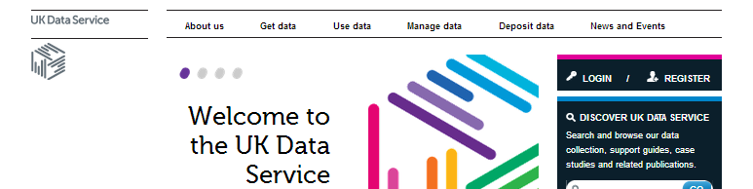
Click on ‘Get data’

This takes you to the ‘Discover data’ page

There are various ways you can search for data.
These include:
1.Key data – includes a list of the most popular data sets
2. Data by theme – lists data under 5 subject themes

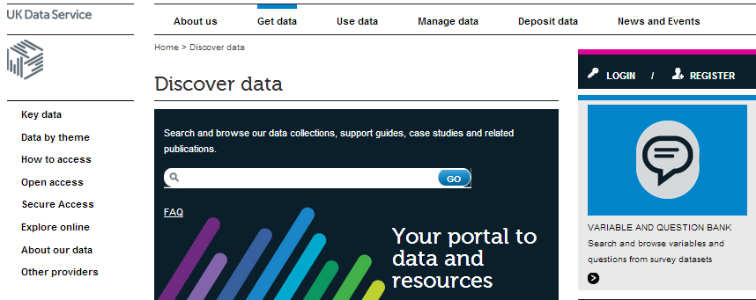
3. Free text search – (a bit like searching for stuff on ebay)
4. Variable and Question Bank lets you search for surveys that include specific questions

We will have a look at each of the above 4 methods for finding data
For this exercise, we will search for data on the broad topic of crime (but the process is transferable to any topic we might be interested in)

Search Method 1: ‘Key data’ a good place to start as it lists the most popular and well used surveys
First click on ‘Key Data’
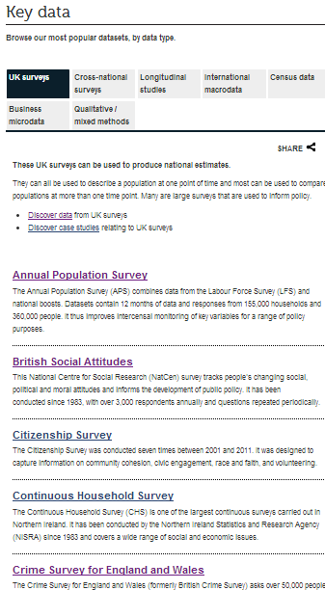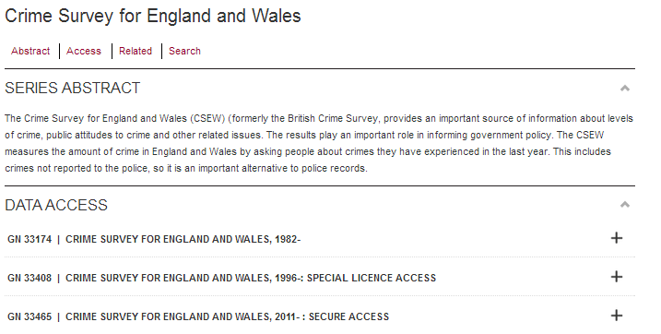
1. The major UK surveys are listed alphabetically ... you’ll see the 5th one down is the Crime Survey for England and Wales, one of the most important sources of data on crime. Click on it

2. Click on the ‘+’ next to ‘Crime series for England and Wales’
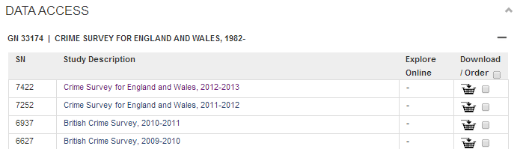
3. Now Click on the most recent version of the survey 2012-2013

This will open up the ‘Catalogue’ entry for the 2012-13 Crime Survey
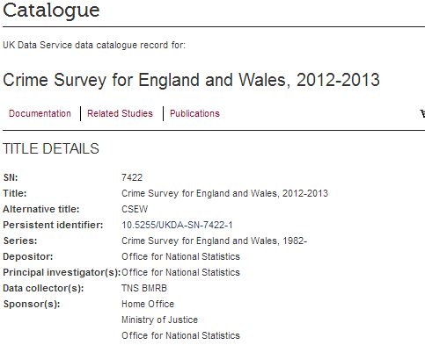
Every dataset held by the UK Data Service has a catalogue entry like this.
It contains useful information about the survey, including who paid for the survey, who collected the data, key topics, the sample used, method of data collection etc that will help you decide whether it is suitable for your research.

Use the information in the catalogue page to find the answers to the questions below..
1. Who pays for the Crime Survey? ...................................................................................................................................
2. Who collects the data? .................................................................................................................................................
3. How long has the survey been going?..........................................................................................................................
4. List 3 topics covered in the Crime survey that you would be interested in looking at .........................................
............................................................................ ...........................................................................................................
scroll down to ‘Coverage, universe, methodology’ section
5 .How big is the sample (how many cases)? ..........................
6. Who makes up the sample? (tip: is it a sample of everyone in the UK.. does it include all ages?) ..........................
............................................................................ ...........................................................................................................
7. What method of sampling was used? ..........................................................................................................................
8. What were the methods of data collection? .................................................................................................................
9.Why do you think the survey used self-completion for topics like drinking and drug use (rather than interview)?
............................................................................ ...........................................................................................................
scroll down to Administrative and Access Information
10. Under Access conditions you’ll see some of the data is only available under ‘special licence’ conditions. Why do you think this is so? .................................................................................................................................................
Getting more detailed information
The catalogue page contains a lot of useful information but we can find more detailed information by following links to other survey documentation including the full survey questionnaire.
Suppose you were interested in doing some analysis relating to experience and fear of crime among the young (school aged) sample – You would want to know exactly what questions were asked of this sample in the survey.
Scroll down the page until you come to the section ‘Documentation’
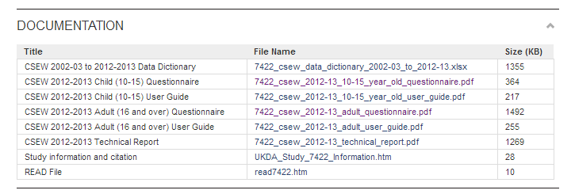
There is a separate questionnaire for children aged 10-15
Click on it to open

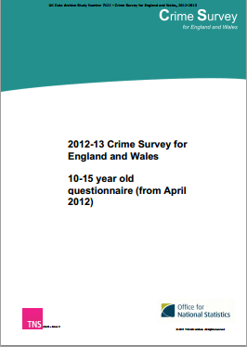
You should find the questionnaire opens up as pdf file..
You could just scroll through it looking at all the questions (there is also a contents page) but if you know what you are looking for you can also do a word search (as the questionnaire is quite long)
Searching a Pdf file is easy, just type ‘Control F’ to open the search box, and type in the word you want to search for
e.g. Suppose you were interested to find if children were asked about the experience of being bullied.. Try entering ‘bullying’ into the search box
This will highlight all places in the questionnaire where the word bullying appears....

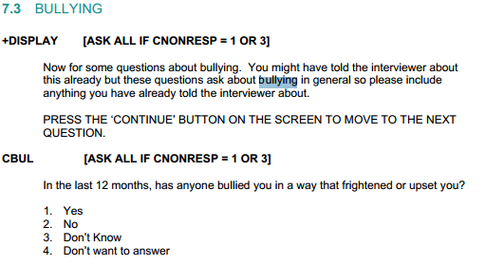
Try repeating this search of the questionnaire for questions on another topic e.g. if interested in drug use you could try ‘cannabis’.
N.B.2 the search will only pick up direct matches in question wording so it’s worth experimenting e.g. if interested in drinking behaviour try ‘alcohol’ and ‘drunk’

Search Method 2: ‘Data by Theme’
Return to the ‘Data Discover’ home page shown on page 2 and select ‘Data by theme’
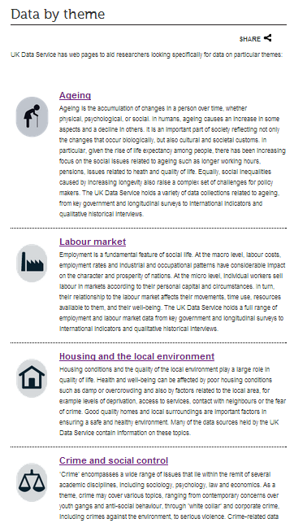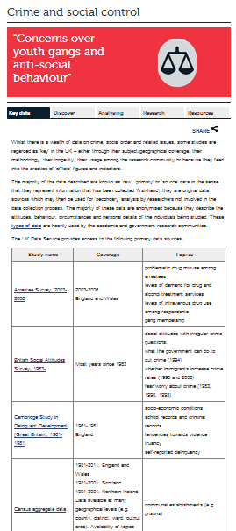
One of the themes is ‘crime and social control’
Click on the link.
You’ll see there are a number of data sets listed under this theme (including the Crime survey for England and Wales we have just looked at).
Click on one or two that look of interest to you and have a quick look at the data catalogue pages to get a bit more information on them

Search Method 3: Carry out a free-text search
Go back to the Data Discover page (as shown on page 2)
Type in Crime
and then click Go

The search results will appear below

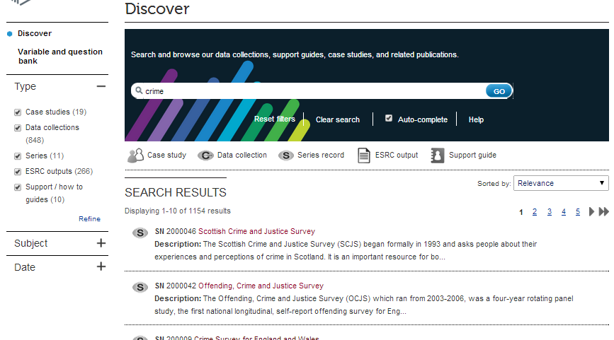
Question – How many ‘hits’ has your search revealed? .................................
This is far too many to be useful! You need to narrow down the search a bit. One way to do this is to restrict the type of resources it searches for (as well as datasets, the Uk Data Services include case studies, reports etc)
Since we are just interested in searching for datasets, on the left hand side under ‘Type’ un-tick everything except data collections (this will ensure it only searches for data sets.
Then click ‘refine’
How many search hits are there now? ..................................
To further narrow down the search select ‘Date’ and limit the search to recent datasets (e.g. those collected in the last 3 years, since 2011)
Click on ‘refine’ again. How many search hits are there now? ..................................
We could refine it further but will stop there. One other thing we can do is change the sorting preference to ‘show latest first’ bringing the most up to date versions of surveys to the top of the list
Now have a look at the first few hits. You will find that the Crime Survey for England and Wales is there again. It will throw up some other interesting surveys. Clicking on any of the data sets will take you to the catalogue page giving more information about the dataset
N.B. Obviously another option for narrowing down a search of this type is to enter something a bit more specific than ‘crime’ into the search box e.g. ‘fear of crime’ or a specific type of crime e.g. ‘burglary’ depending on the focus of your research question.
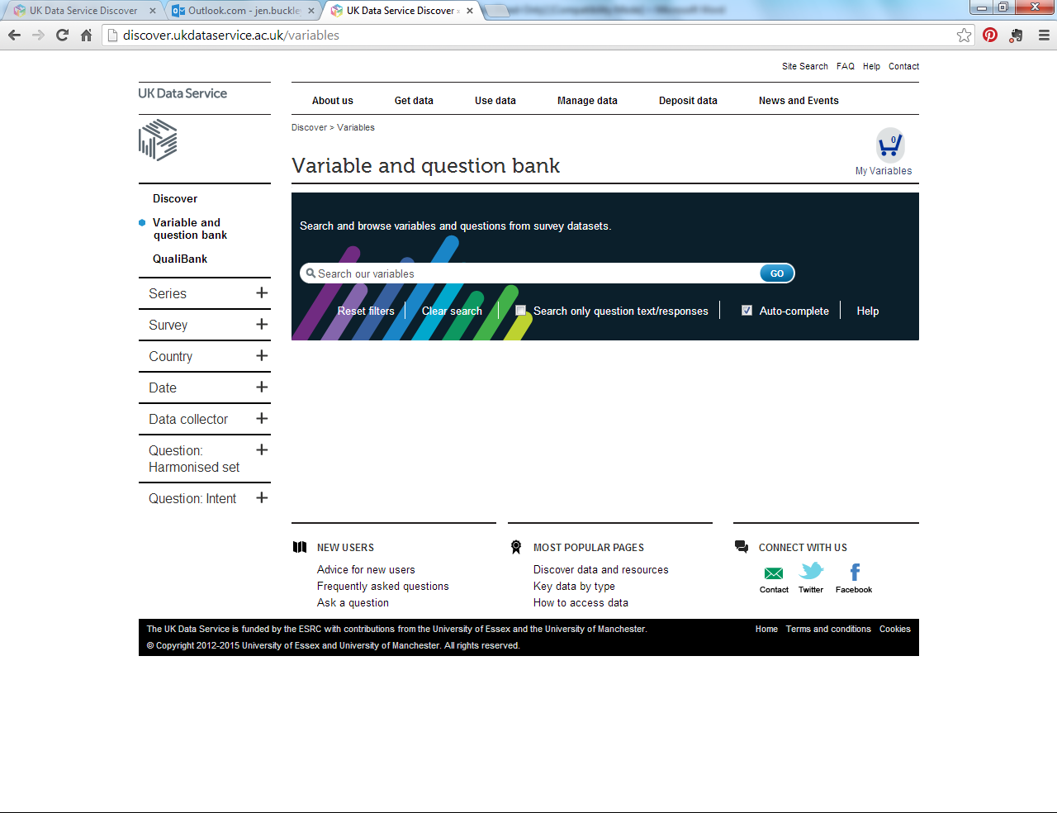
Search Method 4: Variable and Question Bank
On the left-hand menu, click on the ‘variable and question bank’ The variable and question bank allows you to search for surveys that include a specific measure e.g. if you were interested in doing some analysis on domestic violence…. type in ‘domestic violence and Go.
It will search survey questionnaires for that precise term and return hits that give you links to the actual questions asked and the counts of people who answered them in the survey.

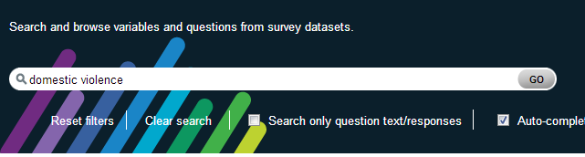

Select the 3rd one down ‘Is DV against a man ever acceptable’ (shown below)
It will open a new window giving you details of the survey, the question text and the number of respondents who answered each category
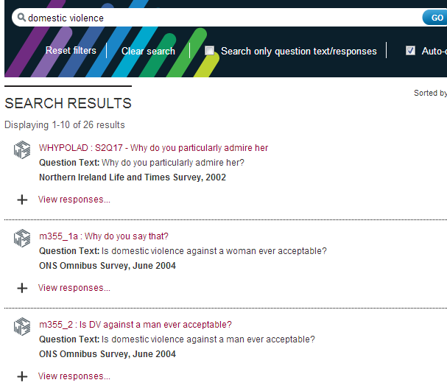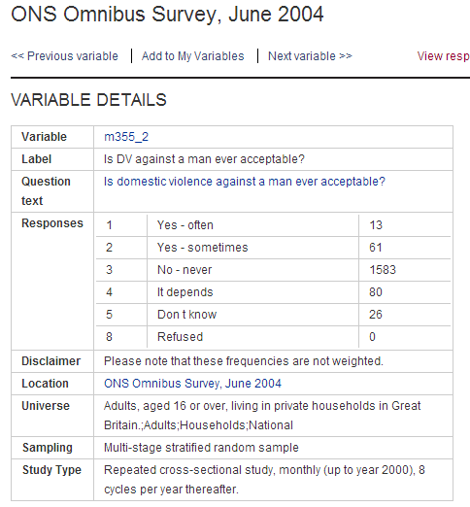
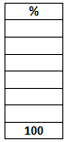

You will notice that the counts for each answer in the table are the actual number of respondents e.g. 13 people said ‘yes often’. Can you convert these counts (called frequencies) into percentages?

Task 2: Now find data on a topic of your choice
Basically this task involves using the same methods to search for data, but this time doing it for a research topic of your own choice
To keep a record of your search you should fill in the separate hand-out ‘Data Search Worksheet ’ as you go along.
Note: Thinking of a research topic/question
As discussed in Lecture 3 when searching for survey data it helps if you can first come up with a clear and specific research question (rather than just a vague topic). This will make it easier when you come to narrowing down your search and working out if the surveys you find are suitable or not (e.g. do they include all the variables you need, does the sample match up with your population of interest etc)

But as a first go at this task it’s fine to work with a general topic of interest, and doing the search may give you ideas for developing a more specific research question.

MB 2014
Data Search Worksheet

PART 1: DATA FOR WHAT?
a) Broad Topic:
a)

b) Research Question(s)

c) Hypothesis(es):

d) Dependent and Explanatory Variables
To help clarify data requirements try and specify a ‘dependent variable’ that you’d require to answer your research question and any main explanatory variables you think you would need e.g. if your question was ‘an investigation of ethnic group variation in the fear of street crime then essential requirements would include a) a measure of respondents fear of street crime (dependent variable) and b) a measure of ethnic group (the key explanatory variable, though there would be others you’d probably want to include e.g. gender and age).

Dependent variable

Explanatory Variable(s)

e) The Survey Population (define the population of interest)
For this consider geography (e.g. are you interested in population for all UK or a sub-national area) and socio-demographic (e.g. all people or just some sub-group)

PART 2: DATA SEARCH

- List up to 3 datasets found in your search that look relevant to your needs (and record the method of search)
Survey (write full title and year)
1.

2.

3.

- For TWO of the surveys listed above, complete the following…
 | Survey 1 | Survey 2
Name and year of survey?
Who carried out the survey?
Who was the sample based on? (i.e. what population?)

What was the sample size?

Is the survey a one-off or available for more than one year?
What method of sampling was used (was it a random sample?)
What was the method of data collection (e.g. interview or self-complete)

Does the survey have the key variables you need?
(note them down)

Is the data available from the UK Data Service?
What documentation can you find for the survey
(e.g. is there a user guide? is the questionnaire available?)

- Which of the surveys you found looks the most promising for answering your research question (and why)?

a)

