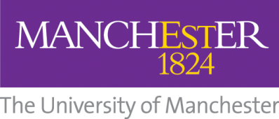

Guaranteed Interview Scheme
The University of Manchester are users of the Disability Two Ticks Symbol which is awarded by Jobcentre Plus. Under this scheme, we guarantee an interview to anyone with a disability who meets the essential criteria for the job.

What do we mean by disability?
The Disability Discrimination Act defines a disabled person as someone who has a physical or mental impairment which has a substantial and adverse long-term effect on his or her ability to carry out normal day to day activities.

The University of Manchester is an Equal Opportunities employer and is committed to supporting disabled people in recruitment, employment and career development.

Using the definition above do you consider yourself to have a disability? | Yes | No

Please indicate below if you would like to be considered under this Scheme.

I would like to be considered under the Guaranteed Interview Scheme | Yes | No

Support
If you are successful in being invited for an interview you will be given the opportunity to discuss any support requirements you might have.

If you are unsure about any aspects of this scheme or the support available and would like to discuss this further please contact the University’s Staff Disability Advisor via:- des@manchester.ac.uk Tel: 0161 275 7512

The information you provide at this stage will be treated with the utmost confidence and will only be shared with the chair of the short listing panel and the local Human Resources Team.

Office use only - Please complete if candidate has asked to be considered under the guaranteed interview scheme

Application Ref: No
Met the essential criteria |  | Not met the essential criteria

