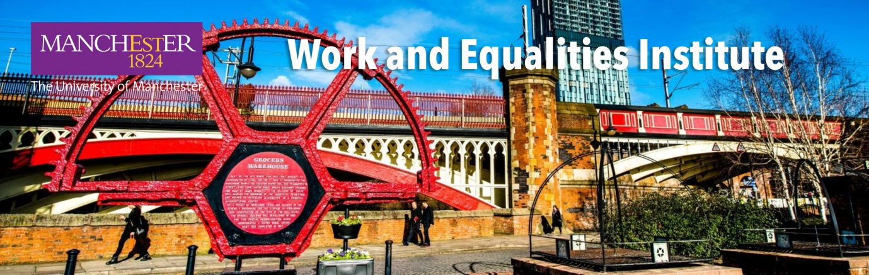

The Launch of The Work and Equalities Institute
Wednesday 14 November 2018 at The University of Manchester
Register here

Debating the future of work and equalities in the fourth industrial revolution
in the birthplace of the first industrial revolution
Our formal launch will take place at a drinks reception at 6.30pm in The Fossils Gallery, Manchester Museum, 14 November 2018.
The launch will conclude an afternoon of three interactive panel debates from 2pm at University Place, to which you are also invited. These will focus on important themes for contemporary society, building on and developing Manchester’s rich legacy of contributions to equalities at work.
The first panel will discuss human rights and the responsibilities of business and society to ensure dignity, fair treatment and fair access to work.
-
The second panel will debate the priorities and possibilities for promoting equalities in the workplace.
-
The final panel debate, to be chaired by University of Manchester governor and distinguished journalist Michael Crick, will consider the impact of the fourth industrial revolution on work and equalities.
These panels, comprising distinguished and informed speakers, will help to set the agenda for the Work and Equalities Institute. New ways of working, new risks to equalities and new concerns over the potential loss of jobs are intensifying debates on how we organise work in the future, what we can do to promote decent forms of work, and the responsibilities society and the business community have towards citizens and workers.

Confirmed speakers and chairs
- Michael Crick, Channel 4 News, and member of The University of Manchester Board of Governors | - Stephanie Barrientos, Professor, Global Development Institute at The University of Manchester
- Gerhard Bosch, Professor, University of Duisburg-Essen, and member of German Government’s Work 4.0 commission | - Sally Bucknell, Head of Diversity and Inclusion, EY
- Tarani Chandola, Professor of Medical Sociology, The University of Manchester | - Lynn Collins, Regional Secretary, TUC North West
- Paul Dennett, Mayor of Salford and Alliance Manchester Business School alumnus | - Tony Dundon, Professor of Human Resource Management, Alliance Manchester Business School, member of WEI management
- Ismail Erturk, Alliance Manchester Business School Deputy Director for Social Responsibility | - Colette Fagan, Professor and Vice President for Research, The University of Manchester
- Debra Howcroft, Professor of Technology and Organisation, Alliance Manchester Business School, Deputy Director of WEI | - Miguel Martinez Lucio, Professor of International Human Resource Management, Alliance Manchester Business School, Deputy Director of WEI
- Ken McPhail, Professor and Research Director Alliance Manchester Business School, and leader of the Business and Human Rights catalyst at Alliance Manchester Business School. | - Jacqueline O’Reilly, Professor of Comparative HRM, University of Sussex
- Florian Ranft, Senior Research Analyst at the Centre for Progressive Policy. | - Jill Rubery, Professor of Comparative Employment Systems, Alliance Manchester Business School, and Director of the Work and Equalities Institute
- Linda Shaw, Chair, Women Working Worldwide | - Nick Srnicek, Lecturer in Digital Economy, King’s College London
- Valerio de Stefano, Professor of Law at the University of Leuven, previously at the International Labour Organisation | - Wilson Wong, Head of Insight and Futures at the CIPD

Schedule
- 1pm: Lunch
- 2-6pm: Panel debates
- 6.30pm: Drinks reception and formal launch
Register for the panel debates and/or the drinks reception here
If you are not able to join us but would like to be kept informed about the activities of the Work and Equalities Institute, you can subscribe to our mailing list by emailing us.

Discover more about the WEI at mbs.ac.uk/WEI

