**International Workshop: New Models of Innovation for Development**

**University of Manchester and UK Development Studies Association**

***4-5 July 2013***

**A Systems-based Model for the Successful Scaling Up of Sustainable Innovation at the Bottom of the Pyramid**

**Roald Suursa, Fernando J. Díaz Lópeza*, Jenny de Boera, Matilde Miedemaa, Linda de Kampc and R. A. Mashelkard**

a Netherlands Organisation for Applied Scientific Research TNO, Innovation for Development Program, the Netherlands

c Technical University Delft, the Netherlands

d Global Research Alliance and CSIR-National Chemical Laboratory, India

*Contact e-mail: fernando.diazlopez@tno.nl

**Abstract**

*Inclusive innovation literature provides manifold examples and some answers as to how projects can achieve the full potential of the BoP market and what factors can be considered important in determining the likelihood of an innovation’s success. But the existing literature and methods for analysis are mostly oriented towards firms’ strategies or project practices, focusing on the micro-level, including such things as products, project organisation, capacity building and the involvement of local stakeholders. Little or no attention has been paid to the surrounding context in which innovation occurs, or to the environmental sustainability of BoP products and technologies. This paper aims to contribute to the debate surrounding new models for innovation within the development sector and to explore the wider implications for innovation in the context of development policies. The central objective guiding this paper is therefore the elaboration of an analytical framework which can be subsequently implemented in analyses of system-wide factors for the successful scaling up of inclusive, sustainable innovations. The authors of this paper present a model for the analysis of the innovation (eco-) system of inclusive innovation. The model includes the following five dimensions: landscape, resources, knowledge, market, and support mechanisms. Ongoing work of the authors currently focuses on the application of this framework to a number of BoP projects conducted within TNO’s Innovation for Development programme and a number of examples from the literature, particularly from India. The outcome of this ongoing work will provide policy conclusions, salient limitations and avenues for future research.*

**Keywords:** *inclusive innovation, bottom of the pyramid, innovation systems, sustainable innovation, resource-based view, international development.*

## Introduction

“Bottom-of-the-pyramid innovation” is a popular concept which aims to describe those innovations that serve the largest and poorest socio-economic markets in developing countries. It is not surprising that the attention in recent innovation literature has shifted to pro-poor growth and inclusive development, ethical legitimacy, sustainable development and policy support (Hahn, 2009). Inclusive innovation focuses on affordable products and services that create livelihood-sustained opportunities (Mashkelar, 2013).

In general, inclusive innovation scholars have provided manifold examples and some answers as to how projects can achieve the full potential of the BoP market and what factors can be considered important in determining the success or failure of an innovation (Prahalad and Hart, 2002). The existing literature is oriented primarily towards firms’ strategies or project practices (Simanis et al., 2008), with a focus on the micro-level, including aspects such as products, project organisation, capacity building and the involvement of local stakeholders. But little or no attention has been given to the surrounding context in which innovation occurs, or to the environmental sustainability of BoP products and technologies. Equally, little has been said about the long-term environmental sustainability of these innovations, albeit in practice a number of inclusive innovations exist in fields related to low-carbon technologies.

Because the surrounding context of any project or company is just as crucial, we suggest that BoP studies adopt a systems approach to innovation (Edquist, 1997, Hekkert et al., 2007). The added value of a systems view of innovation lies in the fact that it is well equipped to identify those drivers and barriers that shape the broader “context” of an innovation project (Coenen and Díaz López, 2010). A systems view of innovation enlarges the focus of BoP interventions by looking at a system in terms of innovation, capacity upgrades, and opportunities to enter global value chains in order to increase market success (Pietrobelli and Rabellotti, 2011).

This paper aims to contribute to the debate surrounding new models for innovation within the development sector and to explore the wider implications for innovation in the context of development policies. The central objective guiding this paper is therefore the elaboration of an analytical framework which can subsequently be implemented in analyses of system-wide factors for the successful scaling up of inclusive, sustainable innovations. The analytical dimensions of such a framework are: the landscape in which innovation takes place, available resources, the knowledge pool, the market, and support mechanisms.

With regard to the theoretical aspects, the authors of this paper have drawn on concepts and notions from innovation studies (innovation systems), strategy research (a resource view of the firm) and development studies (BoP markets, pro-poor innovation). Empirically, the model presented in this paper was further drawn from the analysis of 35 BoP empirical studies. A face- validation of the proposed model was also performed in an expert workshop. The next step toward the validation of this method is due in the summer of 2013. The outcome of this exercise will be the provision of policy conclusions, salient limitations and avenues for future research.

The remainder of this paper is distributed as follows. Section 1 presents a review of past evidence on inclusive innovation projects, together with two bodies of literature which contribute to the integration of an analytical framework for the analysis of inclusive innovations at the systemic level. Next, Section 3 provides a brief description of the methodological approach followed in this paper. The fourth section presents the preliminary results of our literature and evidence-based cases, used for the integration of a first version of an analytical, system-level-based tool for the analysis of inclusive innovation in BoP markets. Finally, some preliminary conclusions are presented.

## Review of past evidence and a framework for analysis

Innovation is defined as ‘technologically novel or improved material goods, intangible services or ways of producing goods and services’ (Edquist, 2005). In this paper we follow Mashelkar’s (2013) working definition of inclusive innovation as: ‘… *any innovation that leads to affordable access of quality goods and services creating livelihood opportunities for the excluded population, primarily at the base of the pyramid, and on a long term sustainable basis with a significant outreach’[1].* The target group in question is often considered to be those living below the income level defined in the First Millennium Development Goal as less than one dollar per day.

Mashelkar reminds us that the objective of a truly inclusive type of innovation would not be just to produce low-performance, cheap knock-off versions of rich countries’ technologies so that they can be marketed to poor people. That is getting “less for less”. Inclusive innovation offers “more from less”. This means that we will have to harness truly sophisticated science and technology, or truly creative non-technological innovation, to invent, design, produce and distribute a reach price-performance envelope that leads to quality goods and services that are affordable for the majority of people. The authors of this paper make a strong plea for considering the sustainability of these innovations with a triple bottom-line logic (economics, environment and society), the so-called sustainable innovations (c.f. Boons et al., 2013 for an overview of recent trend and research challenges). The definition adopted in this paper includes technological and non-technological innovation.

In this section we provide an overview of the literature that aims at a better understanding of the following topics:

* The context in which BoP markets and inclusive innovation traditionally occur;
* The role of strategic management of sustainability in view of innovation; and
* The systemic nature of innovation, beyond projects at the community level; looking at the broader set of actors, networks and institutions[2] and the general framework conditions that affect the functioning of a system and ultimately the scaling up of innovations.

A schematic representation of the (assumed) relationships between the different bodies of literature described in this section is depicted in the figure below.

Figure 1. Conceptual model of the assumed relationships between the different bodies of literature guiding this paper

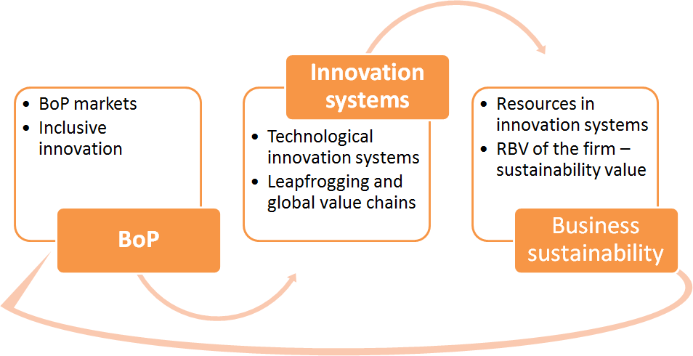

### Inclusive innovation, BoP markets and local development

As noted in the introduction of this paper, inclusive innovation scholars have provided manifold examples and some answers as to how projects can achieve the full potential of the BoP market and as to what factors can be considered important in determining the success or failure of innovations (Prahalad and Hart, 2002). Existing literature is mostly oriented towards firms’ strategies and project practices (Simanis et al., 2008), focusing on the micro-level of products such as project organisation, capacity building and the involvement of local stakeholders. But little or no attention has been paid to the surrounding context in which innovation occurs, or to the environmental sustainability of BoP products and technologies. Most of the methodologies and advice offered in the literature is written for practitioners developing and implementing projects.

In the view of some authors, inclusive innovation is a continuation of the not-for-profit “Appropriate Technology” movement of the 1970s, with a stronger need to develop low-wage and poor-infrastructure appropriate innovations and increased capabilities in the South (Kaplinsky, 2011). The typical outcome of a pro-poor demonstration project aiming at fostering appropriate technology transfer has been extensively documented (e.g. Diaz Lopez et al., 2005). An example was the demonstration programme of the United Nations Development Programme and the Third World Network (Khor and Li Lin, 2001). The analytical focus of this programme focused on development projects implementing technical solutions which could bear the potential to be transferred to other developing economies. The view of scaling up innovations mainly looked at technical and/or market factors, such as the capacity of the device, size, additional funding required, etc. The role of policy was deemed narrow, favouring local technology and public purchasing options for policy intervention. Some authors would like to believe this situation has changed, and that the playing field for pro-poor innovation now allows new entrants and new competitors, notably from East Asia. It is expected that the new generation of appropriate pro-poor innovation will contribute to a wider view of innovation beyond technical specificities, in which growth, poverty reduction and the distribution of income in the South will become a major driving force of innovation (Kaplinsky, 2011).

The work of London and Hart (2004) suggests that the traditional business logic model of companies introducing products into low-income markets requires fundamental rethinking. A stronger focus on the local environment and capacity building, developing relationships with non-usual partners and processes of co-creation of innovations were deemed as necessary factors for success. Such thinking led to the development of the BoP protocol, which is a business model generator based on the principle of co-creation of innovative solutions (Simanis and Hart, 2008). This type of protocol includes the stages of (i) opening up, (ii) building the (eco-) system, and (iii) enterprise creation. In the aforementioned BoP protocol, the view of the ecosystem is defined at the project and local levels. It is used as an analogy to describe a process of building the organisational foundations of the innovation project with a low degree of technological complexity. It includes a project team, the participation of the local community, a conceptualisation of a business prototype and some basic upscaling. Overall, this methodology places no real emphasis on analysing the broader institutional environment in which innovation takes place (e.g. at the national or regional levels), nor the establishment of the market base of the innovation.

A growing number of studies on innovation for BoP markets focus on the role of entrepreneurs and their quest to overcome specific challenges that are uncommon in “regular” innovation projects. Although many inclusive innovation projects nowadays are located within a market based approach, they work in an environment that has a history of aid and development co-operation. Therefore, one of the concerns seen in a number of studies is “the development effect” during the project, as this is influential in decisions about the adoption of new technologies and subsequent behaviour (de Boer et al., 2013). Aligned to the view above, some methodological considerations for successful BoP projects have been added to the ones originally suggested by Simanis and Hart (2008) (collaboration, business models, capabilities, co-creation, social embeddedness, etc., see Figure 1). The methodological guidelines of De Boer et al. (2013) suggest looking at the institutional and policy context in which innovation occurs, e.g. the broader setting of the governance mechanisms of innovation support. In their appraisal, De Boer et al. recognise that despite BoP projects not having an explicit ambition to change policy agendas, governance agendas or policies, these are influenced by national policies and the institutional setting. These factors affect the uptake and implementation of the service on a local and international level; therefore they should be taken into consideration when designing BoP interventions based on innovation. Other important in BoP methodological guidelines relate to social and cultural considerations[3]. Additional insights from this practitioner’s literature are the attention given to the strategic context of innovation projects. This is a topic addressed in the following section.

Figure 2. De Boer et al.’s methodological guidelines for organising inclusive innovation projects in BoP markets

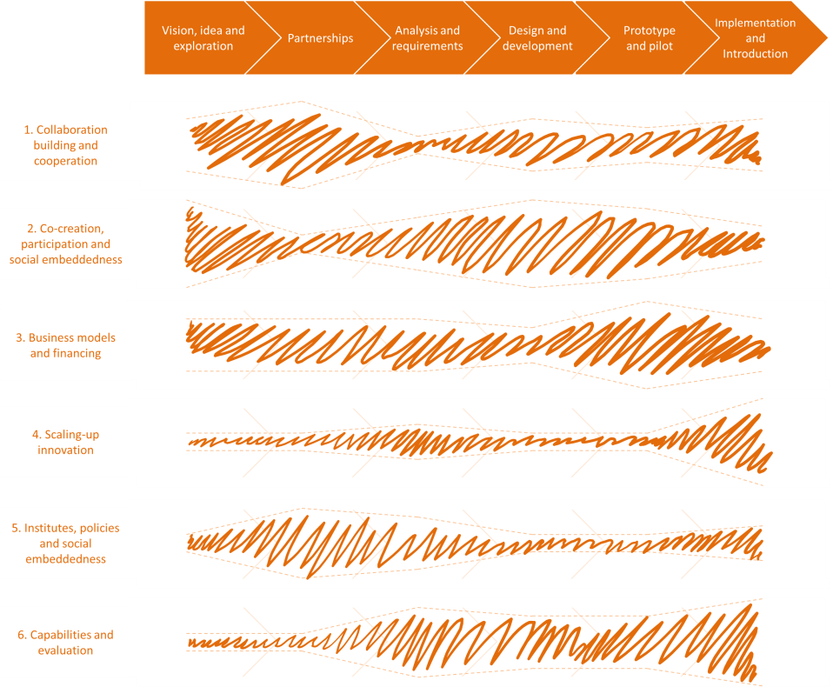

*Source: De Boer et al., 2013*

Mashelkar (2013) suggested a five-point matrix for the qualitative evaluation of inclusive innovation based on the following characteristics: (i) affordable access, (ii) (long-term) sustainable business, (iii) high quality, (iv) inclusion of excluded population, especially BoP, and (v) significant outreach. These five parameters are interdependent. For example, the scale of production determines the price, therefore “significant outreach” and “affordable access” are interdependent. And both of these are, of course, linked to “sustainable business”. By definition, for the same inclusive innovation candidate, the rating on any individual parameter in the matrix will be time-dependent. Mashelkar proposes the Five Point Matrix Evaluation as a support tool for determining government interventions. Notwithstanding, this first generation of evaluation tools does not fully accomplish looking at innovation in the broader perspective, in which the institutional framework and market and systemic failures in the innovation system are systematically identified and addressed.

The following section presents a review of the literature focusing on the systems view of innovation, which has been successfully used to analyse the impact of innovation in the sustainability and competitiveness of countries (Coenen and Díaz López, 2010).

### Inclusive innovation and innovation systems

A system of innovation is defined as networks of organisations and institutions that develop, diffuse and use innovations (Edquist, 1997, Hekkert et al., 2007). In spite of the rich amount of work about innovation systems in developing countries, only a few mentions of inclusive innovation, catching up and development can be identified in the literature. But no provision of an analytical framework has been suggested (Kaplinsky, 2011; Alterburg, 2009).

In this literature, innovation is primarily seen as a means for firms and industries to achieve competitiveness. This approach argues that the right mix of knowledge infrastructure, entrepreneurship, risk capital, launch markets, etc. must be in place. The role of policy is to amend market and system failures and to level the playing field for new entrants (Coenen and Díaz López, 2010). Innovation policies focus on the identification and removal of both market- and system-level failures (Klein Woolthuis et al., 2005) (see table below).

Table 1. Types of market and system failures in an (eco-) innovation system

|  |  |
| --- | --- |
| **Market failure** | **System failure** |
| Public good nature of knowledge gives rise to problems of appropriating the benefits from innovation (e.g., risk of imitation) | Inadequacies in the technology/knowledge infrastructure |
| Uncertainty and incomplete information about the costs and benefits of innovation | Old and rigid technological capabilities within companies, causing transition failures to new knowledge bases |
| Market power | Insufficient entrepreneurship |
| Entry barriers | Not enough risk capital and high capital costs |
| Network externalities causing a lock-out | Regulations acting as barriers to innovation |
| Price gap for environmental innovations at the beginning of the learning curve | Unfamiliarity with and social resistance to certain innovations |
|  | Actors not being able to co-ordinate joint action |

*Source: Kemp (2011)*

Most IS literature is in essence academic (non-intervention based), but it has the power to prescribe policy recommendations useful for policy analysis and policy makers. It also provides further guidance for innovation practitioners by clearly describing what factors could hinder the successful market deployment of an innovation.

A popular approach for studying emerging innovations is the Technological Innovation Systems (TIS) approach (Hekkert et al., 2007, Carlsson and Stankiewicz, 1991). The TIS approach has especially proven itself in explaining why and how sustainable (energy) technologies have either developed and diffused into a society or have failed to do so (e.g. Suurs et al., 2010, Markard and Truffer, 2008). Such studies usually provide a clear map of actors and a description of relevant regulations. Obviously, the technological innovation at the core of the study is also described. In order to assess the performance of the Innovation System, scholars tend to focus on a set of so-called system functions, or key activities necessary for an innovation (eco-) system to perform (see Table 2.

Table 2. Functions of an innovation system

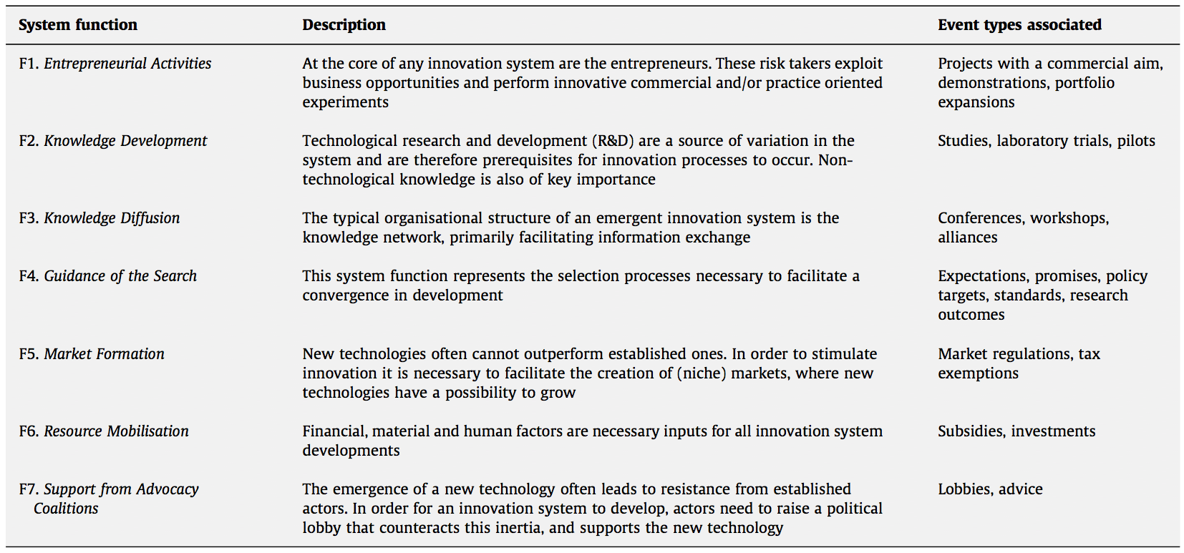

*Source: Suurs, 2009*

Altenburg (2009) highlighted the need to adapt the innovation systems approach to the particularities of inclusive innovation in developing countries. Altenburg suggests a stronger focus on learning, knowledge exchange and capacity building at the national and regional levels. According to this author, a good balance should be kept when analysing the role of governments as resource allocation entities, and more focus should be had on improving basic institutions that support the formation of the market, such as financial intermediation. Emerging economies show a different level of development, as these countries are rapidly catching up with the most advanced Western economies. There are a myriad of examples in which innovation in transitional economies have set up leapfrog dynamics leading to levelling capabilities at the global level (Altenburg et al., 2008), particularly in a number of areas related to sustainable, low-carbon innovation (Walz, 2011). Recent studies have focused on the process of catching up and inserting innovators from developing countries in global value chains (Pietrobelli and Rabellotti, 2011). Pietrobelli and Rabellotti identified a growing trend in open modes of collaboration and association for the deployment of emerging innovations, which has strong implications for the consolidation of regional and global value chains. This observation is based on recent findings in the literature of global value chains in emerging economies (Mexico, South Korea, etc.), which identified a number of areas in which innovation activities play a key role for the integration of value chains, learning mechanisms, knowledge spill-overs, capacity building, etc. Moreover, the innovation system influences decisions on how a global value chain sources its production system, either locally, regionally or elsewhere.

In the context of TIS in developing countries, Van Alphen (2011) replaces knowledge development by creating adaptive capacity, which refers to the capacity which is required to adopt the technology in the developing country.[4] Also, he includes a separate function for “demand articulation” activities. This refers to activities that can affect the visibility of specific needs of users. Van Alphen focuses on the needs of users and not solely on the “guidance of search activities” mentioned above. The table below provides a set of systems functions that is specifically adapted to be used within the context of developing economies. This representation is particularly interesting, as it applies an attractive clustering of the different system functions into four groups. Provided that these kinds of amendments are seriously considered, the framework seems to be useful for the analysis of BoP innovations. It is especially useful as a guide for pointing out important strengths and weaknesses. See Table 3 below for an example.

Table 3. TIS functions adapted to the context of a developing economy (The case of domestic biogas in Rwanda).

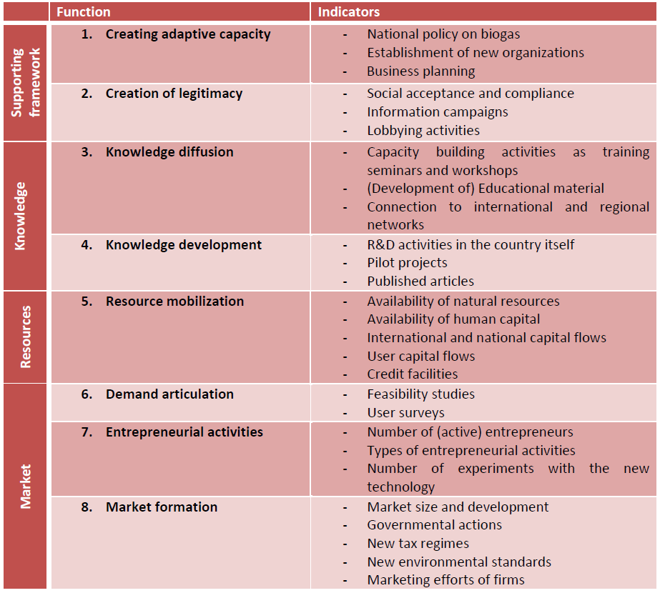

*Source: Van Zuylen Internship Report (TU Delft*).

There is growing concern about the future sustainability of our consumption and production system (Tukker et al., 2010), because the availability of resources and the ecological crisis will have an impact on the future of the wider system in which new sustainable technologies, products and services are being developed (Jackson, 2009, Markard et al., 2012), that is, the *landscape* shaping major sustainability transformations (Geels, 2002).

### Inclusive innovation and strategic management of sustainability

As noted in the preceding section, a key question to ask is whether the BoP projects are successful in realising the potential of the BoP market, and what factors are considered important in determining this success (or failure). The current literature on BoP innovation provides such answers, but it is mostly oriented towards firm strategies or project practices. It focuses on the micro-level: products, project organisation, capacities and local stakeholder involvement.

One of the reasons for a discrete view of innovation (at the project level) can be attributed to the epistemic foundations of BoP research and practice. Prahalad and Hart’s (2002) work on strategic management and value creation in BoP markets was inspired by their earlier work using the resource based-view of the firm, e.g. in (Hart, 1995, 1997, Hart and Milstein, 1999) and in (Prahalad and Hamel, 1990). The resource-based view (RBV) of the firm is located at the heart of the strategic and industrial economics thinking (Barney, 1991). This approach complements the study of economic value creation and competitive advantage (Mahoney, 2005) by positing that valuable, difficult-to-imitate resources, competences and capabilities provide a unique, sustained competitive advantage to the firm. In this approach, a firm (or company) is understood as ‘*…an administrative organisation and a collection of productive resources’* (Penrose, 1959: 31). It is the owner of uncommon firm-specific resources that are difficult to imitate. This theory analyses profitable companies, not because they incur strategic investments, but because they have lower costs, higher quality and higher performance. The RBV literature is academic, and empirical studies building on it can provide some guidelines for corporate strategists about business strategy in view of existing resources and capabilities.

Contemporary to the well-known BoP work by Prahalad and Hart, Hart and Milstein (2003) developed a strategy tool for the creation of sustainable value in organisations, in view of global challenges. For these authors, sustainable value represented a firm’s set of strategies and practices that had the ultimate goal of linking global-scale drivers of sustainability to those of a firm’s shareholder value creation (see below). This approach suggests that corporate strategy could lead to the achievement of environmental sustainability goals and the development of competitive advantages on the basis of how capable the firm is of developing firm-specific competencies and capabilities. This model can be used to analyse returns on investments in sustainability (sustainable value). Value can be seen in terms of short-term results. The vertical axis shows how today’s business are managed while creating tomorrow’s technology and markets, or future growth and in-house/external capability building. The horizontal axis helps to identify current and prospective business models and technologies. Hart and Milstein (2003) built on the three strategic capabilities of Hart’s (1995), which are sources of creative tension for firms (pollution prevention, product stewardship and sustainable development). They added the “clean technology” strategy and changed the “sustainable development” dimension for “sustainability vision”, which is driven by population, poverty and inequality challenges – clear drivers of inclusive innovation.

Figure 1. Hart and Milstein’s (2003) framework of sustainable value creation in organisations



In the past few years the focus of attention of a small number of TIS scholars has realised the need to build on insights from strategic management literature, in particular from the resource-based view of the firm (Markard and Worch, 2009). Resources shape the base of an innovation system, and strategic decisions of individual actors (e.g. companies) can have decisive implications on how an innovation system is shaped or functions (Musiolik, 2012), most notably in view of network and system-level resources. At the company level, innovation studies in developing countries have shown that the gradual accumulation of capabilities depends to a great extent on a firm’s internal technological, organisational, and managerial processes (Kim and Nelson, 2000).

The novelty of the novel RBV-informed TIS studies relies on the understanding of system resources for system-building. Based on our review in the preceding section of TIS in developing countries in global value chains, we can infer some further complementarities for the case of inclusive innovation, in which open modes of collaboration and strategic choices help innovators to access global value chains and increase competitiveness. This is clearly an avenue of research that should be further explored.

What the brief literature review above also suggests is that the environmental dimension of sustainability vision and the development and use of sustainability-oriented innovations is critical in view of sustainability value creation. These are dimensions often ignored in BoP literature, or at least there is often a bias towards the social dimension of sustainability. Interestingly, a recent call was made to align inclusive innovation in view of sustainability challenges (George et al., 2012). Existing BoP literature refers to sustainability as long-term business sustainability, not necessarily sustainable development principles at the company or product levels.

The innovation systems literature addresses the lack of a system-wide focus of innovation. It also provides insights on why certain countries develop faster than others and what conditions should exist if countries are to be immersed in a process of leapfrogging and catching up, especially in view of the challenges and opportunities driven by major sustainability challenges. But the innovation systems literature has focused in emergent technological fields, mostly related to energy and low-carbon innovations. Innovation systems for inclusive innovation could be a way forward for the integration of the topics described in the literature review hitherto presented.

## Research methods

Our research methodology is based on a narrative analysis of documents (Stanley and Temple, 2008). In particular, we followed the advice of (Dixon-Woods et al., 2006, Pratt, 2009) when performing a systematic analysis of literature.

In addition to drawing from the literature, the model presented in this paper was informed by the analysis of a number of master thesis studies carried out in the period 2005-2012[5]. The complete set of 35 studies was subjected to a quick scan in order to arrive at some first insights and to establish an overview of the field. Based on the overview, some case studies were selected for closer study (see Annex 1). From the study and comparison of cases, common drivers and barriers were identified and related to the theories used. Finally, a workshop was organised in which these results were presented to our partners/stakeholders in the field. A face validation of the proposed model was also performed by means of an expert workshop.

The next step of our work will include the application of the framework to a number of BoP projects conducted within TNO’s Innovation for Development programme and a number of examples from the literature, particularly from India[6]. Next, the identification of the systemic nature of and factors conditioning the success or failure of BoP projects will be further identified in an ex-post way. Finally, conclusions, salient limitations and avenues for future research will be presented. At this stage we can only present some inferences and assumptions guiding the work presented in this paper.

Before presenting our findings, it is important to consider the bias of our case selection. To consider this, an overview of the cases studied is provided in Annex 1. Some important general characteristics to take into consideration when interpreting our results are: (i) cases are mainly focused on sustainable innovation, especially decentralised energy production, and (ii) the countries that have been studied most intensively are: Nigeria, Kenya and Bangladesh.

## Findings: towards an integrated framework

This section presents a synthesis of the literature studied. We do this by considering two analytical dimensions: the macro and meso levels of analysis. On the one hand we consider the *BoP Innovation Landscape*, covering aspects that include the landscape or macro view of innovation. On the other hand, we consider the *BoP Innovation (Eco-) System*. Here, we primarily consider the direct surroundings of the *BoP Innovation Project*. Further steps in our analytical work include the development of the project – micro level dimension in our analytical framework.

The review of BoP and inclusive innovation cases and the literature presented in Section 2 provided a useful indication on the information needed for analysing analyse the context where innovation takes place in the view of development interventions. Below we list all the factors found to be relevant for the analysis of the BoP Innovation.

Table 4. The three layers of a BoP Innovation (Eco-) System assessment

|  |  |  |
| --- | --- | --- |
| **Layers** | **Span of influence** | **Builds on…** |
| **Landscape** | Adapt / Accept | * Systems approach to innovation (sustainability transitions) |
| **Eco System** | Influence | * Technological innovation systems * Innovation systems in developing countries * Inclusive innovation |
| **Project** | Control | * BoP markets * Strategic management of sustainability |

We propose considering the so-called DESTEP factors as a starting point. The main purpose of the factors included in this category is to provide general guidance about trends that need to be addressed when operating within a certain country or region. This exploratory level of analysis should provide a rich qualitative description in order to provide a sufficiently concrete basis for action/strategy. Complementary to this, quantitative indicators may be useful, especially when comparing various project locations before actually starting a project. Next, the remaining factors included in the assessment of the Innovation System for inclusive innovation are aimed at identifying drivers & barriers relevant for the uptake of BoP Innovation projects. This concerns factors that will determine the success or failure of the project. Vice-versa, if successful, the project will (by definition) have an impact on these factors.

1. *Landscape* (DESTEP factors): includes demographic, economic, socio-cultural, technological, environmental (ecological) and institutional (political-legal) factors, at the national, regional and/or local levels.
2. *Resources (and capacity):* financial, human and physical, resources are necessary as a basic input to all the activities within the innovation system.
3. *Knowledge:* the required technical and practical knowledge, as well as the proper networks that allow this knowledge to be diffused and applied throughout the system.
4. *Market:* this group involves activities that are commercially oriented. The idea is that BoP innovation cannot prosper without at least a first customer. Local entrepreneurs should also be present to meet the demand(s) of the customer.
5. *Support:* this group involves activities related to the support of government(s), NGOs and other relevant stakeholders. These comprise policies and directives, but also political actions, such as lobbying and campaigning.

It is important to note that the proposed framework should be implicitly applied within a triple bottom-line logic, paying special attention to the environmental, social and economic dimension of BoP projects. Perhaps the ecological dimension of the DESTEP factors could be better operationalised at the project level (see de Boer et al., 2013), but it is important to keep these variables in mind when analysing each of the parameters suggested in the analytical framework first introduced here.

In the table below, the different relevant factors belonging to each of the four groups are presented.

Table 5. Framework for the analysis of a BoP Innovation System

|  |  |  |
| --- | --- | --- |
| Landscape | Demographic factors | Population characteristics |
| Economic factors | National income |
| Poverty situation |
| Socio-cultural factors | Power distance |
| Individualism |
| Masculinity |
| Uncertainty Avoidance Index |
| Long-Term Orientation |
| Technological factors | Knowledge base |
| Technological infrastructure |
| Ecological factors | Environment |
| National resources |
| Political-legal factors | Legal system |
| Governance system |

|  |  |  |
| --- | --- | --- |
| **Resources (and capacity)** | Sustainable use of natural resources | - … |
| Human capital | - … |
| Financial capital | - … |
| Facilities, ICT, etc. | - … |
| Equipment | - … |
| Basic infrastructure | - … |
| Credit facilities | - … |

|  |  |  |
| --- | --- | --- |
| **Knowledge** | Knowledge development | - R&D activities |
| - Pilot projects |
| - Publications |
| Knowledge diffusion | - Regional network strength (scale, diversity of actors) |
| - Specialised education |
| - Connection to international networks |

|  |  |  |
| --- | --- | --- |
| **Market** | Demand articulation | - Comparative advantage BoP innovation |
| - Consumer motivation |
| - Market incentive(s) / affordability |
| Entrepreneurial activities | - Active entrepreneurs (quantity, quality, diversity) |
| - Practical experiments with the BoP innovation (quantity, quality, diversity) |
| - … |
| Market formation | - Market size (potential) |
| - Rate of market growth |
| - Distribution channels target market(s) |
| - Directives, tax exemptions, carbon credits |
| - Standards (quality, safety, compatibility, etc.) |
| - … |

|  |  |  |
| --- | --- | --- |
| **Support** | Absorptive capacity | - Capacity to adopt / adapt external knowledge |
| - Adaptive capacity |
| Public policy | - Support / Opposition by the government |
| Political support / legitimacy | - Support / Opposition locals |
| - Support / Opposition politicians / relevant authorities |
| - Support / Opposition NGOs |
| - Support / Opposition Multi-Nationals |
| - Information campaigns (positive / negative) |
| - Lobbying activity (positive / negative) |

Despite the progress achieved in identifying a number of dimensions and parameters for the suggested framework, the question remains as to how such criteria are to be implemented in practice to actually support BoP projects. The authors of this paper are currently evaluating a number of possibilities.

1. First of all, the framework could be used to perform a quick scan for one or more countries / regions that are ‘nominated’ for a BoP Innovation project. This could be done on the basis of crude qualitative assessment in combination with some of the available quantitative national / regional indices. The quick scan is useful for making a quick assessment of different BoP Innovation (Eco-) Systems.
2. A second application is a more in-depth analysis of a specific case, in which the idea is to determine the feasibility of a project, indicating important strengths and weaknesses. This can be done for the different factors, also on the basis of quantitative and qualitative indicators. This study should be done on the basis of local expertise, typically through a series of interviews. The result can be regarded as a kind of risk analysis, indicating important weaknesses and suitable strategies to deal with them.
3. The third option is to develop the framework into a reflective ‘project monitoring’ tool. The idea is to actually apply the framework, periodically, when the BoP Innovation Project is already running. This way, the assessment serves to point out important changes in the BoP Innovation Landscape and Innovation (Eco-) System. For this application it is useful to develop more solid indicators that work specifically for the project. The advantage of this kind of application is that local expertise is readily available. The results of a BoP Innovation Project are well adapted to its surrounding environment. Also, if properly designed, the indicators will help to measure the impact of the BoP Innovation Project.
4. Finally, the fourth application area is to develop a database that can be used for benchmarking numerous BoP Innovation (Eco-) Systems. This would actually be the result of successful applications in the other three areas.

Linking the micro focus of BoP interventions with the three different layers of analysis (project based, system and landscape) represents an analytical and empirical challenge. The authors of this paper are in the process of selecting option 2, drawing on insights from the RBV of the firm in order to provide the match between the system- and project levels of analysis. Since inclusive innovation in a new market (i.e., a developing country) requires the formation of infrastructure, networks, etc., one way forward might be to focus on the formation of supportive structures, network formation and the mobilisation of collective resources.

## Conclusions and implications for future work

The central aim of this analytical paper has been to elaborate an analytical framework which can be implemented for the analysis of system-wide factors for the successful up-scaling of inclusive, sustainable innovations. By doing so, this contributes to the on-going debate of new models for innovation within the development sector and about wider implications for innovation for development policies.

The authors of this paper presented a summary of reviewed literature and identified a number of salient messages. First and more notably, most BoP literature focuses on the project level (community-based intervention), attending a market failure rationale with a growing focus on the role of entrepreneurs. A rather weak focus on sustainability can be identified (triple bottom line, profit, people, and planet). RBV scholars such as Prahalad and Hart are pioneers in the study and practice of BoP innovation, providing methodologies and frameworks for analysis. They moved from an application of RBV to the environment towards sustainability value and bottom of the pyramid markets. Given the common origin of both bodies of literature, it would be advisable to have an explicit consideration of the former topic in BoP analyses. Secondly, the innovation systems concept is resourceful analytical construct for analysing the firm in a systemic context. System failures can be identified and amended. Innovation systems (and more notably the Technological Innovation Systems approach) focus on emerging technologies at the micro and meso levels of analysis. From our literature review it is evident that two conditions are necessary for a process of leapfrogging – catching up helping the successful up-scaling of innovation in the context of BoP markets: a well-functioning innovation system and an adequate exploitation of the benefits derived from innovation in value chains. The literature review also showed that innovation systems in developing countries often show an uneven and rather weak development. There is also a growing literature on IS in developing countries now focusing on value chains and leapfrogging, where the main message is that only those countries with a similar level of development than industrialised ones (in the same value chain) are well-positioned for leapfrogging. Useful concepts such as adapting capacity and other adaptations may be required to fully capture the dynamic of an innovation system in the context of the lower tier of developing economies. An emerging body of literature linking innovation systems with RBV thinking has been identified. Hitherto, the authors of this paper have explored ways for incorporating the sustainability dimension promoted by RBV-based literature into innovation systems for inclusive innovation.

Based on an analysis of the literature and a number of practical cases, a multi-level analytical framework describing the broader picture of BoP innovation has been suggested. A possible way to operationalise an analytical framework is to adapt the TIS framework for the study of inclusive innovation. The current model for analysis considers five dimensions: (i) landscape, (ii) resources (and capacity), (iii) knowledge, (iv) market and (v) support mechanisms, notably in relation to institutions. Clearly, it is imperative to improve the proposed framework. For each factor in the framework, a clear useable set of indicators and data sources needs to be specified. Where available, quantitative indices should be specified. Ideally, this will be done in projects, with the support of practitioners and people with local expertise. After all, the indicators should be applicable by non-scientists, innovation intermediaries and BoP practitioners. But our advice is that only those innovations which are sustainable should be promoted.

In spite of the progress achieved in this paper, it is necessary to perform a systematic comparison of the complementarities and differences of the different bodies of literature hitherto presented, so that the project-level dimension can be accurately incorporated. The next step of our work will include the application of the framework to a number of BoP projects conducted within TNO’s Innovation for Development programme and a number of examples from the literature, particularly from India[7]. In the third step, the identification of the systemic nature of and factors conditioning success of failure of inclusive innovations will be identified. Finally, conclusions, policy implications, salient limitations and avenues for future research will be formulated.

# References

ALTENBURG, T., SCHMITZ, H. & STAMM, A. 2008. Breakthrough China's and India's Transition from Production to Innovation. *World Development,* 36**,** 325-344.

ALTERBURG, T. 2009. Building inclusive innovation systems in developing countries: challenges for IS research. *In:* LUNDVALL, B.-.-A., JOSEPH, K. J., CHAMINADE, C. & VANG, J. (eds.) *Handbook of Innovation Systems and Developing Countries: Building Domestic Capabilities iin a Global Setting.* Edward Elgar.

BARNEY, J. 1991. Firm resources and Sustained Competitive Advantage. *Journal of Management,* 17**,** 99-120.

BOONS, F., MONTALVO, C., QUIST, J. & WAGNER, M. 2013. Sustainable innovation, business models and economic performance: an overview. *Journal of Cleaner Production,* 45**,** 1-8.

CARLSSON, B. & STANKIEWICZ, R. 1991. On the nature, function and composition of technological systems. *Journal of Evolutionary Economics,* 1**,** 93-118.

COENEN, L. & DÍAZ LÓPEZ, F. J. 2010. Comparing systems approaches to innovation and technological change for sustainable and competitive economies: an explorative study into conceptual commonalities, differences and complementarities. *Journal of Cleaner Production,* 18**,** 1149-1160.

DE BOER, J., STEEN, M. & POSTHUMUS, B. 2013. Six Methodological Guidelines for Organising Inclusive Innovation in BoP projects. *Annual Conference of the Academy of Innovation and Entrepreneurship.* Oxford, United Kingdom: University of Oxford.

DIAZ LOPEZ, F. J., FILARDO, S. & DIAZ, F. 2005. Conocimiento local y tecnologia apropiada: lecciones del Alto Mezquital Mexicano. *Alteridades,* 15**,** 9-21.

DIXON-WOODS, M., BONAS, S., BOOTH, A., JONES, D. R., MILLER, T., SUTTON, A. J., SHAW, R. L., SMITH, J. A. & YOUNG, B. 2006. How can systematic reviews incorporate qualitative research? A critical perspective. *Qualitative Research,* 6**,** 27-44.

EDQUIST, C. 1997. *Systems of Innovation: Technologies, Institutions and Organisations,* London, Washington, Routledge.

EDQUIST, C. 2005. Systems of Innovation. Perspectives and challenges. *In:* FAGERBERG, J., MOWERY, D. & NELSON, R. (eds.) *The Oxford Handbook on Innovation.* Oxford: Oxford University Press.

GEELS, F. W. 2002. Technological transitions as evolutionary reconfiguration processes: a multi-level perspective and a case-study. *Research Policy,* 31**,** 1257-1274.

GEORGE, G., MCGAHAN, A. M. & PRABHU, J. 2012. Innovation for Inclusive Growth: Towards a Theoretical Framework and a Research Agenda. *Journal of Management Studies,* 49**,** 661-683.

HAHN, R. 2009. The Ethical Rational of Business for the Poor – Integrating the Concepts Bottom of the Pyramid, Sustainable Development, and Corporate Citizenship. *Journal of Business Ethics,* 84**,** 313-324.

HART, S. 1995. A natural-resource-based view of the firm. *Academy of Management Review,* 20**,** 986-1014.

HART, S. 1997. Beyond Greening: Strategies for a Sustainable World. *Harvard Business Review***,** 12.

HART, S. & MILSTEIN, M. 1999. Global Sustainability and the Creative Destruction of Industries. *Sloan Management Review,* 41**,** 23-33.

HART, S. & MILSTEIN, M. 2003. Creating Sustainable Value. *Academy of Management Executive,* 17**,** 56-69.

HEKKERT, M., SUURS, R., NEGRO, S., KUHLMANN, S. & SMITS, R. 2007. Functions of innovation systems: A new approach for analysing technological change. *Technological Forecasting and Social Change,* 74**,** 413-432.

JACKSON, T. 2009. Prosperity without growth? The transition to a sustainable economy. London: Sustainable Development Commission.

KAPLINSKY, R. 2011. Schumacher meets Schumpeter: Appropriate technology below the radar. *Research Policy,* 40**,** 193-203.

KHOR, M. & LI LIN, L. 2001. *Good Practices and Innovative Experiences in the South. Social Policies, Indigenous Knowledge and Appropiate Technology,* London, TWN- UNDP.

KIM, L. & NELSON, R. 2000. *Technology, Learning & Innovation. Experiences of Newly Industrializing Economies,* Cambridge, Cambridge University Press.

KLEIN WOOLTHUIS, R., LANKHUIZEN, M. & GILSING, V. 2005. A system failure framework for innovation policy design. *Technovation,* 25**,** 609-619.

LONDON, T. & HART, S. L. 2004. Reinventing Strategies for Emerging Markets: Beyond the Transnational Model. *Journal of International Business Studies,* 35**,** 350-370.

MAHONEY, J. T. 2005. Resource-based Theory, Dynamic Capabilities, and Real Options. *In:* MAHONEY, J. T. (ed.) *Economic Foundations of Strategy.* Thousand Oaks, London, New Delhi: Sage Publications Inc.

MARKARD, J., RAVEN, R. & TRUFFER, B. 2012. Sustainability transitions: An emerging field of research and its prospects. *Research Policy,* 41**,** 955-967.

MARKARD, J. & TRUFFER, B. 2008. Actor-oriented analysis of innovation systems: exploring micro-meso level linkages in the case of stationary fuel cells. *Technology Analysis & Strategic Management,* 20**,** 443 - 464.

MARKARD, J. & WORCH, H. 2009. Technological innovation systems and the resource based view - Resources at the firm, network and system level. *DIME Workshop on Environmental Innovation, Industrial Dynamics and Entrepreneurship.* Utrecht, Netherlands.

MASHELKAR, R. A. 2013. Inclusive Innovation: The Global Game Changer. Pune: CSIR-National Chemical Laboratory.

MUSIOLIK, J. 2012. *Innovation system-building: on the role of actors, networks and resources. The case of stationary fuel cells in Germany.* PhD, Eawag - Swiss Federal Institute of Aquatic Science and Technology , Universität Zürich.

PENROSE, E. 1959. *The Theory of the Growth of the Firm,* Oxford, Basil Blackwell.

PIETROBELLI, C. & RABELLOTTI, R. 2011. Global Value Chains Meet Innovation Systems: Are There Learning Opportunities for Developing Countries? *World Development,* 39**,** 1261–1269.

PRAHALAD, C. K. & HAMEL, G. 1990. The core competencies of the Corporation. *Harvard Business Review,* 68.

PRAHALAD, C. K. & HART, S. L. 2002. The fortune at the bottom of the pyramid. *Strategy+Busines,* First Quarter**,** 2 -14.

PRATT, M. G. 2009. For the Lack of A Boilerplate: Tips on Writing Up (and Reviewing) Qualitative Research. *Academy of Management Journal,* 52**,** 856-862.

SIMANIS, E. & HART, S. 2008. *The Base of the Pyramid Protocol: Toward Next Generation BoP Strategy*, Center for Sustainable Global Enterprise, Cornell University.

SIMANIS, E., HART, S. & DUKE, D. 2008. The Base of the Pyramid Protocol: Beyond “Basic Needs” Business Strategies. *Innovations: Technology, Governance, Globalization,* 3**,** 57-84.

STANLEY, L. & TEMPLE, B. 2008. Narrative methodologies: subjects, silences, re-readings and analyses. *Qualitative Research,* 8**,** 275-281.

SUURS, R. A. A., HEKKERT, M. P., KIEBOOM, S. & SMITS, R. E. H. M. 2010. Understanding the formative stage of technological innovation system development: The case of natural gas as an automotive fuel. *Energy Policy,* 38**,** 419-431.

TUKKER, A., COHEN, M. J., HUBACEK, K. & MONT, O. 2010. Sustainable Consumption and Production. *Journal of Industrial Ecology,* 14**,** 1-3.

VAN ALPHEN, K. 2011. *Accelerating the development and deployment of carbon capture and storage technologies : an innovation system perspective.* PhD, Utrecht University.

WALZ, R. 2011. Competences for Green Development and Leapfrogging: The Case of Newly Industrializing Countries. *In:* BLEISCHWITZ, R., WELFENS, P. J. J. & ZHANG, Z. (eds.) *International Economics of Resource Efficiency.* Physica-Verlag HD.

**Annex 1. Selected BoP Studies**

**Utrecht University / BOP Centre**

|  |  |  |  |
| --- | --- | --- | --- |
| **Author** | **Title** | **Year** | **Subject** |
| Benjamin van der Hilst | Inclusive Innovation Systems:  How innovation intermediaries can strengthen the innovation system. | 2012 | Agro-food sector in Vietnam |

**TU Delft**

|  |  |  |  |
| --- | --- | --- | --- |
| **Author(s)** | **Title** | **Year** | **Subject** |
| Christine van Zuijlen | Bottlenecks and Facilitators of the Implementation of the National Domestic Biogas Programme in Rwanda. | 2011 | Domestic biogas |
| Eric Johnson, Noortje Schrauwen, Julian van Vliet, Wei-Han Wu | Biogas Cooking in Kenya. | 2011 | Domestic biogas |
| Folkert Moll | Cultural differences: The Dutch and Nigerian approach reconciled. | 2010 | Solar energy, rural electrification |
| Juan Leandro del Viejo | Feasibility Study for Solar Energy in Nigeria. | 2011 | Solar energy, rural electrification |
| Karla Romoleroux | Proposal for the Implementation of a Decentralized Energy Supply System Based on a Bottom-up FIS Approach for Rural Development: Case study in Belize. | 2009 | DG / RET |
| Lynn Van Heule | Small Wind Turbines in Kenya. | 2012 | Small wind turbines, rural electrification |
| Max Tack | Actor Network Development in Strategic Niche Management: Analysis in the field of Solar Energy in Kenya. | 2010 | Solar energy, rural electrification |
| Tom vd Voorn | Community Management: A participatory tool for a safe and accessible drinking water supply in rural Bangladesh? | 2008 | Rural drinking water services |
| Wiebe Mulder, Wytse Dassen | Institution Building on Grass Root Level: A study to the sustainability of the Pani Parishad (water council) in Patilburi and Kakonhat | 2005 | Rural drinking water services |

1. R.A. Mashelkar and V.K. Goel originally coined this term during their interaction in the World Bank Missions in the years 2001-02. This term has been consistently used over the past four to five years, leading to a wider acceptance in the creation of national agendas or national progress. The forthcoming book by Mashelkar & Goel, entitled “Inclusive Innovation: More from Less for Many” is built on the essential theme of true inclusion, namely getting ‘*more from less* *for more (people)’* and ‘*not just for more (profit)’*.
2. North (1990) describes institutions as the rules of the game in a society, comprising formal rules, norms and codes.
3. A basic understanding of cultural differences is crucial when analysing factors affecting inclusive innovation. Hofstede (1981) identifies a number of dimensions that indicate important values to consider when doing business across “cultural borders”, including the dimensions of individualism, uncertainty avoidance, power distance, etc.
4. According to Van Alphen, implementation of a new technology is not simply a matter of transferring the technology to developing countries; it should meet local conditions by sharing knowledge and adapting the technology. Clearly, this is a message borrowed from development studies literature (e.g. appropriate technologies).
5. The authors would like to acknowledge the contributions of Linda Kamp (TU Delft), Alexander Peine (University of Utrecht), Myrtille Danse (BoP Innovation Centre) and Marijke de Graaf (ICCO) at different stages of the analytical process. These peers were also supervisors of a number of Master theses used as part of the construction and validation of the proposed framework.
6. These projects are: (i) ergonomic hand tools for farmers in Ghana, (ii) electricity from biogas for households in Rwanda and Bangladesh, (iii) testing antibiotics in drugs for pharmacists in Kenya, and (iv) increasing milk yield of cows by improving their feed for farmers in India.
7. These projects are: (i) ergonomic hand tools for farmers in Ghana, (ii) electricity from biogas for households in Rwanda and Bangladesh, (iii) testing antibiotics in drugs for pharmacists in Kenya and (iv) increasing milk yield of cows by improving their feed for farmers in India