Faculty eAssignment Progress Report 2012-2013 eLearning team, June 2013
Version 2

Executive Summary for TLC

The report summarises the take up of Turnitin/Grademark across Schools within the Faculty for the period September 2012 to May 2013. While the data provided is provisional until all the assessment activity has been completed, an overall increase in the use of both Turnitin and Grademark can already be observed during the2012-13 academic year in all Schools. Most notably in the Schools of Education and Law as well as in the discipline of Geography full roll out on online submission and marking has been achieved successfully.
The evaluation of staff and student experiences – collected via survey – show that students’ experiences is very positive in relation to the easiness and convenience of submission and in feedback satisfaction. Students do not accept that they are collecting their feedback more than they did before when hard copy was used and they disagreed to online processes affecting their personal relationships with tutors.
The majority of academic staff is satisfied with Grademark but report that they are not essentially marking differently than before. Staff report not necessarily giving more feedback than they used to, nor that Grademark has had an effect on marking consistency. On the contrary, the majority of staff find that marking is taking longer when using Grademark.
Administrative staff continue to welcome online process although identification of non-submissions and external examiner access are identified as the largest inefficiencies in the new system.
A number of channels to influence Turnitin software development have been pursued during the 2012-13 academic session. Work will continue with the identification of possible technical solutions at UoM level that may mitigate/by-pass some of the limitations in the tools (identification of non-submissions, group submission, better handling of moderation processes)
Plans for gradual uptake are being made by Schools.
A number of recommendations have been made by eLearning leads and elearning team to:
1) Explore University-wide technical solutions to improve the handling of assessment processes;
2) Research the pedagogical value of Turnitin/Grademark in enhancing student learning experience;
3) Explore a wide range of assessment innovation and online submission and marking tools;
4) Allow local flexibility in eAssessment targets;
5) Achieve greater ownership and role for administrative staff in eAssessment processes;
6) Explore direct access by external examiners to online marked papers.

Introduction
The focus of this report is on the take up of Turnitin/Grademark across Schools within the Faculty. (It should be noted that there is also a good amount of eAssessment activity across the Faculty involving the use of Quizzes, Bb9 assignment, wiki based assessment; however these are not covered here.)
The report covers the period: September 2012 until May 2013.

eAssignment Project Background
The eAssignment project began in Summer 2011 with the objectives to:
- Increase the use of online submission, plagiarism detection and online marking across Schools
- Initiate the mapping of School administrative processes to handle eAssessment
- Explore and develop tools for quality student feedback: marking rubrics, shared feedback library sets and piloting of innovative practice in eAssessment and feedback
A mix of School-drive rollout projects, discipline-driven pilots, and voluntary uptake are taking place during the 2012-13 academic year, focusing on online marking (GradeMark), plagiarism checking (Originality Reporting) or both.
Table 1. Summary of scope of School pilots in 2011-12 and 2012-13 academic years
School | Scope | 2011-12 | 2012-13
SALC | Originality, Online marking/feedback | AHC: HIST: Rolled out to all UG and PG units. Individual trials across AHC  LLC: No piloting at discipline level, individual trials | HIST Consolidation of roll out  Discipline trials: RELT first year courses  Individual trials across ALC
Education | Originality, Online marking/feedback | Grademark Pilot | School-led roll out to all UG and PG units
Law | Online marking/feedback  (all courses in School already using Originality Reporting) | Criminology rollout to all UG and OG units  Wide trial for Law units and some CSEP units. | Criminology Consolidation  School lead roll-out for all Law and CSEP units
SED | Online marking/feedback | Discipline pilot in 2011-12 Geography 3rd year units  IDPM: Turnitin pilot (1 unit)  PLAN: Grademark pilot (1 unit) | Discipline-led roll out for all Geography Units  IDPM: Broader Grademark pilot  Planning: roll out of online submission and Turnitin (dual submission)
SoSS | Originality Reporting | Politics and Philosophy: online submission and Discipline pilots involving all UG and PG modules  Trials in other disciplines | Politics: consolidation of online submission and plagiarism checking
 | Online marking/feedback | Approximately 2 courses per discipline | Voluntary uptake across disciplines
MBS | Originality, Online marking/feedback | Project initiated in 2009. Electronic submission and originality checking by all UG 1st year courses; some 2nd/3rd year courses. | Turnitin embedded in all UG 1st year courses. Good uptake in 2nd/3rd year courses

Uptake
This report covers the period September 2012 to May 2013. The figures reported are current at the time of reporting but provisional as the current assessment period is underway or not started in some units.
Where known, percentages of use of Turnitin and Grademark (columns in bold) have been generated out of the number of units assessed by coursework.
Table 2. School of Arts Languages and Cultures uptake
Discipline | Total number of UG +PG courses (Sem. 1+2+ all year) |  | Courses assessed by at least one element of coursework | Number of units using Turnitin |  | Number of units using Grademark
 | UG | PG
 |  |  |  | Absolute  2011-12 | Absolute (%)  2012-13 | Absolute  2011-12 | Absolute (%)  2012-13
AHVS | 30 | 5 | all | 5 | 15 (42%) | 5 | 14 (40%)
AMER | 26 | 7 | all | 0 | 1(3%) | 0 | 1(3%)
ARGY | 30 | 6 | all | 0 | 0 | 0 | 0
CLAH | 36 | 22 | 19 ug / 11 pg | 0 | 0 | 0 | 0
DRAM | 50 | 12 | all | 0 | 0 | 0 | 0
EALC | 46 | 0 | 45 | 7 | 7(15%) | 7 | 6(13%)
ELAN | 0 | 27 | all | 8 | 11(41%) | 7 | 11(41%)
ENGL | 39 | 22 | 37 ug / 22 pg | 2 | 6(9%) | 2 | 5(8%)
FREN | 33 | 0 | 11 | 0 | 2(18%) | 0 | 2(18%)
GERM | 19 | 0 | 16 | 5 | 1(6%) | 5 | 0
HIST | 53 | 28 | All | 49 | 50ug /24 pg (91%) | 47 | 47 ug / 13 pg (74%)
ICOM - Intercultural Studies | 0 | 5 | 4 pg | 0 | 5(100%) | 0 | 5(100%)
ITAL | 15 | 11 | 9 ug / 11 pg | 0 | 0 | 0 | 0
LALC | 26 | 3 | 23 ug / 3 pg | 0 | 1(3%) | 0 | 1(3%)
LELA | 45 | 23 | 29 ug / 23 pg | 13 | 19(36%) | 13 | 14(27%)
MEST | 44 | 0 | 34 ug | 7 | 3 (9%) | 1 | 1(3%)
MUSC | 67 | 19 | all | 0 | 4 (5%) | 0 | 4(5%)
RELT | 46 | 16 | 43 ug / 16 pg | 1 | 10(17%) | 1 | 7(11%)
RUSS | 14 | 0 | 7 | 0 | 0 | 0 | 0
SAHC | 0 | 29 | 29 pg | 6 | 8(27%) | 2 | 2(7%)
SALC | 9 | 0 | 9 ug | 0 | 3(33%) | 0 | 3(33%)
SPLA | 41 | 0 | 31 | 2 | 2(6%) | 1 | 1(3%)
UL** (ULAC/ULTD/ULHB) | 83 | 4 (ULAC) | 56 ug / 4 pg | 2 (ULAC, ULGE) | 2 (ULAC, ULTD) (3%) | 1 | 2  (ULEN,ULTD) (3%)
Total |  |  |  | 105 | 174 | 92 | 138

Table 3. School of Education uptake
Discipline | Total number of courses (UG, PG, all Semesters) | Courses assessed by at least one element of coursework | Number of units using Turnitin |  | Number of units using Grademark
 |  |  | Absolute  2011-12 | Absolute (%)  2012-13 | Absolute  2011-12 | Absolute (%)  2012-13
EDUC | 279 | ? | 108 | 134 (48%) | 103 | 95 (34%)

Table 4. School of Law uptake
Discipline | Total number of courses (UG, PG, all Semesters) | Courses assessed by at least one element of coursework | Number of units using Turnitin |  | Number of units using Grademark
 |  |  | Absolute  2011-12 | Absolute (%)  2012-13 | Absolute  2011-12 | Absolute (%)  2012-13
CSEP (DL & CB) | 18 | all | all | 18 (100%) | 7 | 11 (61%)
Law & Criminology | 105 | 63 | all | 63(100%) | 53 | 44(70%)
Total |  | 91 | 91 | 91 | 60 | 52

Table 5. School of Environment and Development uptake
Discipline | Total number of courses (UG, PG, all Semesters) | Courses assessed by at least one element of coursework | Number of units using Turnitin |  | Number of units using Grademark
 |  |  | Absolute  2011-12 | Absolute (%)  2012-13 | Absolute  2011-12 | Absolute (%)  2012-13
GEOG | 58 | 50 | 2 | 32(62%) | 12 | 37(74%)
IDPM | 64 + 13 DL | 77 | 1 | 25(32%) | 0 | 9(11%)
PLAN | 65 | 65 | 0 | all | 1 | 2 (3%)
Total |  | 192 | 3 | 122 | 13 | 48

Table 6. School of Social Sciences uptake
Discipline | Total number of courses (UG, PG, all Semesters) | Courses assessed by at least one element of coursework | Number of units using Turnitin |  | Number of units using Grademark
 |  |  | Absolute  2011-12 | Absolute (%)  2012-13 | Absolute  2011-12 | Absolute (%)  2012-13
ECON | 114 | 104 | 4 | 11 (11%) | 3 | 7(7%)
PHIL | 40 | 38 | 11 | all | 2 | 6(5%)
POEC | 3 | ? | 1 | 3(100%) | 0 | 1(33%)
POLI | 83 | ? | 76 | all | 4 | 5(6%)
SOAN | 64 | ? | 9 | 5(8%) | 5 | 3(5%)
SOCH | 4 | 4 | 0 | 4(100%) | 0 | 1(25%)
SOCS | 7 | ? | 3 | 3(42%) | 0 | 0
SOCY | 51 | 44 | 3 | 9(20%) | 3 | 2(5%)
SOST | 3 | ? | 0 | 8 | 0 | 0
Total | 369 |  | 107 | 156 | 17 | 22

Table 7. Manchester Business School Uptake
Discipline | Absolute number of courses (UG, PG, all Semesters) | Courses assessed by at least one element of coursework | Number of units using Turnitin |  | Number of units using Grademark
 |  |  | Absolute  2011-12 | Absolute (%)  2012-13 | Absolute  2011-12 | Absolute (%)  2012-13
BMAN,MBSW, MSEC | Approx. 500 |  |  | 197 |  | 37

Evaluation
Four main aspects were evaluated:
- Comparative experiences of staff and students as regards electronic processes i.e. technical issues, convenience, feedback collection, de-personalisation (Table 8)
- Experiences of online marking and staff views as regards the effect of Grademark on the feedback given (Table 9)
- Student satisfaction with electronic feedback (Table 10)
- Administrative costs and efficiencies resulting from introduction of online submission and marking

Staff and Student opinions survey
Two online surveys, one for staff and one for students were used Faculty-wide. The Student survey accumulates results from 2011-12 session whereas the staff survey covered 2012-13 only. Data and figures from staff and student surveys (n=45 and n=204 respectively) is available in the appendices area.
Table 8. Comparison of views from staff and student survey
 | Staff views | Student views
Submission | About 60% of staff noted that students had reported difficulties in uploading coursework to Turnitin of which the most common issue were:  1) students forgetting to enter their ID,  2) students experiencing technical difficulties  3) submitting the wrong piece of coursework. | Approximately 40% and 34% of students respectively found electronic submission easy  Students did not struggle finding the submission area (70%)
Feedback collection and review | 64% of staff reported that about 80% of their students had accessed the feedback given.  As regards to whether a higher feedback collection rate was emerging as a result of feedback being posted online: 39% of staff said did not know, 34% said it was true - with 21% of other responses and 5% saying it was false. | Are students more likely to collect electronic feedback compared to hard copy collection?  26% agree they are more likely to collect if online  25% strongly agree  16% disagree  13% neutral  8% strongly disagree  Are they more likely to review feedback if online compared to hard copy?  25% neutral  24% agree  19% disagree  12% strongly agree  7% strongly disagree
Effect on electronically available feedback on personal relationship with students | Changed negatively their personal relationship with students  33% strongly disagreed,  31% disagreed,  21% were neutral  8% agreed | Online submission and feedback changing negatively the personal relationship with the course tutor  35% disagree  28% neutral  13% strongly disagree  7% agree  5% strongly agree

Table 9. Marking Experience and Grademark effect on Feedback
Staff able to give more feedback | 32% were neutral, 28% disagreed, 20% agreed  12% strongly agreed, 5% strongly disagreed
Marking quicker than by hand | 38% disagreed; 20% agreed, 18% disagreed or were neutral
Effect on marking more consistently | 40% disagreed; 30% agreed; 22% were neutral  5% strongly disagreed, 2% strongly agreed
Marking differently online and hard copy | 41% said was false; 28% was True and 28% were Undecided
Effectiveness of Grademark features | Bubble comments: effective by over 80% respondents  General comments : effective or very effective by 80% of respondents  Rubric: 66% were neutral or found it effective; approx 13% found it very effective; approx. 13% found it ineffective  QuickMarks: 47% of respondents did not use QM, 27% found them effective, 13% very effective  Building own Comments Library: 44% of respondents did not use this facility; 25% and 19% found it very effective or effective respectively  Audio Feedback: 95% did not use it.
Satisfaction with Grademark | 49% satisfied, 26% neutral, 15% very satisfied, 10% dissatisfied, 0% very dissatisfied. Staff described their satisfaction as:  Negative Positive  Clunky 41% Temperamental 22% Other: eyestrain, ineffective for moderation/second marking Useful 62% Easy to use: 57% Convenient: 54% Quicker return: 46% Time saving: 27% Other: Better for students

Table 10. Student Feedback satisfaction
Feedback received was easier to understand and clearer online than paper based | 24% Agree  17% Neutral  17 % Strongly Agree  (33% No Answer)
Feedback helped to clarify things that were not understood | 28% Agree  17% Neutral  12% Strongly Agree  (34% No answer)
Learned from feedback received | 36% Agree  15% Neutral  14% Strongly agree  (34% No answer)
Feedback received will help perform better on future assignments | 32% Agree  15% Neutral  14% Strongly agree  (34% No answer)
Feedback arrived in time for next assessment | 32% Agree  13% Neutral  11% Strongly agree  (34% No answer)

Evaluation of admin efficiencies end to end
Discussion with administration teams in Geography, Law and ALC confirmed that admin staff are generally satisfied with online submission and marking and are positive to find work-arounds where bottlenecks or adaptations are required.
Pros | Cons
- Time Savings: no hand-in times  - No paper piles  - No scripts lost  - No manual entering of marks in CS  - Effective archiving – space saver | - Ineffective way to check for non-submissions.  - Online processes need to be drawn and agreed by the relevant committees and need to be communicated to avoid lack of clarity and disparity of feedback methods.  - Distribution of scripts to external examiners is not effective enough. Decision to allow access to BB and Tii by External Examiners would make system more effective.  - Losing a way to monitor UK/BA requirements  - Personalisation: Online submission may have indirect implications for administrative staff relationship with students – admin staff may provide something close to a pastoral relationship with students. Some admin staff claim that they know the students and remember their performance throughout the year.

A number of obstacles to effecting administrative economies have been identified:
- Admin teams in some Schools are not familiar with Blackboard or Turnitin. A culture where Blackboard is perceived as solely of academic responsibility is present in some Schools administration teams. A change in culture towards a deeper familiarity and involvement of admin staff with Blackboard and Turnitin will be needed as online submission and marking is a process that end-to-end involves administration and academic collaboration.
- Familiarity with Blackboard and Turnitin is a bigger challenge for those Schools which display very short administrative staff retention, i.e. where staff turnaround and mobility occurs frequently.
- Inconsistencies in submission procedures generate confusion as well as resistance from admin and academic staff
- There seems to be little to no-communication between administration teams in Schools/disciplines on how to overcome local obstacles and identify best practice
In early May 2012 Turnitin implemented a change in their system that will affect the administrative task of identifying non-submissions. A work-around whereby anonymity was lifted temporarily to reveal names of non-submitters will not be able to continue except at the price of loosing anonymity. Faculty communications and guidance to administrative and academic teams were sent shortly after the change in Turnitin performance was identified

Responding to staff feedback

Influencing Turnitin product development
At the Turnitin User Group meeting of February 2013 a number of enhancements were announced by Turnitin that may address some of the usability issues experienced by UK institutions, namely ability to moderate and second mark, ability to customise general comments area, offline marking for iPad users. Other UK wide requests, however, appear not to be in Turnitin’s list: notably group assignments, ability to identify non-submitters, offline marking.
The number of channels for influencing Turnitin available is limited and the following have been pursued in order to respond to staff concerns as well as staff requests for enhancements:

1.a. Software Development via Turnitin Forum
A report containing a list of the most popular requests for change on Turnitin was drawn at the end of the 2012-13 session out of staff evaluations that had been conducted for the last 2 years of piloting the tool. While a number of other issues had been experienced by the end of 2012 – Turnitin outage, changes in quality of technical support – the project concentrated on seeking to put forward views and influence Turnitin as regards product development. An initiative whereby academic and admin staff were encouraged to support a shortlist of commonly requested enhancements directly to Turnitin was trialled. eLearning leads were contacted informally first to provide the give the background of the initiative. They were then provided with a draft email communication which subject to editing would explain the rationale for asking colleagues to cast votes at the Forum. The email also included a guide on how to access and cast votes to support a number of possible discipline/School requests. At different times during February and March 2013 all staff in Education, Geography, Law, and staff using Grademark in SoSS and ALC were emailed by their eLearning leads and called to support a handful of requests for change.

1.b. Software Development via concerted action with other UK HEIs
A meeting with Neil Ringan, chair of the Heads of eLearning Forum (HelF) was arranged on 26 February to explore HeLF as a possible avenue to influence Turnitin product development. Neil noted that HeLF cannot be used by IParadigms as the main vehicle to liaise with Turnitin users and that HeLF role was not to influence commercial providers and advised the use of the Turnitin Forum.
The elearning team supervises communications between Turnitin UK users via Turnitin distribution lists and has been testing the appetite of Turnitin users in the UK to work in a collective manner to put forward concerns from software development that guarantee assessment workflows in HEI to support and performance issues. Late in Semester 1 an effort was made to liaise with other HEIs in the UK and build a common front for influence. There is only anecdotal evidence as to which institutions may have similar conditions as Manchester. Turnitin declined to provide information on what Universities in the UK are the largest users of Grademark and Turnitin (email to Gill Rowell in late March 2013). Via Turnitin emailing list, a few possible partners have been identified. A proposal made by Swansea University appears currently to be the most positive way forward: requesting Turnitin set up a product development board where UK user representatives are involved in direct discussions with the developers and can help shape and prioritise Turnitin’s software development decisions.

Developing local solutions
There appears to be scope for developing building block between Blackboard and Turnitin. However, local solutions cannot be implemented until a substantial Turnitin API upgrade is completed.
In the meantime, the eLearning team is preparing a specification document addressed to the eLearning Applications Team (eLAt) that will include key technical enhancements that academic and admin staff in Schools have raised as priorities: including the ability to identify submission by ID number, ability to identify non-submissions, ability to view grade column when marking by groups, ability to moderate scripts, group submission and marking. Consultation with examination officers will take place and the specification document will be circulated to eLearning Leads before being submitted to ELAT.
Support from Humanities Schools: a request to University IT Services to invest in a local solution that would benefit both Humanities and the other Faculties is likely to strength the case for resources to be assigned to developing a UoM building block.

Improvements to the management of local requests for access to Turnitin submissions
Evaluation of 2011-13 eAssignment project raised the concern of academic and administrative staff of receiving multiple emails from Turnitin and on behalf of UoM academic staff for access to papers also submitted to UoM courses.
A change request was submitted by Humanities eLearning Team at the end of March 2013 to modify UoM administration settings and allow for immediate access by UoM staff to papers submitted to UoM courses. Request was approved by all Faculties and change to the system came into effect by mid May 2013.

Guidance on eAssessment process
In order to make documentation on online submission and marking processes widely available, a guidance document outlining the wide range of aspects involved in the management of electronic submission and marking of student coursework has been approved by the Faculty of Humanities. The guidance document will be available on Faculty’s T&L website within the following weeks.

External Examiners (EE) access to Grademark scripts
Distribution of marked scripts to external examiners was outlined by admin teams as one of the top inefficiencies in the current eAssignment processes during the 2011-12 project. To facilitate the distribution of marking samples to external examiners a secure web-based server was set up. While the server was in place in the first semester well in time for external examiner moderation, delays from central TLO delivery of registration and IT sign up processes for External Examiners resulted in the web server solution not being implemented. TLO informed School of Education in early May that the process is very near completion.
Alternative solutions for distribution i.e. via Livelink/Sharepoint also rely on EE registration and IT sign up and therefore cannot be implemented until EE are set up into UoM systems. As Sharepoint is replacing Livelink during the summer of 2013, it is expected that by late summer a better system will be in place for distribution of marked scripts to EE either via Sharepoint or Humanities EE web server.
Independently from the above, a new role for External examiners is currently been tested that provides instructor access to Bb and may imply access to Turnitin.

Projections and Plans 2013-14

Education and Law
While there has not been specific discussion or confirmation, it is expected that both the Law School and Education will maintain their preference for online submission and electronic feedback delivery for the 2013-14 session.

MBS
Online submission is now standard practice in MBS and is embedded in all Level 1 courses with a view to it being made mandatory for all courses. This is pending on-going discussion, a review of workflow processes and staffing resources. Grademark use in MBS remains low but it is hoped that the introduction of the Turnitin iPad application, along with streamlined workflow processes, will encourage further use across the School.

SALC
During the first semester of 2012-13, the merger of LLC and AHC and setting up of new divisions took priority over other projects such as the introduction of online submission and marking. At the start of second semester and in preparation for 2013-14 academic year, SALC agreed to use the remaining of the academic year 2012-13 to draw and put in place processes to cover online submission in marking for those units that may be using Turnitin/Grademark next year as well as train administrative teams in handling electronic submission processes in parallel to hard copy processes. A first stage of training has been completed for admin teams and exams officers and further training has been scheduled for the remaining of the academic year.
Meetings with discipline leads and demonstrations of what the tools can do have been scheduled to plan initial uptake next year.

SED
While there has not been specific discussion or confirmation, it is expected that Geography will maintain their preference for online submission and electronic feedback delivery for the 2013-14 session. Formal evaluation of Turnitin and Grademark use with IDPM and Planning during the 2012-13 has not taken place yet.

SoSS
At SoSS SPRC meeting of 12 May 2013, SoSS agreed to the target of using GM for all 1st year and all PG courses from September 2013, subject to exclusions based on type of work e.g. coursework relying on maths/stats work for which the system is not deemed suitable.

Recommendations
A number of recommendations for progress towards the Faculty plan have been made by eLearning leads and elearning team:
1. Exploring and supporting University-wide technical solutions to improve the handling of assessment processes for those Schools and disciplines already using online submission and marking. In consultation, and with advice from eLAt (elearning Applications team), technical solutions that can remedy Turnitin/Grademark shortcomings should be investigated by Faculty in conjunction with other Faculty teams. An initial scoping exercise, including its resource implications could be outlined and, if viable, UoM technical solutions should be developed and implemented as soon as technically possible (this can only take place post Turnitin API upgrade, due in late 2013 for which there is no date currently).
2. Undertake academic research that seeks to outline the pedagogic value of online marking processes and academic online marking experiences.
3. Exploring and broadening the range of online submission and marking options in those Schools/disciplines
a. where submission and marking is best delivered by tools other than Grademark e.g. Blackboard for group submission requirements, annotating pdfs, Word track-changes, tablet marking, etc.
b. where use of advanced features of Grademark e.g. QuickMarks and Rubrics could provide increased efficiencies
4. While retaining Faculty targets for online submission and marking, afford greater flexibility in uptake by allowing Schools to set their own targets within an open schedule for implementation of electronic submission and marking, including dual submission as an interim measure. However the rationale for dual submission must be articulated to students.
5. Stronger administrative input in e-assessment processes to counteract some of the process limitations in the eAssessment tools e.g. admin teams communicating to staff recommended settings or fully handling Grademark deployment; administration teams reinforcing communication with students (entering ID numbers), and ensuring consistency in marking procedures. At the same time administration teams expect leadership from appropriate academic committees including assessment officers, teaching and learning directors and/or programme directors, including the outlining of online assessment processes.
6. Proposals aimed at improving efficiencies in aspects such as access to Grademark scripts by External Examiners have suffered long delays. Direct access to Turnitin for External Examiners remains a priority for all Schools. The eLearning team will continue to explore and support development of solutions.

Appendices

1. Staff Survey data
Inline/Bubble comments
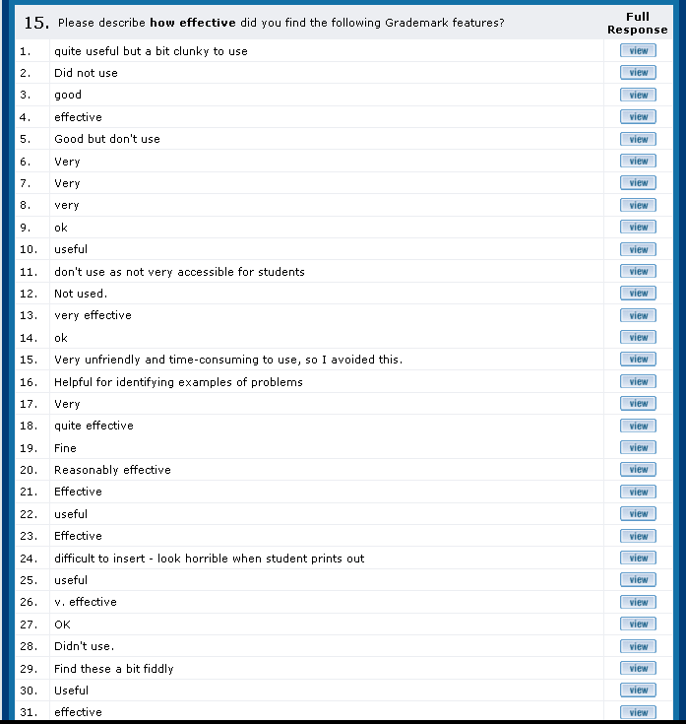
General Comments box

Rubric

Library of comments:
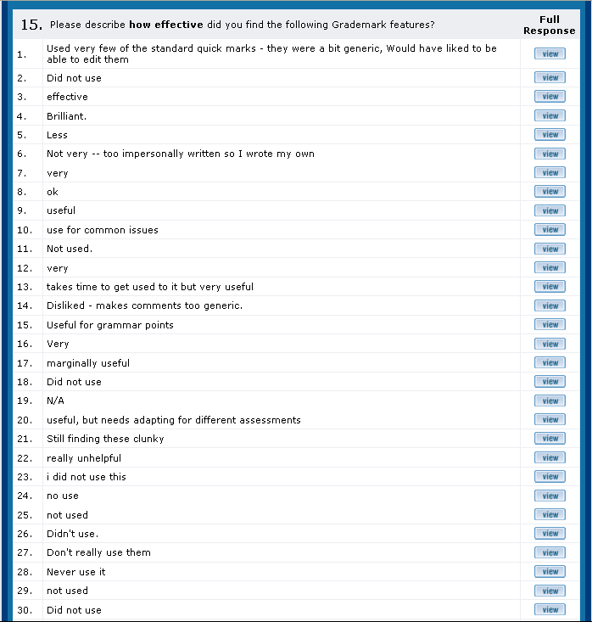

Building your own personal library of comments

Audio Feedback
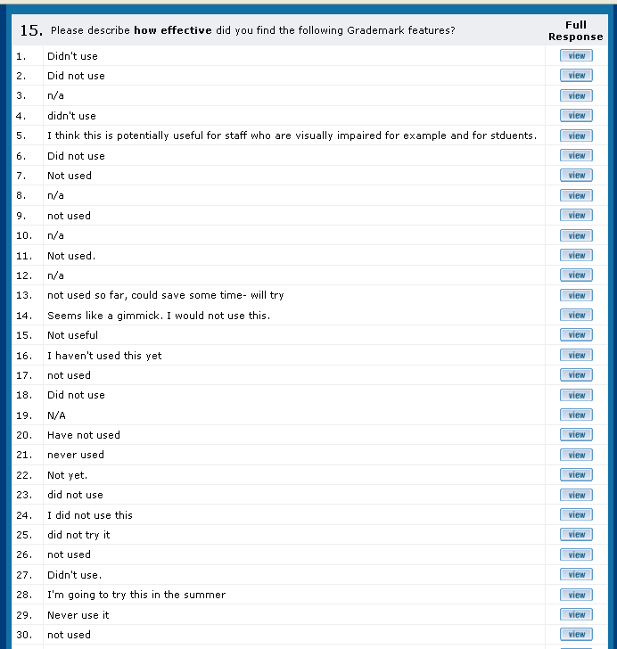
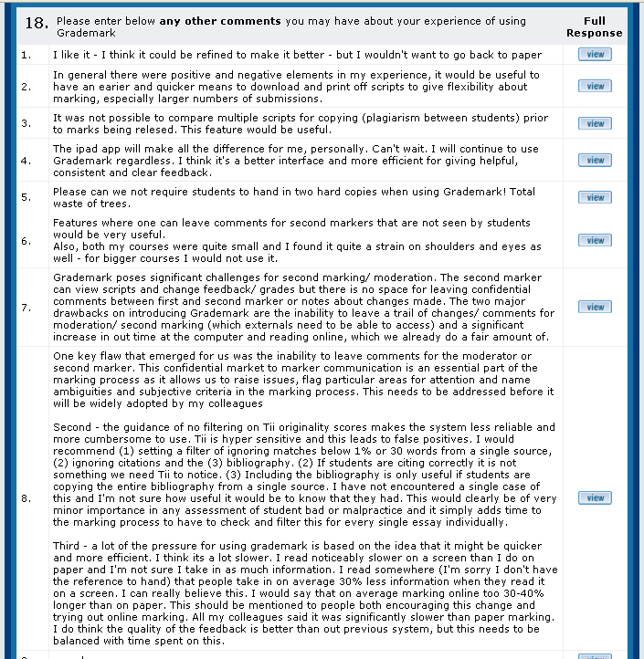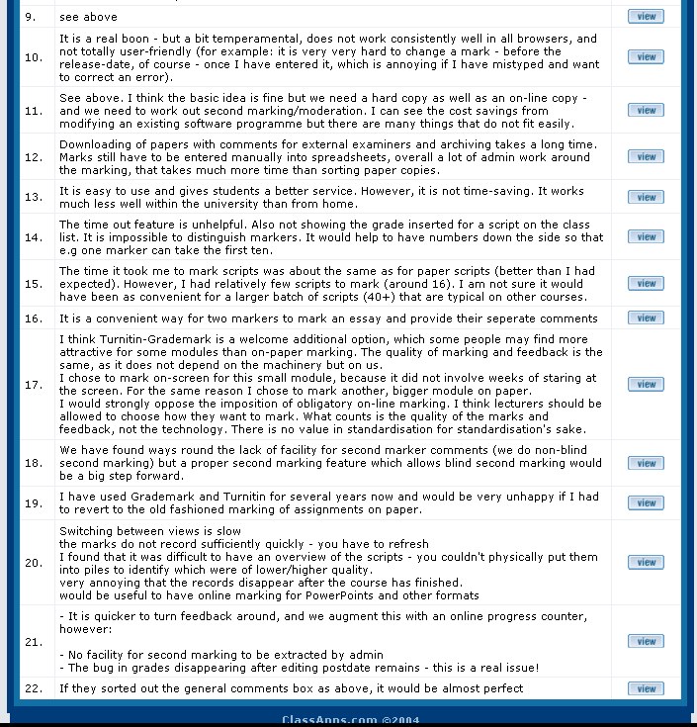

2. Student survey data
I struggled finding the coursework submission area in my course
 | Total | %
Strongly agree | 17 | 8.33
Agree | 21 | 10.29
Neutral | 20 | 9.80
Disagree | 76 | 37.25
Strongly Disagree | 70 | 34.31
No Answer | 0 | 0.00
Total | 204 | 100.00

Electronic submission was easy to use
 | Total | %
Strongly agree | 69 | 33.82
Agree | 81 | 39.71
Neutral | 18 | 8.82
Disagree | 18 | 8.82
Strongly Disagree | 15 | 7.35
No Answer | 3 | 1.47
Total | 204 | 100.00

I prefer online feedback to hand-written feedback
 | Total | %
Strongly agree | 53 | 25.98
Agree | 49 | 24.02
Neutral | 50 | 24.51
Disagree | 19 | 9.31
Strongly Disagree | 14 | 6.86
No Answer | 19 | 9.31
Total | 204 | 100.00

I am more likely to collect my feedback online than collecting it hard copy.
 | Total | %
Strongly agree | 24 | 25.26
Agree | 25 | 26.32
Neutral | 12 | 12.63
Disagree | 15 | 15.79
Strongly Disagree | 8 | 8.42
No Answer | 11 | 11.58
Total | 95 | 100.00

I am more likely to review feedback from my tutors if it is online
 | Total | %
Strongly agree | 11 | 11.58
Agree | 23 | 24.21
Neutral | 24 | 25.26
Disagree | 18 | 18.95
Strongly Disagree | 7 | 7.37
No Answer | 12 | 12.63
Total | 95 | 100.00

The online submission and feedback process has negatively impacted the personal relationship with my course tutor
 | Total | %
Strongly agree | 5 | 5.26
Agree | 7 | 7.37
Neutral | 27 | 28.42
Disagree | 33 | 34.74
Strongly Disagree | 12 | 12.63
No Answer | 11 | 11.58
Total | 95 | 100.00

I always review the feedback I receive in order to improve my performance in my next assessment (Question withdrawn end January 2013)
 | Total | %
Strongly agree | 72 | 59.02
Agree | 32 | 26.23
Neutral | 8 | 6.56
Disagree | 1 | 0.82
Strongly Disagree | 0 | 0.00
No Answer | 9 | 7.38
Total | 122 | 100.00

The feedback I received was easier to understand and clearer online than paper based
 | Total | %
Strongly agree | 34 | 16.67
Agree | 48 | 23.53
Neutral | 34 | 16.67
Disagree | 15 | 7.35
Strongly Disagree | 5 | 2.45
No Answer | 68 | 33.33
Total | 204 | 100.00

Feedback on my work helped me clarify things I did not understand
 | Total | %
Strongly agree | 24 | 11.76
Agree | 57 | 27.94
Neutral | 35 | 17.16
Disagree | 15 | 7.35
Strongly Disagree | 4 | 1.96
No Answer | 69 | 33.82
Total | 204 | 100.00

I learned from the feedback I received
 | Total | %
Strongly agree | 27 | 13.24
Agree | 73 | 35.78
Neutral | 20 | 9.80
Disagree | 11 | 5.39
Strongly Disagree | 4 | 1.96
No Answer | 69 | 33.82
Total | 204 | 100.00

The feedback I received will help me perform better in future assignments
 | Total | %
Strongly agree | 28 | 13.73
Agree | 66 | 32.35
Neutral | 30 | 14.71
Disagree | 6 | 2.94
Strongly Disagree | 4 | 1.96
No Answer | 70 | 34.31
Total | 204 | 100.00

The feedback I received arrived in time to be able to improve my performance in my next assessment
 | Total | %
Strongly agree | 22 | 10.78
Agree | 66 | 32.35
Neutral | 27 | 13.24
Disagree | 11 | 5.39
Strongly Disagree | 9 | 4.41
No Answer | 69 | 33.82
Total | 204 | 100.00

Operational definitions: This report refers to Turnitin as the overall software facility, which has three main components: (i) electronic submission; (ii) Originality Reporting to facilitate plagiarism checking; (iii) GradeMark for online marking and feedback
Staff and student surveys are available at: https://selectsurveys.humanities.manchester.ac.uk/TakeSurvey.aspx?SurveyID=m4K09881 (academic staff survey) and https://selectsurveys.humanities.manchester.ac.uk/TakeSurvey.aspx?SurveyID=m6K0l595 (student survey)
Report available at \\vdm05-g1.ds.man.ac.uk\fs_shared_08$\Hum8\Admin\ICTOffice\Teaching_and_Learning\Projects\Current_Projects\HumeL080_Assessment_Feedback_Faculty\2012-13\lobbying\Requests_for_change_Turnitin_v2.docx
Two public JISC Turnitin user lists are currently available (TURNITINUK-USERGROUP@JISCMAIL.AC.UK; TURNITIN@JISCMAIL.AC.UK). In addition a private JISC list is only available to Turnitin system administrators (https://turnitin.uservoice.com/forums/33601-turnitin-higher-education-administrators).
With thanks to Dan Rigby for providing expertise in the presentation of the raw data.

