Faculty eAssessment Report 2011-2012 eLearning team, July 2012

eAssessment Project Background

The eAssessment project began in Summer 2011 with the objectives to:
- Increase the use of online submission, plagiarism detection and online marking across Schools
- Initiate the mapping of School administrative processes to handle eAssessment
- Explore and develop tools for quality student feedback: marking rubrics, shared feedback library sets and piloting of innovative practice in eAssessment and feedback
A mix of both discipline-driven pilots (with specific targets and time-scales) and individual piloting took in place over the 2011-12 academic year, focusing on online marking (GradeMark), plagiarism checking (Originality Reporting) or both.

Table 1. Summary of School pilots
School | Scope | Courses involved
AHC | Originality, Online marking/feedback | - Discipline-led pilot: all HIST modules  - Individual trials across AHC
Education | Originality, Online marking/feedback | Discipline-led pilot involving 86 units
LAW | Online marking/feedback  (all courses in School already using Originality Reporting) | Discipline-led pilot involving:  - All UG 3rd year courses  - All Criminology units (UG & PG)  - 7 CSEP Units
SED | Online marking/feedback | Discipline-led pilot involving all GEOG UG 3rd year courses
SoSS | Originality Reporting | Discipline pilot involving all Politics modules
 | Online marking/feedback | Approx. 2 courses per discipline
SLLC | Originality, Online marking/feedback | No piloting at discipline level, individual trials
MBS | Originality, Online marking/feedback | All UG 1st year courses; some 2nd/3rd year courses

Overview of Activity

2.1. Use of Turnitin across Schools for online marking/feedback, originality reports

Table 2. Use of online marking/feedback, originality reports across Schools

School  (showing total no. of course units) | Turnitin use as % of overall courses | No. of course units using Turnitin in 2011-12 | No. of pilot courses using online marking  (as % of pilot activity) | No. of pilot courses using originality reports (as % of pilot activity) | Academic staff involved in pilot
AHC  (409) | 14% | 56 (18 in 2010-11) | 49 (88%) | 56 (100%) | 35
Education (143) | 68% | 86 (7 in 2010-11) | 86 (100%) | 86 (100%) | 30
Law  (132) | 100%* | 86 (69 in 2010-11) | 59 (100%) | 86 (100%) | 40
LLC  (374) | 11% | 42 (21 in 2010-11) | 26 (74%) | 34 (97%) | 18
SED  (177) | 11% | 20 (6 in 2010-11) | 18 (90%) | 2 (10%) | 19
SoSS  (276) | 34% | 94 (23 in 2010-11) | 17 (18%) | 94 (100%) | 52
MBS  (424 excl. MBSW) | 33% | 140 | TBC** | 140? (100%?)** | TBC**
FACULTY  TOTAL  (1925) | 27% | 515  (375 + 140 MBS)  (169 + MBS in 2010-11) | 273 + MBS* | 489*

*Law: All assessed coursework throughout the School has been submitted via Turnitin for plagiarism checking since 2009-10.
** MBS: are compiling a School specific report outlining their piloting of Turnitin in 2011-12 (to follow as Appendix 4)

Comparative use of GradeMark, 2009-10, 2010-11, 2011-12 (not MBS)
Year | No. of new Turnitin enabled courses | No. of pilot courses using GradeMark | % of pilot courses using GradeMark
2009-10 | 128 | 18 | 14%
2010-11 | 59 | 34 | 58%
2011-12 | ??  (As activity increases, it becomes increasingly difficult to track all new usage) | 273 | 73%

Comparison of Turnitin training delivered by Humanities eLearning team, 2010-11, 2011-12
School / Faculty unit | No. of attendees 2010-11 | No. of attendees 2011-12
Cross Faculty eLearning | 2 | 0
School of Arts, History and Cultures | 6 | 13
School of Education | 3 | 50
School of Law | 5 | 29
Languages, Linguistics and Cultures | 39 | 10
School of Environment and Development | 1 | 14
School of Social Sciences | 7 | 56
Manchester Business School (where training delivered by Hum eLearning Team) | 2 | 7
Careers | 4 | 0
Total | 67 | 179

  - Development of advanced feedback features in Schools

Two distinct features in GradeMark have the potential to lead to improvement in feedback quality:
a) Rubrics in GradeMark perform the role of defining assessment criteria for the benefit of students. They identify assessment criteria and describe student performance across the conventional ranges of marks. Rubrics allow for a quantitative or qualitative description of individual student performance across a range of discipline chosen descriptors.
b) QuickMarks are sets of stored pre-written comments that can be inserted into student papers as and when required. They are useful where similar feedback commenting is recurrent across student submissions, particularly as personalised comments can be added alongside. QuickMarks sets exist at University level and can be generated at School or Discipline level.
Example screenshots of both features can be found in Appendix 2
Table 3. Rubrics in place across Humanities
 | School approved Rubrics | Discipline approved rubrics | Individual rubrics
AHC | 1 | 0 | 0
Education | 2 | n/a | 6
Law | 3 | 1 | 1
LLC | 0 | 0 | 1
SED | 1 | 0 | 0
SoSS | 0 | 1 | 2

To date no School has developed discipline-wide QuickMarks although gathering of comments has been initiated within Law subjects and in Social Anthropology. Some reservations to a possible ‘generisation’ of feedback even where the tool allows customisation of QuickMarks have been expressed.

3. Evaluation
Evaluation of Turnitin/GradeMark was carried out in both the 1st and 2nd Semester – evaluation of 2nd Semester activity is necessarily preliminary for those disciplines undertaking marking at the time of completing this report (SoSS mainly).
The review presented below is the result of feedback from evaluation meetings conducted with Schools (including admin teams, exams officers, UG directors as well as academic staff), a log of incidents and issues reported by Schools and individuals through the year.
Student evaluation was carried out by posting a student survey in Blackboard. Some disciplines (Geography, Criminology) also conducted focus groups meetings with students.

Overall academic /admin staff satisfaction
While there are a number of inefficiencies in the tools, feedback indicates that across each School, members of staff viewed Turnitin/GradeMark largely positively. Those who have used it intend to continue using it.

Online Submission
Results from the Student survey and anecdotal evidence suggest that students found the online submission process straightforward, except in particular circumstances:
- Where recommended settings were not followed, e.g. where Turnitin inboxes were set up with no resubmission option should students happen to upload a wrong file (NB arguably the chances of error in submitting wrong files are higher online than on paper), or where late submission inboxes were not clearly labelled;
- Where Bb facilities such as ability to hide/display inboxes to different students (adaptive release) were not taken up by academic or administrator;
- Where the assignment document to be submitted was not within file type range accepted by Turnitin;
- Where file size exceeded the maximum file size (20 MB).
Where dual submission (hard-copy and online submission) is used:
- There is no easy way to check whether hard copies are identical to electronically submitted assignments.
- Admin staff time-save benefits are not realised.
- Traditional hard copy marking and adapted online marking processes have co-existed.

Plagiarism
While no Humanities-wide staff satisfaction survey has been carried out, Turnitin Originality Reporting appears to be widely welcomed as a tool that can assist the academic task of identifying possible plagiarism, poor referencing and document sourcing. Turnitin relies on academic judgement to interpret an originality report.

Anonymity and related issues
Turnitin’s ability to preserve anonymity is widely welcome; however a number of issues surrounding anonymity settings in Turnitin continue to be a problem, especially for administrative staff (it normally being administrator responsibility to identify non-submissions):
- Where students fail to follow file name convention (of naming submission files with Student/ID number) and to enter ID number at the time of submission, administrative staff are unable to identify who has not submitted.
- In large courses where students have entered their student number in the title box, administrative staff can quickly identify non-submitters by lifting anonymity instead of manually going through a long list of usernames. However, using such a ‘work around’ to lift anonymity can cause temporary disappearance of marks.
Problems triggered by the lifting of anonymity conditions are one of the most common cause of both academic and student concern as regards the robustness of online submission and marking.
In cases where lifting of anonymity causes a temporary non-display of grades, this can lead to anxiety for both staff and students. In some cases academics have unnecessarily re-entered marks.
Temporary disappearance of grades can also occur if academic staff change the post date e.g. in an attempt to release feedback earlier than originally planned.

Marking and feedback
GradeMark can be a time saver where:
- Staff are equipped with adequate PCs, screens and good connection
- Staff can touch-type
- QuickMarks can be used
GradeMark facilitates giving more detailed feedback and can lead to better feedback when advanced features (rubric, QuickMarks) are used appropriately.
Overall evidence across courses is that students are logging into Blackboard to access their online feedback.

Student satisfaction
While the number of responses to the voluntary humanities survey was small (n= 75) the results reveal that:
- Over 75% of students found submission process easy
- About 70% of student prefer online feedback to hand-written feedback
- 60% of students declared that the online feedback they received had helped them clarify things they did not understand
- Over 70% of students declared that they had learned from the online feedback they had received.
- Over 65% of students declared that the online feedback they received would help them perform better in future assignments
- Over 65% of students declared that received their feedback in time to be able to improve their performance in the next assignment.
Further details can be seen in Appendix 3.

School Processes
The need for clear and robust processes across all aspects of online assignment handling is central to fuller uptake:
- Assignment creation and submission: setting assignments, tracking non-submissions, handling extensions
- Identifying possible plagiarism: providing evidence
- Online marking and feedback: consistent, timely and appropriate feedback to the student
- Moderation and external examination: appropriate access to assignments
- Exporting/Recording indicative grades, archiving assignments
While GradeMark is specifically designed for online marking and feedback by the first marker, work round processes have to be applied if online second marking is needed, and there is no further online facility for moderation or external examination (instead, PDFs of assignments are batch generated for such purposes, as well as for archiving).
Uncertainty can stem from either lack of documentation of how traditional School assignment handling and marking methods are adapted to electronic means, or from insufficient internal School communication of new processes to all staff.

4. Issues
A summary of most pressing issues impacting satisfaction and adoption include:
Turnitin issues (also previously identified in 2009/10 Report):
- Disruptive effects of changes in post date and/or GradeMark’s inability to differentiate between administrator/academic roles; first/second marker.
- No versioning/lock down of feedback comments once post date reached.
- GradeMark inability to accommodate moderation and also second marking processes especially where commentary is meant to be not visible to students. Schools or disciplines have to develop work-arounds/procedures to handle moderation that is not directed to students.
Technical issues
- PC performance in some cases, screen size. As GradeMark performance has improved it uses a larger amount of memory, so older machines may struggle.

Teething issues
- Errors in setting up assignments correctly.
- Process uncertainties: uncertainty and the need to develop or adapt School/discipline processes to manage online submission and marking
Policy/institutional issues
- Inefficiencies and frustration expressed by Schools from the inability to give external examiners online access to Turnitin inboxes.
- Lack of lobbying power vis-à-vis GradeMark to press for changes to technical performance
- Unlike Blackboard, online submission and marking involve both academic as well as admin teams. School lead or senior staff support/championing the use of Turnitin/GradeMark would facilitate a wider deployment both for leadership, coordination and communication of all parties involved. The eLearning team is unable to effectively lead in School communication or coordination between admin and academic staff but can support such processes.
- Better documentation and/or communication of processes to be followed by all staff; needs to be owned by discipline/School.
- The plethora or exams officers for UG and PG matters and of discipline procedures in large Schools make the adoption of processes for a smooth roll out of Turnitin/GradeMark more arduous.

Upgrade features
- Audio feedback was made available in May 2012.
- Spell and Grammar check of student papers (e-rater) in currently available for staff preview. As an additional tool the University would need to contract this facility at an additional expense.
- Offline marking is ‘Under Review’ by GradeMark. No formal commitment has been made by Turnitin so far.

5. Conclusion
There has been significant increase in the number of courses using Turnitin for online marking and for plagiarism checking in 2011-12. The project evidenced that there where the project objectives were expressly backed up and led by School/discipline (Education, Geography, Law & Criminology, Politics) a substantial increase in the use of Turnitin for originality reporting/online marking was obtained. For those Schools or disciplines where piloting of Turnitin/GradeMark remained voluntary the use remained similar to previous years.
As regards barriers to full-scale implementation, whilst there are a number of technical, policy and teething issues where solutions or work-arounds need to be found, there does not seem to be a single insurmountable obstacle to progress towards a wider roll-out of the tools.
At the time of writing this report, a number of targets for the 2012-13 academic year have been announced or are pending confirmation:
- SAHC: RELT intends to expand the use of Turnitin/GradeMark to all level 1 courses.
- Law is considering the move from dual submission to a fully online system, and to progress to a full roll out of GradeMark across all Law course units assessed by coursework at all levels.
- Education: PG Taught programmes have agreed to use Turnitin/GradeMark exclusively.
- SoSS: GradeMark piloting be extended; each DA to find a further four or so volunteers to try it out.

6. Recommendations
University
- Develop appropriate managed relationship to take forward University priorities with iParadigms (the company behind Turnitin):
- Develop dialogue with Turnitin to examine solutions to issues: anonymity and identifying non-submitters, identifying first and second marker activity; moderation and external examiner access.
- Consider a model for change requests and institutional lobbying of Turnitin.
- Investigate tools that allow adequate monitoring and reporting of deployment progress across Schools/Faculties
Schools
- Develop School’s eAssessment targets as part of School/discipline eLearning strategy.
- Identify senior figures in School/discipline e.g. UG director, exams officer, T&L director to own and lead the progression, coordination and communication of eAssessment in their disciplines.
- For those Schools where a substantial number of courses have piloted Turnitin/GradeMark (Law and Criminology bar CSEP; Education; History; Geography), to ensure School leadership in revising and consolidating eAssessment processes in place. Successful piloting approaches by those Schools could act as models for Schools with less experience, to ensure School or discipline leadership on the development of processes for handling online submission and marking.
- With assistance of the Faculty eLearning team, develop prioritised School requests to rally academic support and exert pressure for change on Turnitin features and capability
- Make further use of GradeMark’s enhanced features (rubrics, QuickMarks library sets) and evaluate whether they can improve feedback quality.

Faculty
- Liaison between each School, IT Services, eLearning and Teaching & Learning Office to ensure that back up processes are in place meeting University requirements for the secure archiving of summative assessment.
eLearning Team
- Pilot and evaluate new Turnitin features, for example, Audio feedback.
- Support Schools in developing their use of Turnitin/GradeMark enhanced features.
- Lead on the organisation of regular School Exams Officer meetings to share knowledge and experience of online submission and marking processes.
- Review training and user documentation and consider additional training needed for managing the assignment handling process.

Appendices
Appendix 1
Breakdown of Turnitin use across Schools (excluding MBS: will be incorporated in Appendix 4)

AHC  Total School units 409 | Discipline activity | Discipline units in CS | Piloting units | Using Originality Reports | Using GradeMark | Academic staff involved
 | HIST | 47 | 42 | 43 | 43 | 30
 | RELT | 73 | 1 | 1 | 1 | 2
 | AHVS | 29 | 5 | 5 | 5 | 3
 | ENGL |  | 2
 | SAHC |  | 6
 | Total |  | 56 | 49 | 49 | 35

Education | Discipline  activity | Total School units in CS | Piloting units | Using Originality Reports | Using GradeMark | Academic Staff involved
 | EDUC | 143 | 86 | 86 | 86 | 30

Law  Total School units 122 | Discipline | Discipline units in CS | Piloting units | Using Originality Reports | Using GradeMark | Academic Staff involved
 | Law | 77 | 67 | all | 52 | 20
 | Criminology (LAWS) | 35 |  | all |  | 15
 | CSEP (DL and CS) | 20 | 19 | all | 7 | 5
 | Total | 132 | 86 | 86 | 59 | 40

LLC | Discipline activity | Discipline units (in CS) | Piloting units | Using Originality Reports | Using GradeMark | Academic Staff involved
Total School Units 374 | EALC | 46 | 7 | 7 | 7 | 2
 | ELAN | 30 | 8 | 8 | 8 | 2
 | GERM | 30 | 4 | 4 | 4 | 1
 | LELA | 71 | 11 | 11 | 9 | 7
 | MEST | 48 | 7 | 7 | 6 | 1
 | SPLA | 37 | 3 | 0 | 3 | 2
 | ULAC | 7 | 2 | 2 | 2 | 1
 | Total |  | 42 | 39 | 39 | 18

SED | Discipline activity | Discipline units (in CS) | Piloting units | Using Originality Reports | Using GradeMark | Staff involved
Total School Units 177 | GEOG | 57 | 18 | 0 | 18 | 18
 | IDPM | 98 | 1 | 1 | 0 | 1
 | PLAN |  | 1 | 1 | 0
 |  |  | 20 | 2 | 18 | 19

SoSS | Discipline activity | Discipline units (in CS) | Piloting units | Using Originality Reports | Using GradeMark | Staff involved
Total School units 276 | ECON | 124 | 3 | 3 | 3 | 2
 | PHIL | 44 | 2 | 2 | 2 | 2
 | POLI | 84 | 75 | 75 | 4 | 38
 | POEC | 3 | 2 | 2 | 0 | 2
 | SOAN | 54 | 9 | 9 | 5 | 5
 | SOCY | 60 | 3 | 3 | 3 | 3
 |  |  | 94 | 94 | 17 | 52

Appendix 2: Enhanced features of GradeMark

(i) Example of rubric (marker selects the appropriate scale for each criterion)

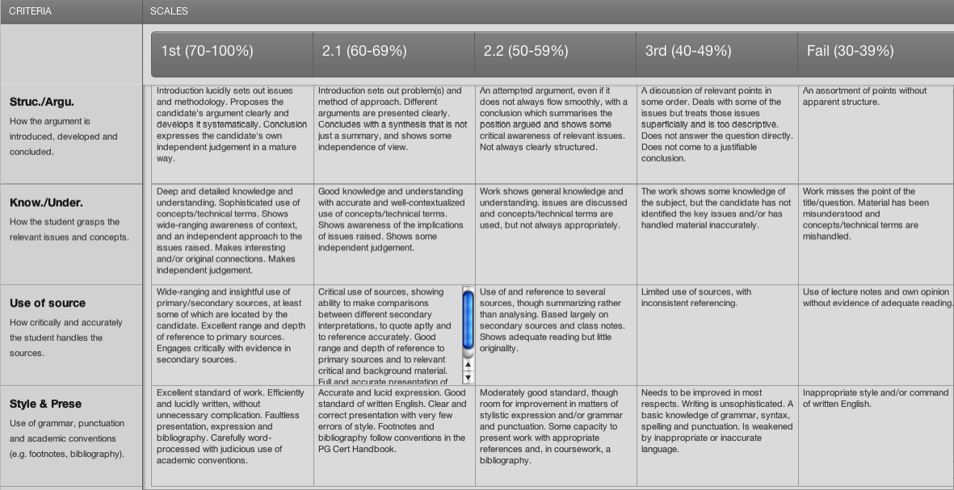

(ii) Example of QuickMarks set
The marker has inserted a pre-worded QuickMarks comment from the set and added additional points relevant to the particular student

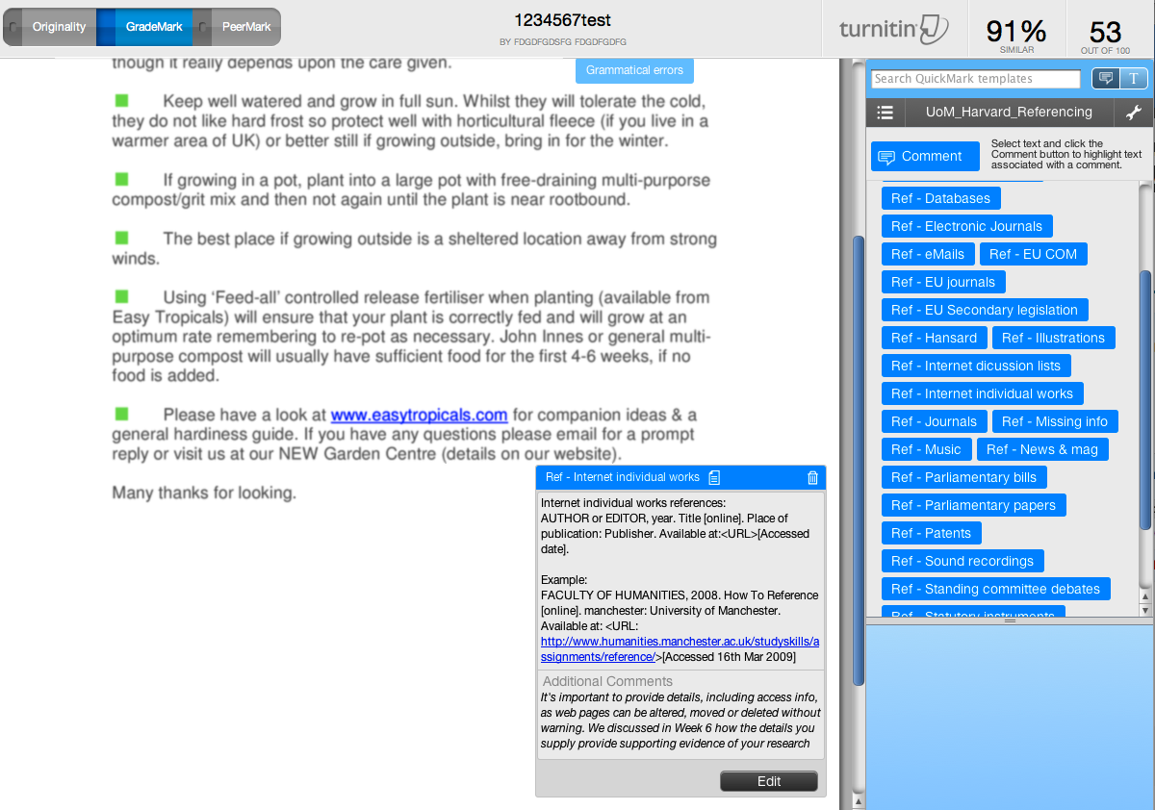

(iii) Example of marked assignment with QuickMarks and Rubric marking applied
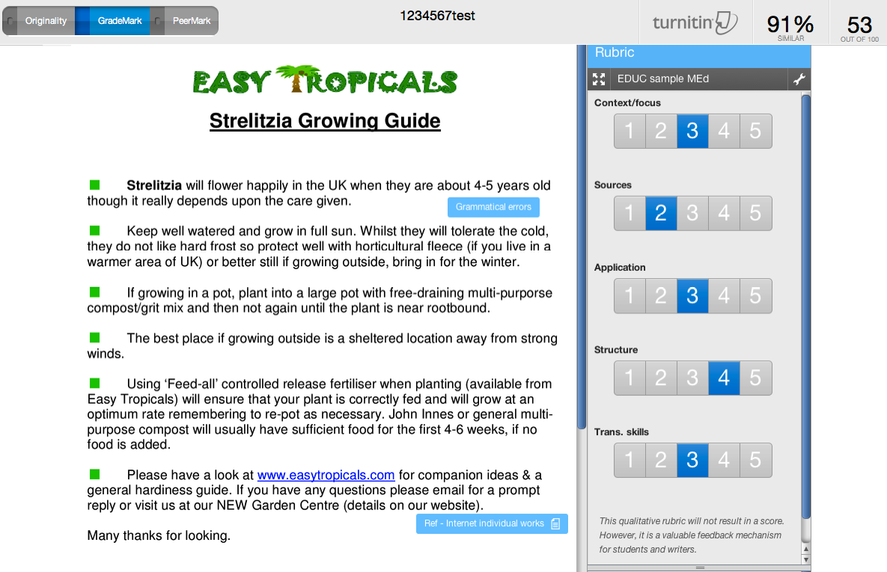

Appendix 3: Student satisfaction survey (Note: covers both eLearning and academic aspects)
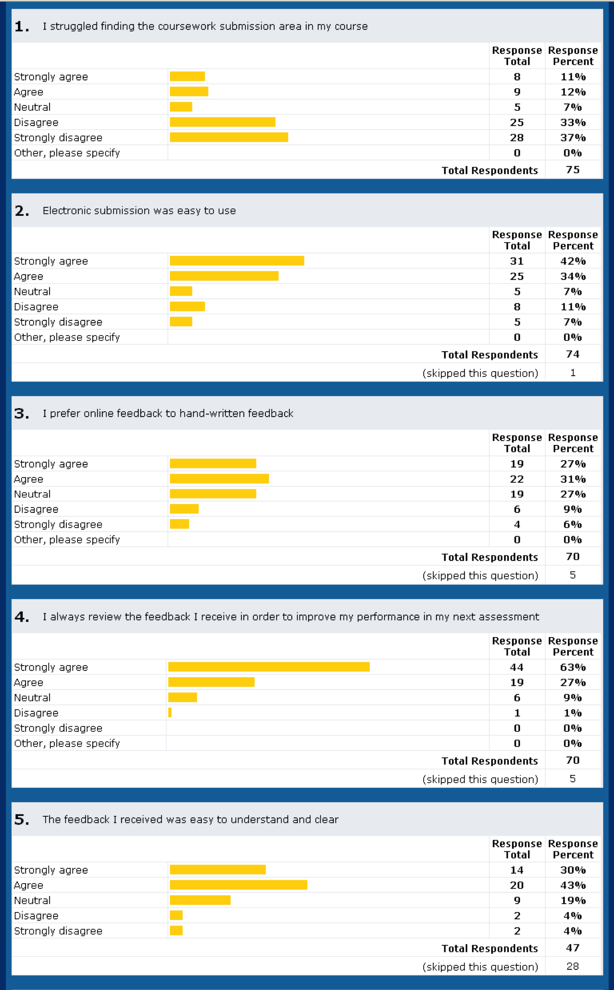
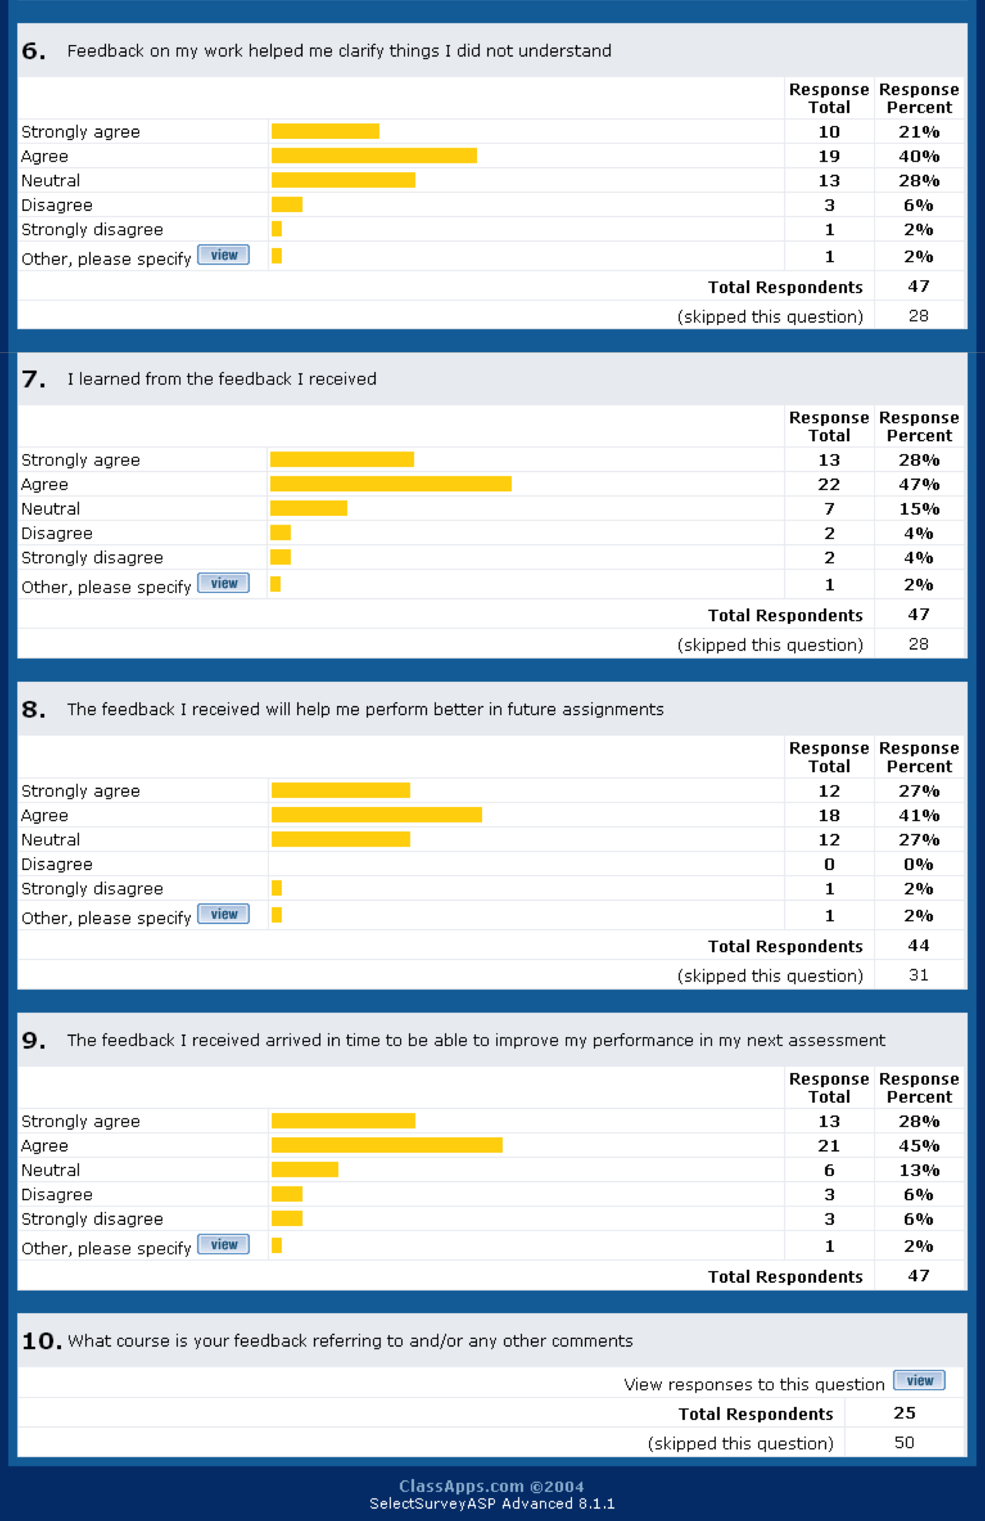

Appendix 4: Manchester Business School report/summary
Towards the end of the 2008/2009 academic year we worked with administrators and lecturers across MBS to analyse the existing paper-based course work submission and marking process so that we could establish the feasibility of replacing this with online submission and marking.

As a consequence of the analysis we ran four pilots in Semester 1 of academic year 2009/2010. We also liaised with the faculty of Life Sciences who were also piloting similar systems. The result of this exercise was the development of a recommended process for the support of online course work submission. For the next academic year online course-work submission was supported on an ad-hoc basis.

In the summer of 2011, the Undergraduate Services and the Manchester Enterprise Centre (MEC) expressed a desire to move to online course work submission across the board. We developed a formal process for managing online submission and included online submission as an item in the school Blackboard templates. The template item includes instructions for both staff and students and a recommended structure for an assignment for which work will be submitted online. The template item supports both Turnitin and Blackboard assignments. Training was provided for staff and GTAs.

Undergraduate Services decided on a phased roll-out starting with the 2011 year 1 intake (around 33 courses), with use on years 2 and 3 being voluntary. The Manchester Enterprise Centre opted for an across-the-board implementation (around 40 courses). The full-time MBA opted into the scheme also (46 courses). Postgraduate Taught and Postgraduate Research currently use the system on an ad-hoc basis. In all cases, online marking is voluntary for markers. In line with the findings across the University, the most contentious issue is changing the marking process for markers who have developed systems that work well for them. Access to Blackboard for external examiners has also proved to be problematic.

Over this summer we will refine the process and template in consultation with administrators, lecturers and, hopefully, students. Undergraduate Services are currently reviewing how they wish to proceed with the roll-out.

Operational definitions: This report refers to Turnitin as the overall software facility, which has three main components: (i) electronic submission; (ii) Originality Reporting to facilitate plagiarism checking; (iii) GradeMark for online marking and feedback.
Survey available at http://windev.humanities.manchester.ac.uk/surveys/TakeSurvey.asp?PageNumber=1&SurveyID=5KK3m50L558L08
Information on data: Figures on the total number of discipline units includes both semesters and UG and PG and are taken from Campus Solutions Schedule of Classes. Caveat should be noted in that not all units may be assessed by coursework. Figures from 2010/11 appear in brackets. Number of academic staff involved is approximate – no recorded data on GTAs involvement is available.
Piloting units include any unit that trialled Originality Reports and/or GradeMark. It should be noted that some units may use Turnitin/GradeMark for formative purposes only.
Figures of academic staff include primary instructor only, i.e. does not include possible GTAs marking or involvement of other academics in second marking.

