Workshop: Measuring civic participation with the British Election Study (BES)
Earlier this semester you were asked to complete a short Blackboard survey. The questions in the survey were taken from the British Election Study (BES). The BES is a long running social science survey that takes places immediately after general elections. Since the first study in 1964, the BES provides data to help researchers understand changing patterns of party support and election outcomes. The British Election Study 2015 is managed by a consortium led by The University of Manchester.

Here are the results for the class
How often do you talk about politics with friends?
 | POLI10251 | National
Frequently | 33.74%
Sometimes | 50.60%
Rarely | 14.46%
Never | 1.21%
Unanswered | 0%
Total | 100%
Number of cases | 83

About how active you may be in politics and community affairs in the next few years. How likely is it that you will ... Participate in a protest, like a rally or a demonstration, to show your concern about a public issue or problem |  |  |  | About how active you may be in politics and community affairs in the next few years. How likely is it that you will ... Work for a party or a candidate in an election campaign.
 | POLI10251 | National |  |  | POLI10251 | National
1 Very unlikely | 4.82% |  |  | 1 Very unlikely | 4.82%
2 | 3.61% |  |  | 2 | 9.64%
3 | 7.23% |  |  | 3 | 8.43%
4 | 6.02% |  |  | 4 | 7.23%
5 | 7.23% |  |  | 5 | 12.05%
6 | 4.82% |  |  | 6 | 18.07%
7 | 12.05% |  |  | 7 | 20.48%
8 | 9.64% |  |  | 8 | 9.64%
9 | 15.66% |  |  | 9 | 3.61%
10 Very likely | 26.51% |  |  | 10 Very likely | 3.61%
Don't know | 2.41% |  |  | Don't know | 2.41%
Unanswered | 0% |  |  | Unanswered | 0%
Total | 100% |  |  | Total | 100%
Number of cases | 83 |  |  | Number of cases | 83
About what a democracy should be. Do you agree or disagree that ... In a true democracy, the majority has a responsibility to protect the rights of all minorities |  |  |  | Political parties that wish to overthrow democracy should not be allowed to stand in general elections
 | POLI10251 | National |  |  | POLI10251 | National
Strongly Agree | 56.63% |  |  | Strongly Agree | 14.46%
Agree | 33.74% |  |  | Agree | 28.92%
Neither Agree nor Disagree | 4.82% |  |  | Neither Agree nor Disagree | 18.07%
Disagree | 3.61% |  |  | Disagree | 27.71%
Strongly Disagree | 1.21% |  |  | Strongly Disagree | 10.84%
Unanswered | 0% |  |  | Unanswered | 0%
Total | 100% |  |  | Total | 100%
Number of cases | 83 |  |  | Number of cases | 83

AIMS OF THE WORKSHOP
The aim of this workshop is to show you how to source your own data from the main BES. Specifically you will…
Task 1. Find the national results for the 5 selected questions and compare them with the class results
Task 2. Run some cross-tabulations to look at how answers to these questions varied between different sub-groups in the national population (e.g. by age or education level of the respondent)
Task 3. Source data for some additional BSA questions of your own choice
N.B. You will probably only have time to do Task 1 and 2 in the Workshop – but will be able to complete task 3 in your own study time

Sourcing Data from British Election Studies
Go to http://www.besis.org/
BEFORE YOU START... GET REGISTERED
To use the site you first need to register. This is done very quickly on line. Just click on registration – and give your email address and choose a password when prompted.
IF YOU HAVE ALREADY REGISTERED JUST LOGIN (Top right of screen)

TASK 1. Find the national results for the four questions and compare them with the class of POLI10251
Once registered, getting the data is simple. You just follow these 3 steps:
Step 1 Step 2 Step 3
Request the data as a table / graph
Select the question you want
Select the survey years

The following screenshots show how this is done but at each step on-line instructions are given on screen
STEP 1: Select the year of data
- Click on ‘survey years’
Select ‘All years’ (this will ensure the search covers all survey years)

STEP 2: Choose the survey questions/variable you’re interested in
There are two ways you can do this:
- Selecting ‘contents list’ lets you search for questions by browsing topics
- Selecting ‘Search questions’ lets you search for specific questions that you know the wording for
For task 1, we will use ‘search questions’ as we know the wording of the questions we want data for
Select… Search Questions
Then, search for a question by typing in a key part of the question. For example, for the question ‘how much interest do you have in politics?’ you could search using ‘interest in politics’ or for the question ‘how often do you talk about politics with friends?’ you could try ‘talk about politics’.
Then click search.
Search results
The search results list the years of the BES survey with questions that relate to your search term.
(If the search did not reveal any results, check your search term for typos and try using a different term.)
If we click on the ‘+’ next to a year, we get details of the specific questions. In this case, we will look at the most recent survey.

The results show that in the BES there are several questions relating to talking about politics.
We want ‘with friends’. To get data relating to this question click on 1) ‘+’ and then 2) ‘View results’

STEP 3: Get the results
Results appear as a table (and bar charts) and include all years when the question has been asked.
Write down the most recent results in the table on page 1 of this hand out.
Note: you have the option to export the results to Word or Excel.
For reflection:
How do the national results for this question compare with those for the class of POLI10251?
Looking at the national data, summarise how answers to this question have changed.
Repeat the above steps to get the national data for the other questions and enter the results in the tables on page 1

TASK 2. Run cross-tabulations to look at how civic attitudes and behaviour vary between different sub-groups in the national population (e.g. by age or education of the respondent)
In this example, we will examine whether age is related to the view that political parties that wish to overthrow democracy should not be allowed to stand in general elections.
First, get the main results up again for this question (as below). Now click on Cross-tabs
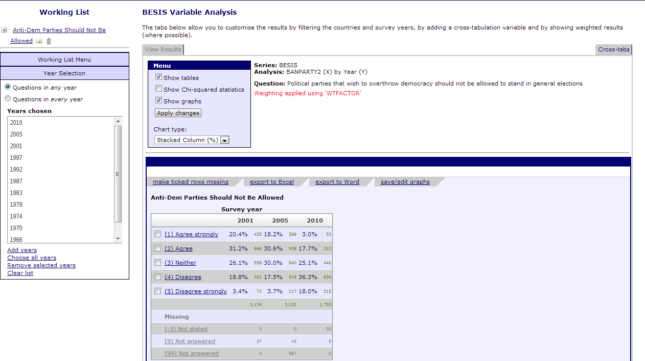
Second, choose the variable you want to use in the Crosstabs by clicking on the circle. We are interested in age differences and will look at age in 3 categories.
Click view results

On the right there is a summary of the three age categories.

Results are presented as tables and graphs.

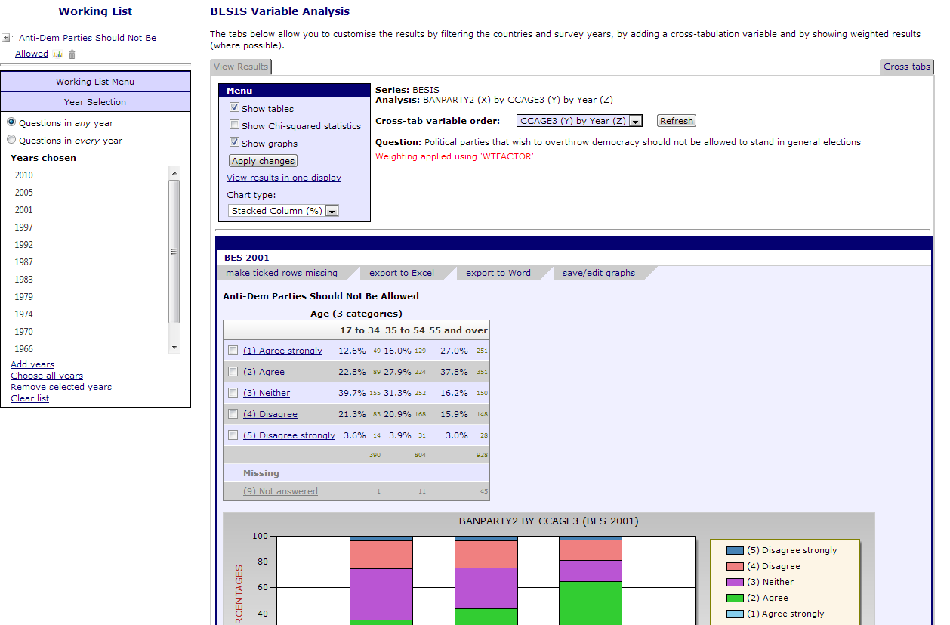

For reflection…
Compare the results for the different age groups. Are they as you would expect?
Compare the results for POLI10251 to the younger age group. Are they more alike?
Try repeating this exercise using other variables in the crosstab. e.g. education, employment status and gender.
Try repeating this exercise for one of the other questions on civic attitudes and behaviour

FINALLY… If you have time, and for private study…
TASK 3. Source the data for some additional BES questions of your own choice
For this task, you may find it easier to search for questions by browsing the ‘contents list’ rather than ‘search questions’ option from the menu. You’ll find questions relating to Civic participation under POLITICAL BEHAVIOUR, CORE BELIEFS AND VALUES (see below) - but note there are many sub-categories and variables in the BES, so you may have to search a while to find the variables that best suit your research needs.
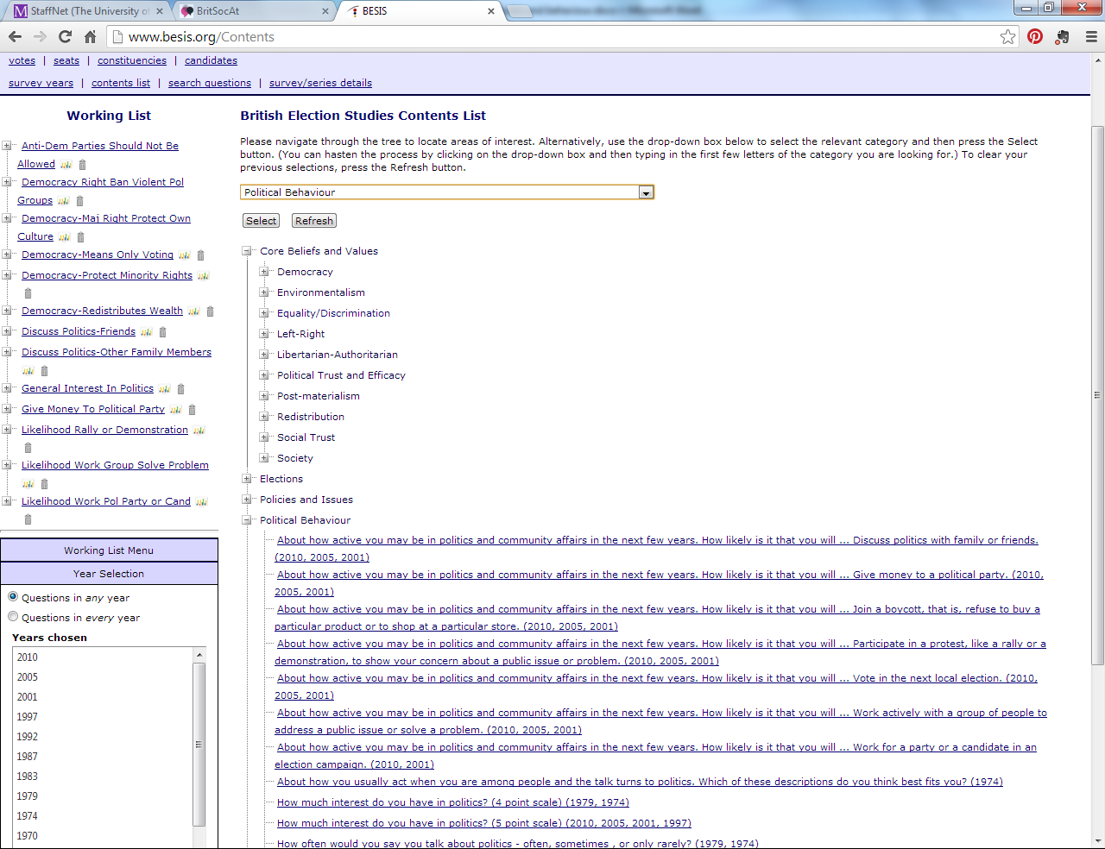
Alternatively, you can carry on using ‘search questions’ and try different key words e.g. type in the word ‘benefits’ to reveal all questions that contain the word ‘benefits’.
Good searching!

Mark Brown and Jen Buckley, September 2014

