Workshop: Measuring attitudes on inequality with the British Social Attitudes Survey

Earlier this semester you were asked to complete a short Blackboard survey including 7 questions taken from the British Social Attitudes Survey (BSA). The BSA is a national survey of attitudes conducted annually since 1983

Here are the results for the class
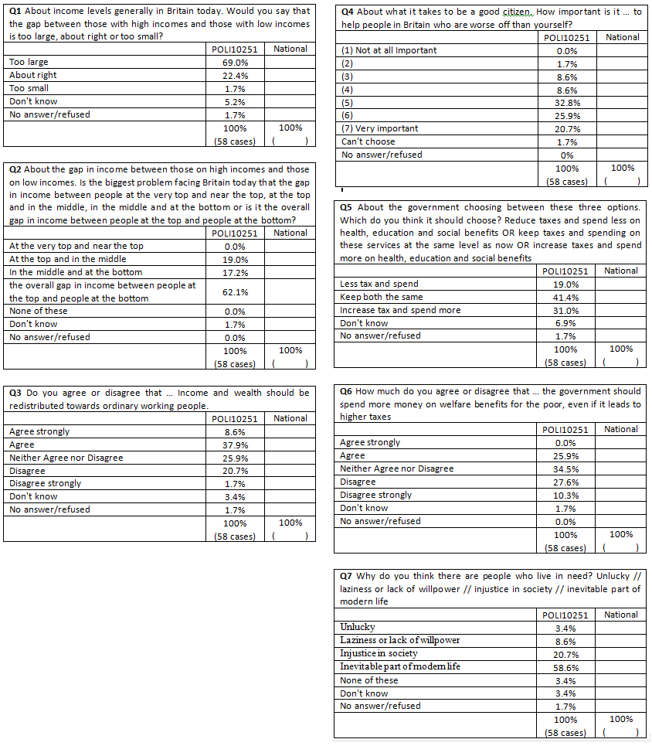
AIMS OF THE WORKSHOP
The aim of this workshop is to show you how to source your own data from the main BSA survey (a nationally representative random sample of about 3000 adults). Specifically you will..
Task 1. Find the national results for the 7 selected questions and compare them with the class results
Task 2. Run some crosstabulations to look at how answers to these questions varied between different sub-groups in the national population (e.g. by age or education level of the respondent)
Task 3. Source data for some additional BSA questions of your own choice (relevant to your projects)
N.B. You will probably only have time to do Task 1 and 2 in the Workshop – but will be able to complete task 3 in your own study time

Sourcing Data from British Social Attitudes (BSA)
Go to www.britsocat.com/Home
N.B. This site works best in Internet Explorer (less well in Google Chrome)
BEFORE YOU START... GET REGISTERED
To use the site you first need to register. This is done very quickly on line
Just click on registration – and give your email address and choose a password when prompted
IF YOU HAVE ALREADY REGISTERED JUST LOGIN (Top right of screen)
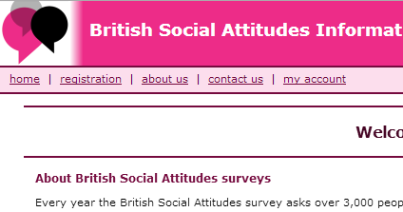

TASK 1. Find the national results for the seven questions and compare them with the class of POLI10251
Once registered, getting the data is simple. You just follow these 3 steps:
Step 1 Step 2 Step 3
Request the data as a table / graph
Select the question you want
Select the survey years

The following screenshots show how this is done but at each step on-line instructions are given on screen
STEP 1: Select the year of data
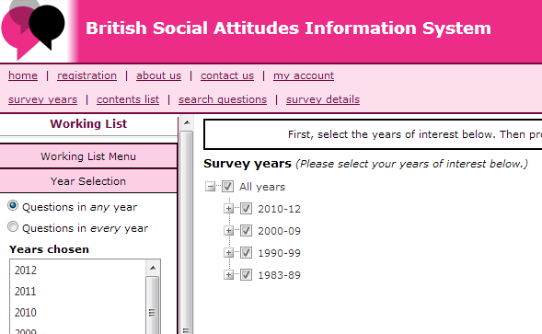
- Click on ‘survey years’
Select ‘All years’ (this will ensure the search covers all survey years from 1983 to 2012)

STEP 2: Choose the survey questions/variable you’re interested in
There are two ways you can do this:
- Selecting ‘contents list’ lets you search for questions by browsing topics
- Selecting ‘Search questions’ lets you search for specific questions that you know the wording for
For task 1 we will use ‘search questions’ as we know the wording for the 7 specific questions we want data for
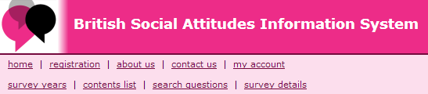
Select… Search Questions

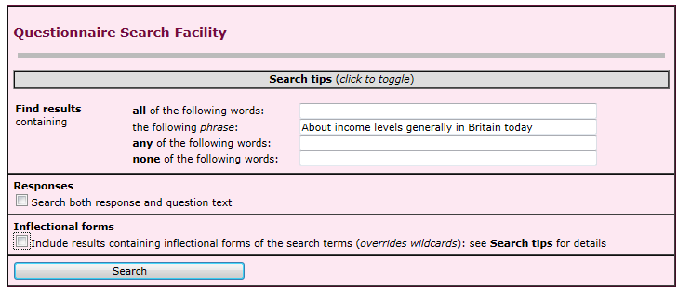
Type in the first part of the question – here we’ve typed in the first part of q1.
Then click search
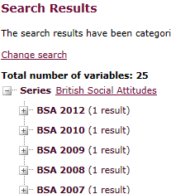
The search results show a match (if not check if you made any typo’s in writing in the question). Click on the ‘+’ next to the most recent hit (2012)
This reveals the question we’re after (the years in brackets show which years this question was asked, so almost every year from 1983 to 2012)
Now click ‘View results’ to reveal the survey findings …
Results appear as a table (and bar charts)
Scroll along for the results for 2012

STEP 3: Get the results
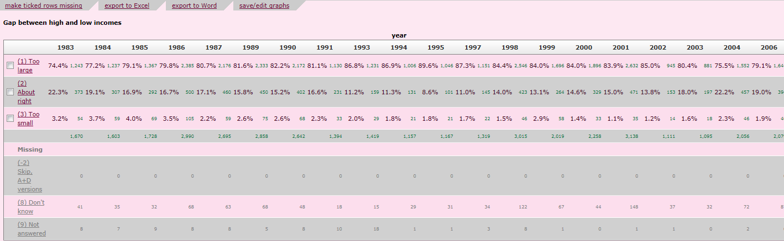
Note you can save the results to Word or Excel for reference

Now copy the results for 2012 into the table on page 1 of this handout
For reflection:
- How do the national results for this question compare with those for the class of POLI10251?
- Looking at the national data, summarise how answers to this question have changed since it was first asked in 1983
NOW repeat the above steps to get the national data for the other 6 questions and enter the results in the tables on page 1
TASK 2. Run some crosstabulations to look at how attitudes on these questions vary between different sub-groups in the national population (e.g. by age or education of the respondent)
We will do this for Question 7
Q7 Why do you think there are people who live in need? Unlucky // laziness or lack of willpower // injustice in society // inevitable part of modern life
First get the main results up again for this question (as below)
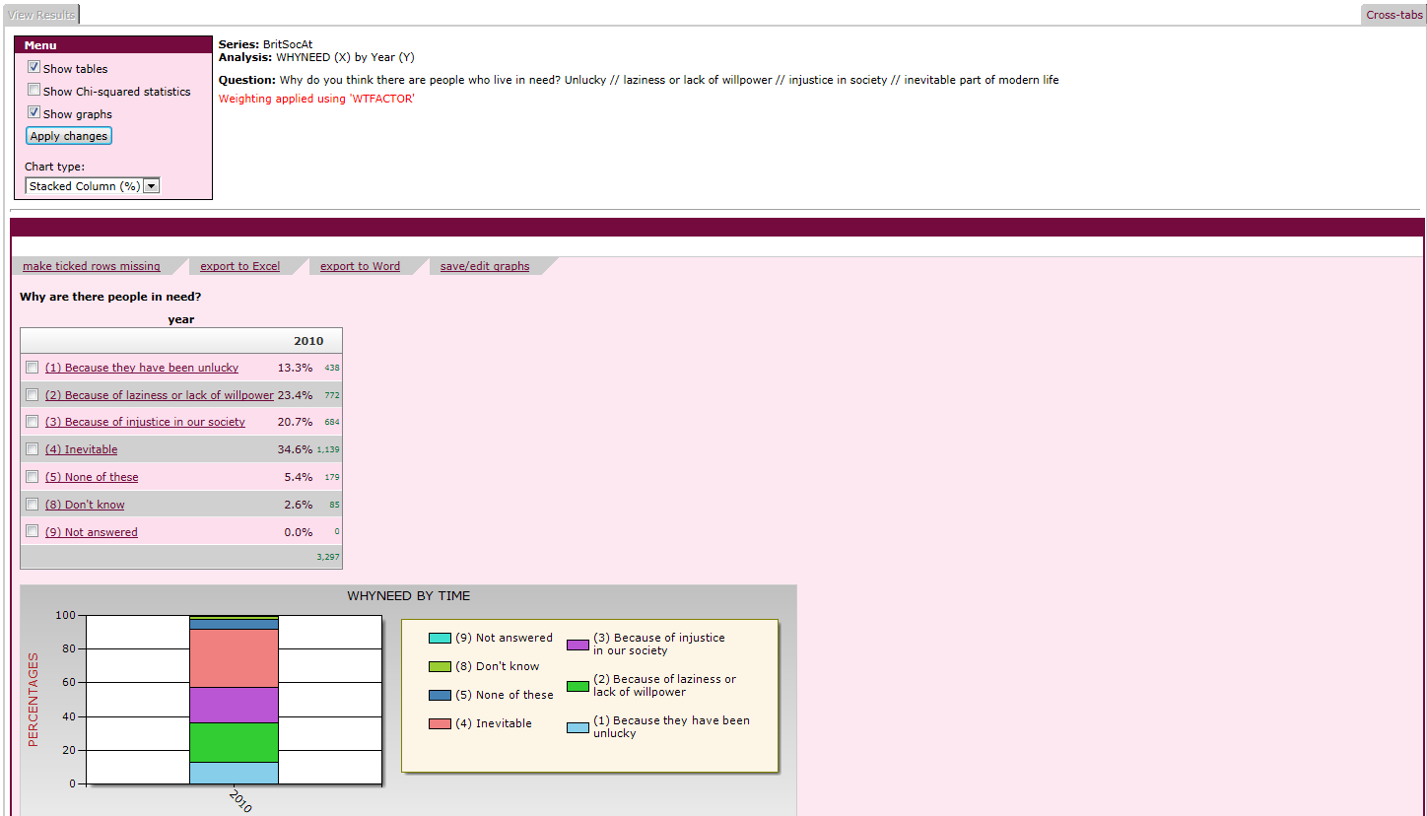
Now click on Crosstabs

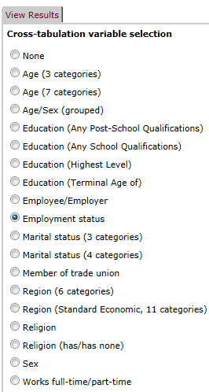
And choose the variable you want to use in the Crosstabs
Here we select ‘Employment Status’
(we might theorise that people in work will view the cause of living in need differently to those who are employed)

Finally, click on ‘View Results’

Again results are shown as a table and bar chart

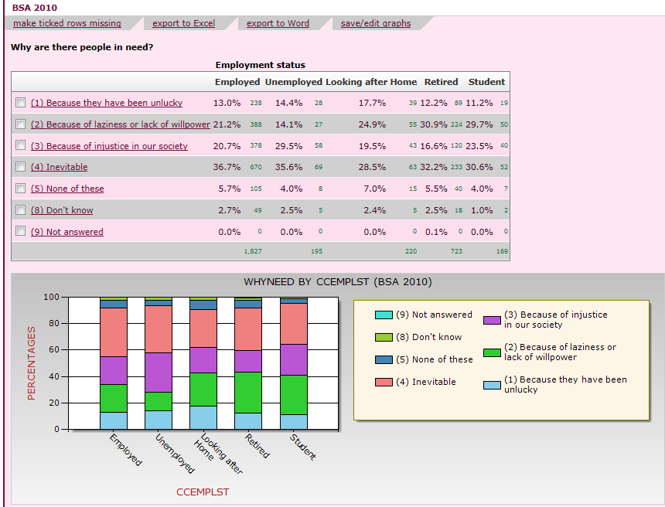
Again note you can save the results to Word or Excel for reference

For reflection…
Compare the results for unemployed and employed. Are they as you would expect?
Compare the results for ‘students’ in the national data with the results for POLI10251.
Try repeating this exercise using some other variable in the crosstab (e.g. look at differences by age)
Try repeating this exercise for one of the other six questions

FINALLY… If you have time, and for private study…
TASK 3. Source the data for some additional BSA questions of your own choice (relevant to your projects)
For this you may find it easier to search for questions by browsing the ‘contents list’ rather than ‘search questions’ option from the menu. You’ll find most relevant questions for your projects under the INEQUALITY, INCOME REDISTRIBUTION AND SOCIAL WELFARE’ section (see below)but note there are many sub-categories and hundreds of variables in the BSA so you may have to search a while to find the variables that best suit your research needs.
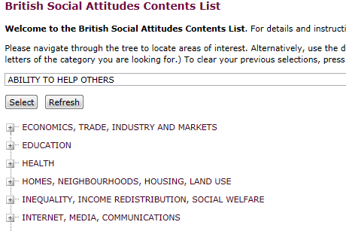
Alternatively, you can carry on using ‘search questions’ and try different key words e.g. type in the word ‘benefits’ to reveal all questions that contain the word ‘benefits’
Good searching! Mark Brown 06/11/13

