Quantitative Data for Dissertations

The method and data required for research depends entirely on the research question but there are many ways you can bring quantitative data into dissertations.
Sometimes your research question will suit a mainly quantitative approach e.g. an analysis of a social survey using SPSS. But even where your research design is mainly based on the use of qualitative methods and data, almost all dissertations can benefit from inclusion of some quantitative data, even if it just a table from a survey or Census to provide context for your study. The same is true for many assessed essays.
This short guide discusses different ways to access quantitative social data, including five examples of on-line data sources that do not require the use of specialist statistical software.
Contents
1. Data for a dissertation based on a secondary analysis of a survey data set (using SPSS)
2. On-line sources of quantitative data
Example 1: Data from British Social Attitudes (BSA)
Example 2: Data from the Centre for Comparative European Survey Data
Example 3: Data from the 2011 England Wales Census through NOMIS
Example 4: Neighbourhood Statistics
Example 5: International data from the World Bank

About this resource
Quantitative Data for Dissertations (October 2013) has been developed by Mark Brown and Jen Buckley as part of the ESSTED project at the University of Manchester. ESSTED was funded through the ESRC Curriculum Innovation Initiative and ESRC Researcher Development Initiative.
You can find details of the ESSTED project and others resources on the project website
http://www.socialsciences.manchester.ac.uk/essted/.

ESSTED resources are released under the Creative Commons Attribution-ShareAlike 4.0 International License. Please use and adapt as you need, but acknowledge the creators and the ESSTED project as the source.

1. Data for a dissertation based on a secondary analysis of a survey data set (using SPSS)
This would typically involve an SPSS secondary analysis of a large scale Social Survey – the UK Data Service http://ukdataservice.ac.uk has a huge range of social survey datasets that can be accessed and downloaded for a dissertation of this type.
The module SOST20012 gave you the skills to undertake a dissertation of this type including how to search the Data Service for data on your topic and how to conduct analysis using SPSS. The workshop guides from the course will help, and see also a more detailed guide on ‘how to find data in the UK Data Service’ (available on Blackboard). Please also make use of the additional guidance and advice available via the drop in sessions (details above).

2. On-line sources of quantitative data
Carrying out an SPSS type analysis is not the only way to include some quantitative data in your research. Here are five examples of on-line services that give you quick and easy access to some really good quantitative data (tables and graphs) on a range of topics.

Example 1: Data from British Social Attitudes (BSA)
www.britsocat.com/Home
BSA is a great source of data on public attitudes in the UK across a huge range of topics. It’s been running annually since 1983 so can be used to look at how attitudes on topics change over time as well as differences between different social groups.
The BSA data can be downloaded and analysed in SPSS (as described in 1 above) but there is an alternative way to access tables and graphs from the BSA using an on-line service; it requires registration but this is quick and easy.
In this example, let’s suppose you want to obtain some statistics on public attitudes to capital punishment (though the same steps are involved whatever questions you are interested in)
Get registered... To use the site you first need to register. This is done very quickly on line
Go to http://www.britsocat.com/Home
Just click on registration – and give your email address and choose a password when prompted
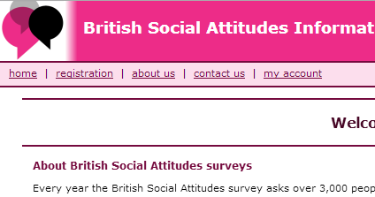
Once registered, getting the data is simple. You just follow these steps:
Select the survey year
Request the data as a table / graph
Produce some crosstabs

Select the question

The following screenshots show how this is done but at each step clear on-line instructions are given at the top of the screen
STEP 1: Select the year of data
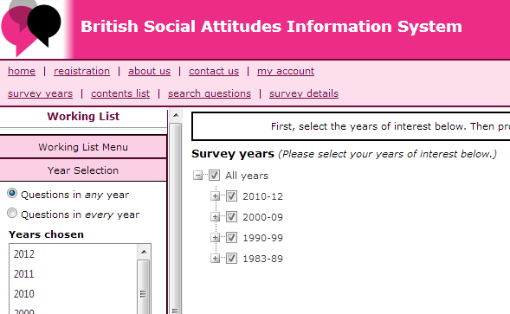
- Click on ‘survey years’

- Choose the range of years you are interested in (the BSA goes back to 1983). Here we’ve checked ‘all years’ so we can see the full range of questions ever asked on this topic
STEP 2: Choose the survey questions/variable you’re interested in
Select… Contents list from the menu
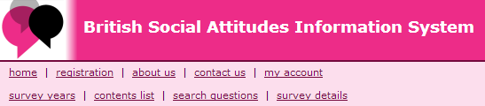

Navigate through the tree (as shown below) to locate areas of interest (alternatively if you know what you’re looking for you can type in the first few letters of the category you are looking for into the drop down box and click select)
For this example we selected ‘Capital Punishment’ from the pull down menu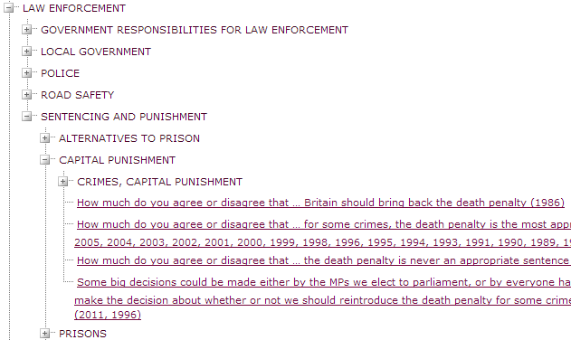
This reveals 4 questions on this topic – note after each it gives the year (or years) in which the question was asked

STEP 3: Show the results
To see the survey results for your question you simply click on the question you want (here we pick the second one down as it has been asked every year and can be used to look at changing support over time)
Results appear as a table....
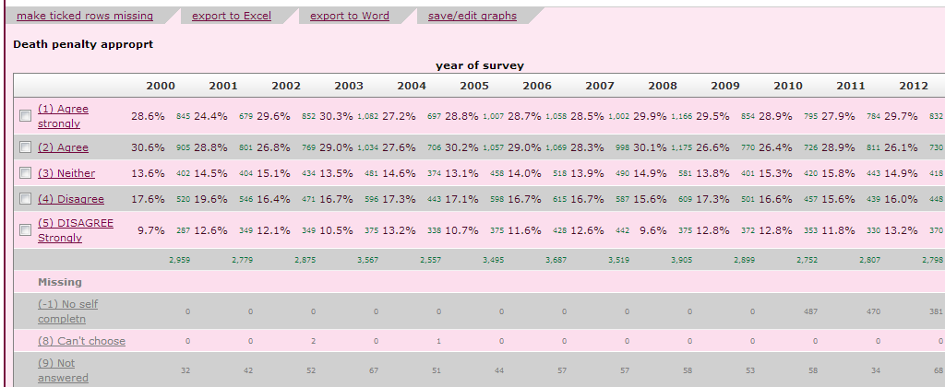
and as a bar chart...
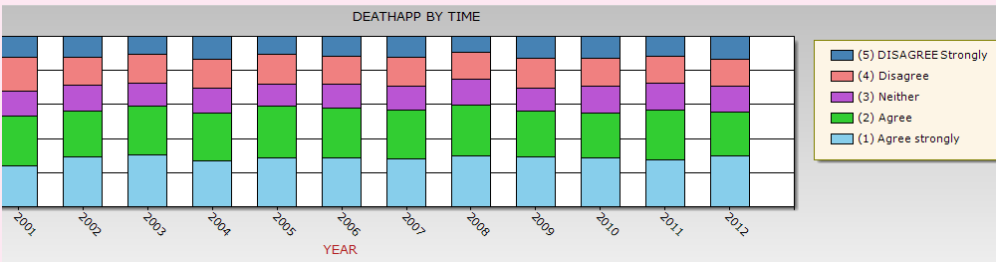
Note you can then save these outputs e.g. to Excel or Word (often a good idea to export to Excel where you can manipulate the data further and produce your own graphs)

STEP 4: Crosstabs... and a chi square test for statistical significance
You will notice that at the top of the results page you have the option to request crosstabs and a chi square test
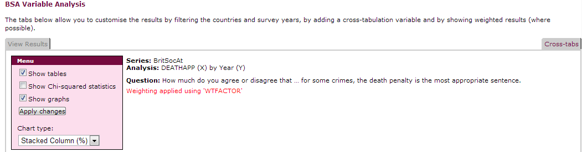
Select the chi square box...
... and then click on crosstabs..

Now select the variable you want to use in the crosstab from the list provided ...
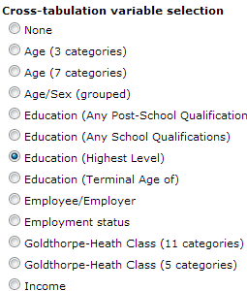
here we’ve selected education
Click ‘show results’ and you get the crosstabulation shown as a table and as a stacked bar chart
(just shown here for most recent year 2012 )

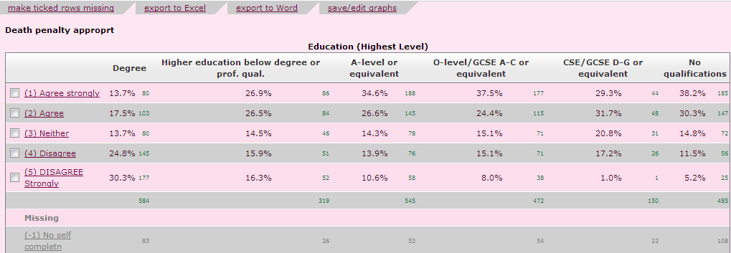

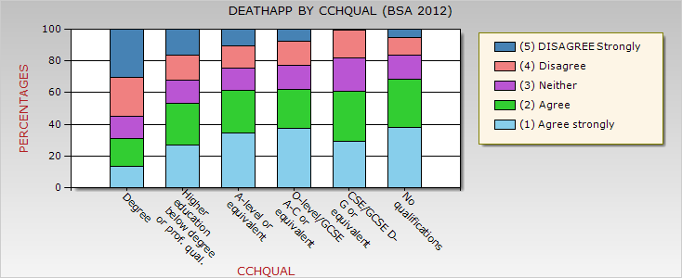

Again, you can choose to save the results as an excel file for your own use

Example 2: Data from the Centre for Comparative European Survey Data
http://www.ccesd.ac.uk/Home
This site includes the UK BSA shown in Example 1 and comparative data for the rest of Europe.
The way you use this site is very similar to Example 1 (the BSA site is maintained by CCSESD).
The main difference is that there is an extra step at the beginning, in which you select the countries you want data for as well as the years.
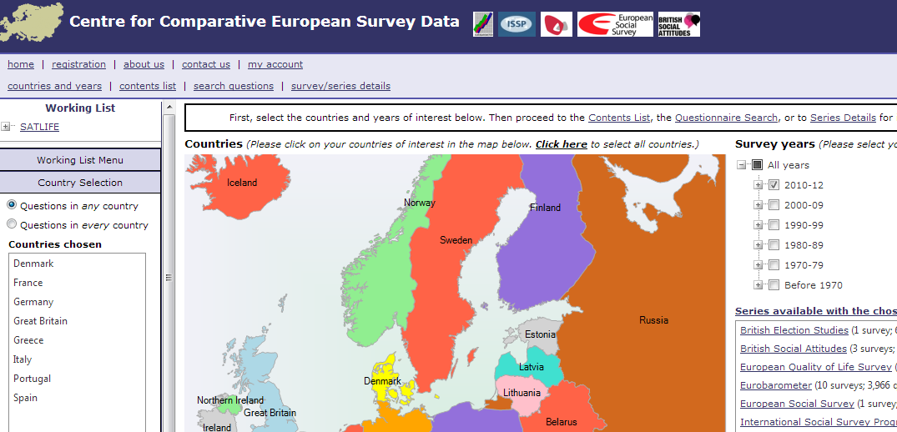
Select ‘Countries and Years’

Select countries by clicking on the map
Select the years here
The datasets it will search are listed here (includes the BSA)

The next steps are similar to Example 1. Click ‘contents list’ and search the tree menu for the topics of interest. When you find the question you want click on it to get the results.

In this example we show the results for a question on ‘satisfaction with life’ for a selection of European countries
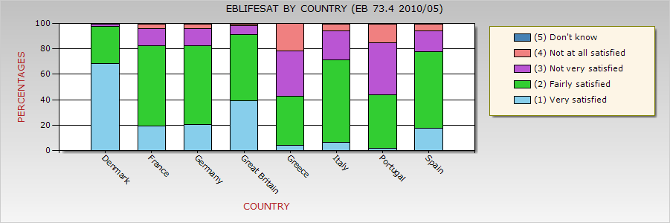

Example 3: Data from the 2011 England Wales Census through NOMIS
http://www.nomisweb.co.uk/census/2011
The 2011 Census collected data on characteristics of the population of England and Wales including age, occupation, ethnicity, household composition and size, car ownership, religion and unpaid care work.
You can access tables from the 2011 census through on on-line service without needing to register.
The tables can include statistics for one census topic (e.g. statistics on religion) or you can look combine data for more than once topic (e.g. religion categories broken down by age). Additionally, tables can refer to the level of country, or in many cases, specific regions and local authorities.

How to find tables – A step-by step guide
From the main census page (web-address above) you can find different options for finding relevant data.
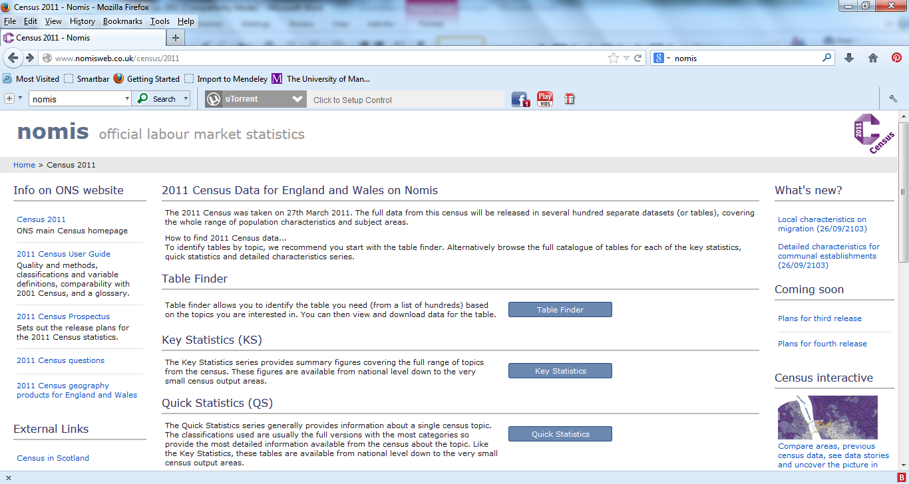
Option 2
Use ‘Table Finder’ to search through a wider selection of tables, including tables combining census topics e.g. ethnic group by age
Option 1
Select ‘Quick Statistics’ to quickly find data on the main census topics e.g. the age or ethnic profile of England and Wales

The following steps show how to search using Table Finder. In this example, we’ll look for data for statistics on different living arrangements in the England and Wales.

Step 1: After selecting Table Finder from the main page, you’ll find a long list of tables to choose from. You can just scroll down the screen and look for a table or, you can use Keyword or search Table Titles to limit the choice (e.g. try typing in ‘living’.
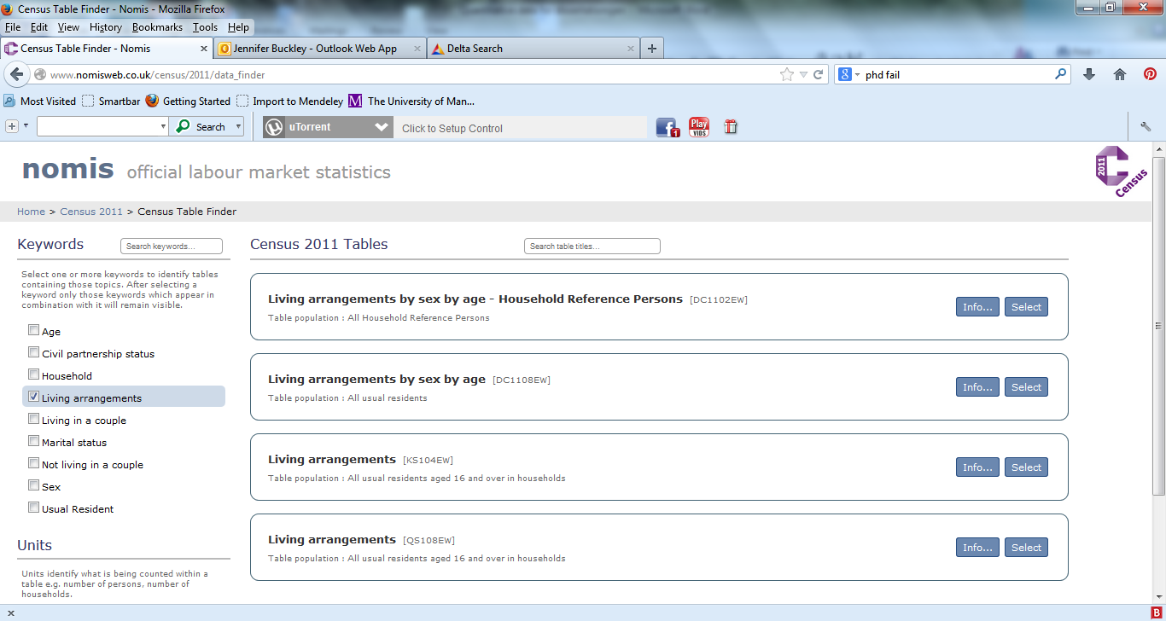
In this example, there are different tables relating to statistics on living arrangements.
The bottom options (‘living arrangements’) relates to the statistics just for living arrangement whilst the options above give the data by sex and age.

Step 2: Once you’ve found the relevant table press select.

Step 3: Having selected the table you want, you’ll come to a page that gives more information about the data.
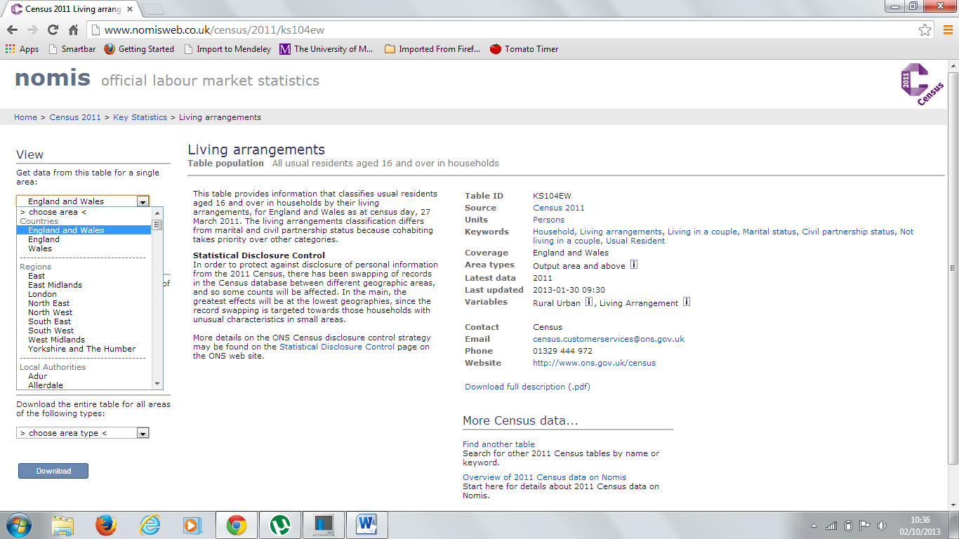
To get the table, you need to use the drop down menus to choose how you want to view it.

First, select the area you want data for – for ‘Living Arrangements’ you can get the data at country level or for regions and Local authorities (But, not all tables are available below country level).

Then, if you are combining more than one topic (e.g. living arrangements by age) select one to go in the rows of the table and the other in the columns.

Step 4: Press View to get the table

The table appears on the screen.
Step 5: Download to the data to Excel and make tables and graphs to suit your needs.
Census topics, like living arrangements, tend to include lots of categories, often leading to larger and more complicated tables than you need.
You can simplify the table by looking for broader categories.
In this case ‘Living in a couple’ and ‘not living in a couple’ are broad headings containing different categories e.g. those living in a couple can be ‘married in a civil partnership’ or ‘cohabiting’.
Here is an example of a table made using Excel. The Table below includes data for Manchester and England Wales, which allows us to compare how the population of Manchester varies from England and Wales as a whole (if you look at the numbers you can see some big differences).
It was collected by going through the steps above twice: the first time Area=’England and Wales’ and the second ‘Area=Manchester’. Once the data was downloaded it was copied and pasted into the one spreadsheet.
Table 1 Living arrangements in Manchester and England and Wales
(Percentage)
 | Manchester | England and Wales
Married or in a civil partnership | 28.5 | 45.9
Cohabiting | 13.2 | 11.9
Not living in couple | 58.3 | 42.2
Source: 2011 Census
Notes: The ‘Not living in a couple’ category includes the following Single (never married or never registered a same-sex civil partnership); Married or in a registered same-sex civil partnership; Separated (but still legally married or still legally in a same-sex civil partnership); Divorced or formerly in a same-sex civil partnership which is now legally dissolved and widowed or surviving partner from a same-sex civil partnership

The table was made simpler by looking at those ‘Not Living in a Couple’ as one category; to make this clear to others a note was added below the table. Additionally, to make it clear where the data came from the source was indicated below the table.

Example 4: Neighbourhood Statistics
http://www.neighbourhood.statistics.gov.uk/dissemination/
This is a great source of statistics on local areas in the UK. This can be very useful when you want some data to provide context for a local study e.g. statistics on the ethnic composition of the local population, or the crime rate etc.
It’s a very easy site to use, no registration required.
Method 2: For a neighbourhood summary just type in a postcode here
Here we have a neighbourhood summary for M13 9PL (postcode for Manchester University).

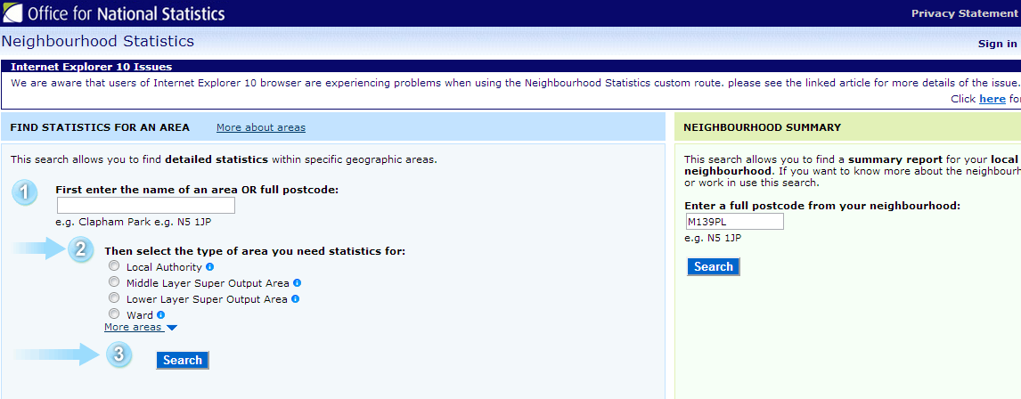
Method 1:
To find specific statistics for a local area just type in a postcode here and choose the level of geography you want data for (ward is the smallest) .

Tabs at the top cover different topics – here we show health - a graph of life expectancy (men and women) compared to the national figures.
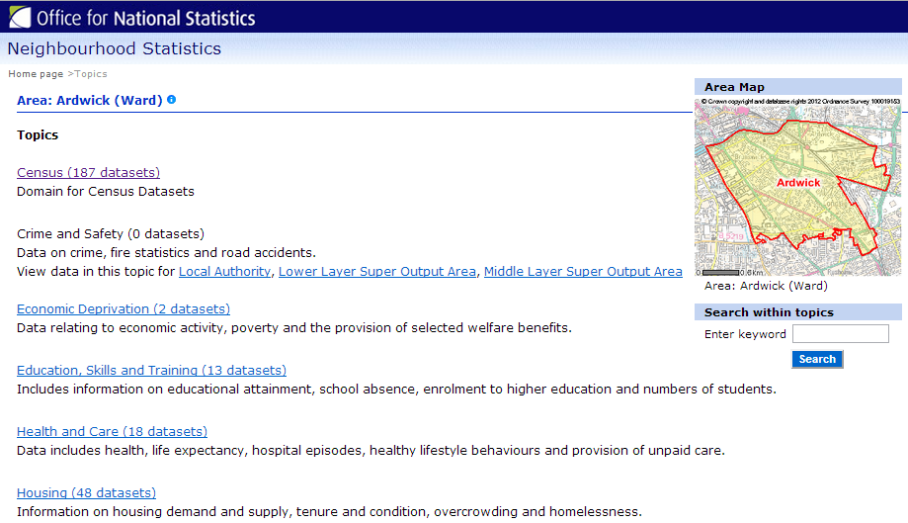

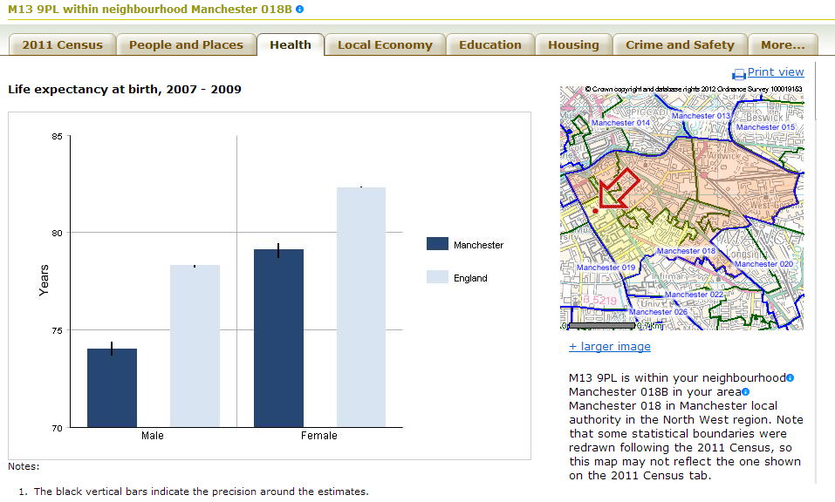

Just click on the topic of interest from the list for a range of data on that topic for the local area requested.

Example 5: International data from the World Bank
If your research involves other countries it is worth having a look at the World Bank Development indicators.
This data is freely available via an on-line service – accessed via the UK Data Service
A clear and detailed guide on how to do this is available at:
http://stats.ukdataservice.ac.uk/ModalHelp/UKDS/UKDS.Stat_User_Guide.pdf
Data can be shown as tables, graphs and even in map form (the example below maps international variation in the share of parliamentary seats taken by women)
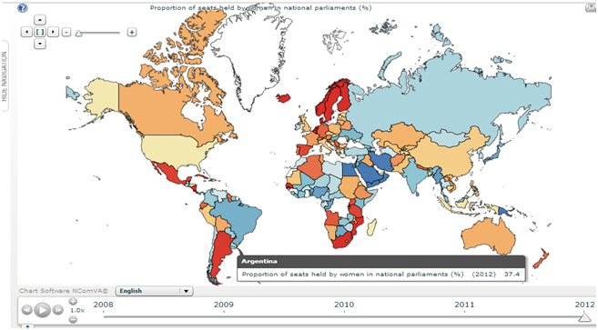
Map showing percentage (%) of parliamentary seats held by women
(World Bank 2011)

