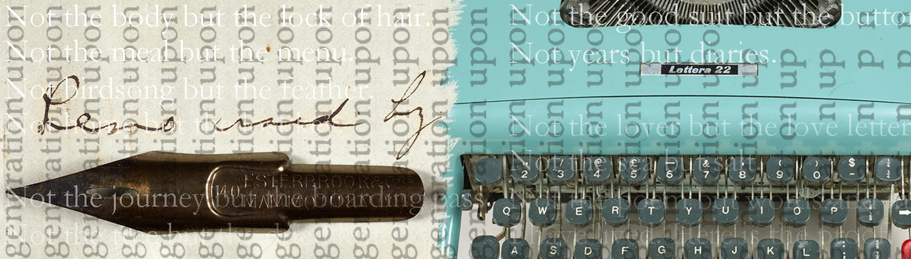

ARCHIVAL AFTERLIVES: POSTWAR POETRY IN ENGLISH
(27-29 June 2017)
THE JOHN RYLANDS RESEARCH INSTITUTE,
UNIVERSITY OF MANCHESTER
PROGRAMME

TUESDAY 27 JUNE 2017

1-1.30pm | Foyer  Registration
1.30-1.45pm | Historic Reading Room  Opening Remarks  Hannah Barker (Director of the John Rylands Research Institute)
1.45-3.15pm | Historic Reading Room  Roundtable: The Global Diaspora of Modern Literary Archives  Chair: Stella Halkyard  Stephen Enniss (Harry Ransom Center, University of Texas, Austin)  Rachel Foss (British Library)  David Sutton (University of Reading)
3.15-3.45pm | Foyer  Coffee Break
3.45pm-5pm | Historic Reading Room  Panel 1: Digital Archives (Chair: Fran Baker)  Ailbhe Darcy (Cardiff University): ‘Putting the Audiobank to Use: What poetry reading archives can teach us about poetry readings’  Ruth Burton & Sarah Prescott (University of Leeds): ‘Way-finding and Walking Home: Signposting magic and meaning in the Simon Armitage Archive’  Mark Byers & Kate Sweeney (Newcastle University): ‘The Bloodaxe Archive: Criticism, Engagement Interpretation’

Christie Room
Panel 2: Genetic Criticism and Poetry: Drafts, Revisions and Intertexts (Chair:
Laura O’Connor (University of California, Irvine): ‘Passionate Attachments: Medbh McGuckian’s Intertextual Props’

Carrie Smith (Cardiff University): ‘‘"They wrote themselves": The 'shock' composition of Ted Hughes's Crow poems'

Wim Van Mierlo (Loughborough University): ‘Poetic Archaeologies: Ted Hughes’s Creative Layering in Birthday Letters’

WEDNESDAY 28 JUNE 2017

10.00-11.15am | Historic Reading Room  Panel 3: Sylvia Plath (Chair: Vona Groarke)  Heather Clark (Graduate Center, City University of New York): ‘The Archival Afterlives of Sylvia Plath and Al Alvarez’  Fran Baker (University of Manchester Library): ‘Spectral Traces: Searching for Sylvia Plath in the Rylands’ Archives’  Ikram Hili (University of Monastir, Tunisia): ‘The Box is Only Temporary: Taking the Lid Off Sylvia Plath’s Boxes of Manuscripts’
Christie Room
Panel 4: Seamus Heaney and Translation (Chair: Florence Impens)
Stephen Regan (Durham University): ‘The Archival Afterlife Of Seamus Heaney’s Sweeney Astray: From Notebook To Translation’

Rachel Falconer (University of Lausanne): ‘Virgilian Afterlives In Heaney's Late Poetry’

Michael Parker (Independent Scholar): ‘Keeping Time’: Seamus Heaney’s The Last Walk And The Need For Translation’

11.15-11.45am | Foyer  Coffee Break
11.45am-1pm | Historic Reading Room  Panel 5: Collecting and Preserving Archives (Chair: John Hodgson)  Maryanne Dever (University of Technology Sydney): ‘Mourning and Materiality: Archiving Valentine Ackland’  John Wells (Cambridge University Library): ‘Collecting the ‘Cambridge School’’  Charlotte Berry (Magdalen College, Oxford): ‘The “archivist effect”: defining a theoretical framework for exploring the role of the archivist as an agent of modern British literary archives’

Christie Room
Panel 6: Carcanet Poets (Chair: Michael Schmidt)
Katherine Bone (University of St Andrews): ‘Not fixed discovery but the means to discovery: The Evolution of Louise Glück’s Visual Language’

Rebecca Cullen (Nottingham Trent University): ‘World, how did I get here? Tempo and Temporality in the poetry of Sujata Bhatt’

Florence Impens (University of Manchester): ‘Digging in Translation Archives: Elaine Feinstein and Marina Tsvetaeva’

1-2pm | Foyer  Lunch
2.00-3.15pm | Historic Reading Room  Plenary Lecture: ‘The Archival Afterlives of Ted Hughes and Seamus Heaney.’  Stephen Enniss (Harry Ransom Center, University of Texas, Austin)  Chair: Vona Groarke
3.15-3.45pm | Foyer  Coffee Break
3.45-5pm | Historic Reading Room  Panel 7: Literary and Publishing Networks (Chair:  Stewart Smith (University of Strathclyde): ‘A poetry enlarged: Ian Hamilton Finlay’s correspondence as active space’  Jaclyn Allen (University College, Dublin): ‘The Poet and her Editors: Elizabeth Dayrush and the Winters’  Nadia Georgiou (University of Surrey): The tangled web of network mapping: the poetics and politics of a translator’s correspondence’
Christie Room
Panel 8: The reception of neglected poets (Chair: Lucy Burns)
Imogen Durant (University of Manchester): ‘Understanding Mid-twentieth-century Poetry through the Papers of Dawson Jackson’

Tara McEvoy (Queen’s University, Belfast): ‘The black is in my lungs now, and in my poems’: the Poetry of Padraic Fiacc’

Douglas Field (University of Manchester): ‘Mapping the Jeff Nuttall Archive’

5.00-6.00pm | Bible Room  Collection Encounter (Fran Baker)  Delegate Free time
6-7.30pm | Roundtable: Poetry Publishing  Chair: Vona Groarke  Peter Jay (Anvil Press)  Robyn Marsack ((Royal Literary Fund/University of Glasgow)  Deryn Rees-Jones (Pavilion Press/University of Liverpool)  Michael Schmidt (Carcanet Press)

THURSDAY 29 JUNE 2017

9.30-10.45am | Historic Reading Room  Panel 9: Self-curating and the ‘manipulation’ of archives (Chair:  Chris Clarke (Independent Scholar): ‘Inside Robert Creeley’s Personal Library: Ann Quin and the Limits of Postwar Avant-Garde Institution’  Karl O’Hanlon (University of York): ‘Difficult, Refractory, and Suffering Material: Geoffrey Hill’s Archive’  James Underwood (University of Huddersfield): ‘When the archivist becomes the archived: Philip Larkin’
10.45-11.15am | Foyer  Coffee Break
11.15-12.30pm | Historic Reading Room  Panel 10: Uncovering new critical interpretations in archives (Chair: Imogen Durant)  Lucy Burns (University of Manchester): ‘Reading Olson’s Archive: Projective Verse and the Projective Test’  Adam Hanna (University College, Cork): ‘Pushing the Envelopes: Researching in the Seamus Heaney Correspondence Archive at Emory University’
Christie Room
Panel 11: Archives and the Creative Process (Chair:
Mariah Whelan (University of Manchester): ‘Creative Afterlives: Using a Family Archive to Prompt a Creative Work’

Angus Connell Brown (University of Birmingham): ‘Material Worlds: Erasure Poetry and the Book as Archive’

Carol Mavor (University of Manchester): ‘Reading the ‘Life Objects’ of Niccolo Petroni as Sequenced Poetry’

12.30-1.30pm | Foyer  Lunch

1.30-2.45pm | Historic Reading Room  Plenary Lecture: ‘Archival Elegies: Recovering Irish Women Poets’  Lucy Collins (University College, Dublin)  Chair: John McAuliffe
2.45-3.15pm | Foyer  Coffee Break
3.15-4.30pm | Historic Reading Room  Panel 12:‘Archival Beforelives’: The Poets’ View  Vona Groarke (University of Manchester)  Evan Jones (University of Bolton)  Frances Leviston (University of Manchester)  John McAuliffe (University of Manchester)
4.30-5.30pm | Delegate Transport to Irish World Heritage Centre  Meet in Foyer of the John Rylands Library
5.30-6.15pm | Irish World Heritage Centre  Reception
6.15pm | Irish World Heritage Centre  Poetry Reading  Elaine Feinstein and Tara Bergin, introduced by Michael Schmidt.
7.45pm | Irish World Heritage Centre  Conference Dinner

Venues:

The conference will take place at the John Rylands Library, 150 Deansgate, Manchester M3 3EH.
The poetry reading and conference dinner on 29 June will take place at the Irish World Heritage Centre, 1 Irish Town Way, Manchester M8 0AE. Free delegate transport will be provided between the venues.

Steering Group:

Florence Impens, Fran Baker, Imogen Durant, Douglas Field, Vona Groarke, Stella Halkyard, John McAuliffe.

Conference Email Address: jrri.conference2017@manchester.ac.uk

Twitter: #JRRIConf2017

