FINAL SESSION
GTA Training
Andrew Davies
Session 6
GTA Training

Learning/reflection log
This log is a vital aid to recording your own learning and to developing your own skills as a reflective practitioner. It need not be shown to anyone. This is only an example and could be adapted for your PPP.
What have I learned? |  |  | What am I going to do about it?
Experiences/Actions  What were the main experiences for me or the main things that I did since the last checkpoint. | Reflection  How did I feel during these experiences? | Learning  What did I learn about myself or about other people. | Goals  What do I want to do about this? What ideas would I like to test out? What skills do I want to develop? | Planning  What can I do to help me achieve goals?

Teaching | Learning
Motivation | Development
Enthusiasm | Knowledge
Communication | Curiosity
Approachable | Methodological
Fun | Achieving
Preparation | Patience
Management | Performing
Challenging | Challenging

Words we have associated with Teaching and Learning.

Evaluating your teaching
STUDENT-TEACHER’S SELF-EVALUATION RECORD AND ACTION PLAN
Student’s name: Date:

To be completed by the student-teacher at the end of the teaching session:
- Provide both positive and negative feedback and give examples from your session to illustrate your points
- Suggest how you intend to improve future sessions and identify your future personal development aims

Planning: Did your plan meet the needs of every learner during the session? Evaluate how your plan met individual needs.

Justify your selection of resources for the session. Where possible, analyse how effective the resources were in supporting the session delivery.

Teaching: Justify and evaluate your selection of teaching and learning approaches for the session.

Evaluate the effectiveness of your teaching and suggest how you would modify the session to make it more effective.

Evaluate your own communication skills and identify how you could improve. How could you overcome any barriers to effective communication next time?

Explain how you used feedback and questioning In your session to support the assessment of learning. Where possible, analyse how the feedback and questioning contributed to learning.

Using feedback from others (including learners, peers and your tutor) evaluate how you could improve your own practice. Reflect on how effective others thought you were and suggest modifications to your teaching as a result.

PLANS FOR PERSONAL DEVELOPMENT. From your evaluation above, what main points will you take forward to help with being a more effective teacher next time?

Student-teacher’s signature: Date:
(Adapted from: OCR (2009))

Lesson observation form from OFSTED.
form shows areas of teaching that are being assessed by OFSTED durring their visits to Higher Educational institutes. We will focus on "Good", "Satisfactory" and "Inadequate".

Grading Category | 2. Good | 3. Satisfactory | 4. Inadequate
Planning  Content  Aims | Clear structure & links to SoW.  Well planned and ensures productive use of learners’ time.  Aims and objectives are clear and shared with learners. | Acceptable outline of methods & some links to SoW  Indicative content outlined  Clear objectives and students know what they are doing. | Sketchy with minimal detail & few links to SoW.  Little, if any, content indicated.  No clear aims/objectives & they are unsure what to do.
Learning  Methods &  Resources | Good and imaginative use is made of resources, including new technology to enhance learning. | Adequate use of a range of resources, including new technology, to support learning. | Inadequate use of resources and activities are not well matched to provide suitable challenge.
Student Learning  Student Focus | Students acquire knowledge, develop understanding and learn and practise skills well.  Keen to do well, diligently and work at a good pace. | Students acquire knowledge, understanding and practise skills at least satisfactorily.  Most work effectively & steadily when guided, lack confidence in improving quality of work. | Acquire knowledge, learn and practise inadequately.  Many fail to work effectively unless closely directed and give up easily. Don’t enjoy the activities.
Assessing  Feedback | Well-organised. Students are provided with detailed feedback.  Listens to, observes and questions students in order to reshape tasks and to improve learning | Adequate. Monitors students’ work during lessons.  Picks up general misconceptions and adjusts their plans accordingly to support learning. | Assessment is inadequate.  Too little account of prior learning or understanding of tasks and ineffective to help improve.
Pace | Pace of lesson matches the subject and most learners’ needs and level. | Overall pace promotes some learning and interest. | Activities lack pace/rigour and do not promote learning.
Timing | Most activities were well-timed and structured to ensure comfortable completion in the time available. | Number/structure of activities fitted reasonably well into time available, but some signs of mistiming seen. | Number/ structure of activities not well judged to ensure completion in time.
Different-iation  (SEN) | Good individual support evident through development and use of resources and range and scope of planned activities. | Some individual support evident through development and use of resources, and range and scope of planned activities. | Little evidence of planning to meet individual learning needs.
Inclusion | Teaching & reference materials promote inclusion through highly effective use of diverse examples. No bias. | Teaching & reference materials show knowledge of inclusion through use of some diverse examples. No bias. | Little or no knowledge or awareness of inclusive learning principles. Resources use stereotypical, inaccurate and/or offensive examples.
Student  Behaviour  E.g. | Students’ behaviour makes a strong contribution to good learning in lessons:  - respond to expectations  - and to guidance on conduct  - behave considerately to peers | Students behave so that learning proceeds appropriately and time is not wasted:  - know what is expected when  working alone or small groups  - only gentle prompting needed  - generally respond to sanctions | Poor behaviour/rudeness occurs more than on very isolated occasions:  - time wasted on persistent  low-level disruption  - excessive chatter  - Some lack of respect
Student Progress | Majority make at least good progress, with nothing that is inadequate. | Students make expected progress given starting point & some may make good progress. | Students, or particular groups of students, make too little progress.
Ongoing Review  Summary | Good review/recap at points in the lesson  Clear summary of progress with reference to the next lesson. | Some review of learning  Brief summary at the end and  brief reference to next lesson. | Insufficient or no review of learning  Insufficient or no summary, little reference to next one.
Inspiring  Expert  Effective | Consistently effective in ensuring students are motivated/engaged.  Generally has strong subject knowledge which enthuses and challenges most students  Contributes to their good progress. | May be good in some respects and there are no major inadequacies.  Subject knowledge is secure, students are generally engaged by work & little time is wasted.  Students show interest in the work. | Fails to promote the students’ learning and enjoyment.  Command of the subject is inadequate for level demanded by the course.  Students show little/ no interest in their work.

Now compaire this to the "Outstanding".

Grading Category | 1. Outstanding
Planning  Content  Aims | Highly detailed, clear links to SoW (timing, structure and method).  Thoroughly prepared and allow unanticipated opportunities to arise  Aims and objectives are clearly explained.
Learning Methods &  Resources | Resources, including new technology, make a marked contribution to the quality of learning.
Student Learning  Student Focus | Students acquire knowledge, develop understanding and learn & practise skills exceptionally well.  Excellent concentration, rarely off task. Persevere when challenged.
Assessing  Feedback | Rigorous and well organised. Dialogue with students is consistently of a very high quality.  Systematic and effective checks of understanding throughout, anticipating when to intervene with a striking impact on the learning.
Pace | Pace of lesson clearly matches subject and learner level.
Timing | Number and scope of activities was very well-judged to ensure completion in the time available.
Different-iation  (SEN) | Excellent awareness of needs of all. Differentiated resources and activities available: extension work, structured group/individual work and carefully planned in-class customised support
Inclusion | Teaching and reference materials promote inclusionpromote inclusion through highly effeffective use ofeffective use of diverse examples. No bias.
Student Behaviour  E.g. | Students’ consistent, thoughtful behaviour is an outstanding factor in their successful learning:  - extremely positive class ethos - highly considerate/ support peers  - no evidence of disruptions
Student Progress | Progress is at least good for all students & is exemplary in some.
Ongoing Review  Summary | Highly effective review of learning at intervals through the lesson.  Very clear summary linked to aims & objectives and the next lesson.
Inspiring  Expert  Effective | Highly effective in inspiring students & ensuring they learn extremely well.  Excellent subject knowledge is applied consistently to challenge and inspire.  Acutely aware of abilities and of prior learning and plans effectively to build good relationships.

Lesson Plans
LESSON PLAN
TUTOR |  | DATE AND TIME | CLASS DETAILS | LOCATION
Name: |  | Date: | Size: | Room:
 |  | Start time: | Type:
 |  | Duration: | Level:
SESSION |  |  | COURSE
Title: |  |  | Title:
Reference:
RESOURCES AND EQUIPMENT |  |  | ROOM LAYOUT
INTENDED OUTCOMES

STRUCTURE (CONTENT AND SEQUENCE) OF LESSON
Phase: | Tutor Activities: |  | Learner Activities: |  | Time:
ASSESSMENT

COMMENTS (Eg EVALUATION OF SESSION, POINTS TO CARRY FORWARD TO NEXT SESSION, etc)

Feedback

Qualities and attributes

How can we best give feedback to students? There are many suggestion in the literature regarding "Best practice in Feedback" but the main points seem to be, for example, that feedback needs to be:

• Timely. The sooner the better. There has been plenty of research into how long after the learning event it
takes for the effects of feedback to be significantly eroded. Ideally feedback should be received within a day or two, and even better almost straightaway, as is possible (for example) in some computer-aided learning
situations, and equally in some face-to-face contexts. Although this is not always possible, there are guidlines to feedback and the time expected. Most institues seem to adopt the 2 or 4 week for a written thesis. How long is yours?

• Intimate and individual. Feedback needs to fit each student's achievement, individual nature, and personality. Global ways of compiling and distributing feedback can reduce the extent of ownership which students take over the feedback they receive, even when the quality and amount of feedback is increased. Each student is still a person. It is all too easy to adpt a cut and paste attitude.

• Empowering. If feedback is intended to strengthen and consolidate learning, we need to make sure it doesn't dampen learning down. This is easier to ensure when feedback is positive of course, but we need to look carefully at how best we can make critical feedback equally empowering to learners.

• Feedback should open doors, not close them. In this respect, we have to be particularly careful with the
words we use when giving feedback to students. Clearly, words with such 'final language' implications as 'weak' or 'poor' cause irretrievable breakdowns in the communication between assessor and student. To a lesser extent, even positive words such as 'excellent' can cause problems when feedback on the next piece of work is only 'very good' - why wasn't it excellent again? In all such cases it is better to praise exactly what was very good or excellent in a little more detail, rather than take the short cut of blanket praising.

• Manageable. There are two sides to this. From our point of view, designing and delivering feedback to
students could easily consume all the time and energy we have - it is an endless task. But also from students'
point of view, getting too much feedback can result in them not being able to sort out the important feedback
from the routine feedback, reducing their opportunity to benefit from the feedback they need most.

What else? These are only five qualities and attributes that we could adopt when planning our feedback. You might want to look at a longer list such as: 'Guidelines on Giving Feedback', provided by Brenda Smith and Sally Brown in 'Getting to Grips with Assessment'. This has further suggestions that may help you with your feedback and help make it an integral part to learning. SEDA's website is at www.seda.demon.co.uk.

Handwritten feedback on students' work

This is the most widely used form of feedback to students. It includes our written feedback on essays, reports or dissertations. Not that long ago, there were few alternatives and it was usually accompanied by an assessment grade or mark of one kind or another. So what are the :
Advantages
• Feedback can be personal, individual, and directly related to the particular piece of work.
• Feedback may be regarded as authoritative and credible.
• The feedback can be tailored to justify an accompanying assessment judgement.
• Students can refer to the feedback again and again, and continue to learn from it.
• Such feedback provides useful evidence for external review by awarding bodies.

Disadvantages
• Handwritten feedback can be hard to read!
• Due to its authoritativeness, handwritten feedback, when critical, can seem to be threatening.
• It is very time-consuming to write individually on students' work, and also very hard to find the time when class sizes are large.
• It becomes difficult to refer to your own feedback to different students unless you keep photocopies of their work and your comments.
• It becomes too tempting to degenerate, for example, into shorthand, ticks and crosses, rather than to express positive and critical comments.

Word-processed comments on student's work

This is feedback which you compose, then print out, for each student, summarising your assessment to their work. It may also be accompanied by a grade or mark.
Advantages
• Such feedback can remain individual, personal and authoritative.
• It is easier to include pre-prepared statements, using 'cut and paste'.
• Students can refer to it time and time again.
• It is easier to read.
• You can keep copies (paper or electronic) and refer to it again.
• It also provides useful evidence for external moderation.

Disadvantages
• Even printed feedback can be seen as threatening to students when critical.
• It could appear less personal to students than handwritten feedback.
• It is not as easy to link each feedback point to the exact part of the work which you want to address.
• The 'cut and paste' elements may show up too strongly to external reviewers, if they have been used too
widely.
• It's not so easy to make emphasis in word-processed feedback, so that the most important messages stand out from those that are merely routine.

The following is an example of work marked and fedback given. Read the responces from the tutor and evaluate the students work yourself. What do you think of the tutors feedback? Any other comments?
Examples of poor feedback, these are accual feedback given on an undergraduate Business Studies course.
- That was ok but you need to do XXX next time.
- You have some areas of weakness we have to work on.
- I thought that went really badly, what about you?
- What on earth did you do that for?
- 3 out of 10 for giving it a go!
- I've got a list of development areas, how many do you think you have?
- I can't believe you just said that, what were you thinking?

Feedback is not opinion and should be:
- Specific and concrete
- Examples should be given
- Descriptive
- It must be realistic
- Consistent and fair
- Supportive of personal development
- Non-judgmental
- It is not 'advice' it is a measurement against 'agreed' standards and or criteria.

Student feedback - Student evaluation forms
Not only may you be required to give feedback to your students, but you also require feedback from them. It is important to us as reflective practitioners and teachers to have feedack on our performance as a teacher but also on the content, speed and areas for development.
It will be up to you as teacher/trainer/tutor to to assess what feedback you require and why.

Think of an area that may require feedback in following one of your sessions..and why! Give justification on feedback.
________________________________________________________________________________________________________________________________________________________________________________________________________________________________________________________________________________________________________________________________________________________________________________________________________________________________________________________________________________________________________________________________________________________________________________________________________________________________________________________________________________________________________________________________________________________________________________________________________________________________________________________________________
Try to develop your own evaluation forms:

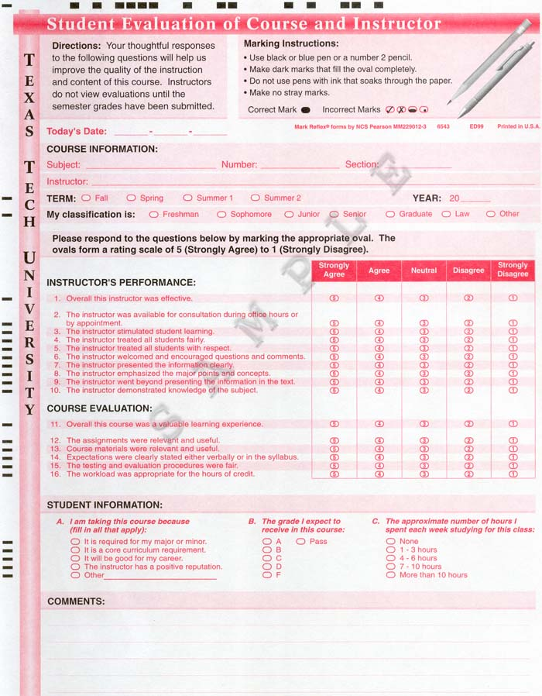
Example of a student evaluation form

