Hiding Course Content in Blackboard – Quick Guide

In light of courses from previous years becoming available to students, you may want to revisit these spaces and hide certain content. You could delete things if they’re definitely no longer required, but it’s probably safer to simply hide anything that you don’t want students to access.
There are three main ways to do this, each with a different level of scope.

1. Hide an entire content area

This will hide an entire content area by making the navigation link disappear from the navigation menu from the students’ point of view (i.e. it will still be available to staff). To do this:
1. Hover over the navigation link you want to hide, and click the little chevron button that appears:
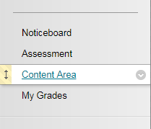
2. Select the ‘Hide Link’ option:
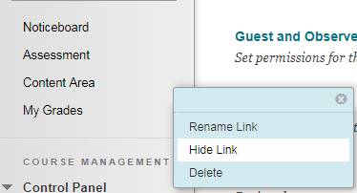
3. The page will refresh and you’ll now see a little icon next to the navigation link that you’ve hidden.
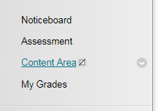
Success!

2. Hide a folder of content within a content area

Perhaps instead of hiding an entire content area you only want to hide a specific folder within a content area. This will hide everything inside the folder (items, sub-folders and all) as well as stopping the folder itself showing up. To do so:
1. Navigate to the folder you want to hide, hover over it, and click the chevron button that appears: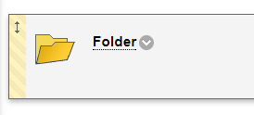
2. Select ‘Edit’ from the popup menu:
3. On the resulting page, scroll to the ‘Standard Options’ section at the bottom and make sure ‘Permit Users to View this Content’ is set to NO.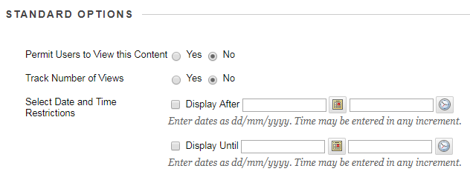
4. Click the submit button to return to the content area where you will now see that the folder is not available (to students). The folder icon will also be faded:
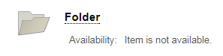
Success!

3. Hide an individual item

Finally, you might only want to hide an individual item. The process is the same as hiding a folder.
1. Find the item you want to hide, hover over it and click the chevron button that appears:
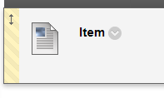
2. Select ‘Edit’ from the popup menu:
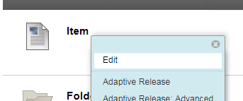

3. On the resulting page, scroll to the ‘Standard Options’ section at the bottom and make sure ‘Permit Users to View this Content’ is set to NO.
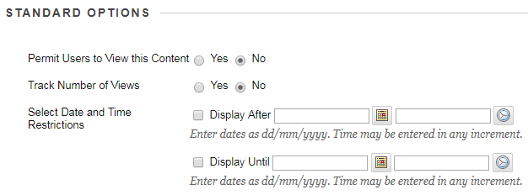
4. Click the submit button to return to the content area where you will now see that the item is not available (to students). The item icon will also be faded:
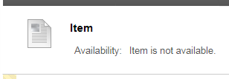
This process should work the same for most types of content within your Blackboard course (i.e. web links, images, files).

